PREPARATION AND CHARACTERIZATION OF CHITOSAN BASED POLYMER MEMBRANES FOR WATER PURIFICATION APPLICATION
Thesis

Submitted in partial fulfillment of the requirements for the degree of

DOCTOR OF PHILOSOPHY
by

RAJESHA KUMAR A.



DEPARTMENT OF CHEMISTRY
NATIONAL INSTITUTE OF TECHNOLOGY KARNATAKA
SURATHKAL, MANGALORE – 575025.
July, 2013

DECLARATION

I hereby declare that the thesis entitled Preparation and characterization of chitosan based polymer membranes for water purification application which is being submitted to the National Institute of Technology Karnataka, Surathkal in partial fulfillment of the requirements for the award of the Degree of Doctor of Philosophy in Chemistry is a bonafide report of the research work carried out by me. The material contained in this thesis has not been submitted to any University or Institution for the award of any degree.

RAJESHA KUMAR A.
Reg. No. CY10P02
Department of Chemistry

Place: NITK, SURATHKAL

Date:

CERTIFICATE

This is to certify that the thesis entitled Preparation and characterization of chitosan based polymer membranes for water purification application submitted by Mr. Rajesha Kumar A. (Register Number: CY10P02) as the record of the research work carried out by him, is accepted as the research thesis submission in partial fulfillment of the requirements for the award of degree of Doctor of Philosophy.

Dr. Arun M. Isloor

Research Guide

Dr. Darshak R. Trivedi
Research Co-guide

Chairman- DRPC

Dedicated
To
My Beloved
Mother and Sisters
ACKNOWLEDGEMENTS

Foremost, I would like to thank my research supervisor Dr. Arun M. Isloor, whose enthusiasm made the work a lot easier. His perfect balance between laboratory freedom and supervision, gave me a lot of liberty to pursue my own ideas and to work independently. I am fortunate enough to work under the guidance of a very helpful and understanding supervisor. I owe my deepest gratitude to him for his patience and belief in me.
I would like to thank Defense Research Development Organization (DRDO), government of India for financial support.
I would like to thank my Co-research supervisor Dr. Darshak R. Trivedi, Department of Chemistry for his encouragement.
I would also like to express my sincere gratitude towards my RPAC committee members: Prof. M. B. Saidutta, Department of Chemical Engineering and Prof. D. Krishna Bhat, Department of Chemistry, for spending their valuable time in evaluating my progress and providing thoughtful suggestions.
I sincerely thank Head of the Department, Prof. A. Chitharanjan Hegde and former Heads of the Department, Prof. A. Nithyanand Shetty, Prof. A. Vasudeva Adhikari for providing the laboratory facilities. I am also thankful to Prof. B. Ramachandra Bhat and Dr. D. Uday Kumar for their moral support and help.
A special thanks to Prof. Ahmad Fauzi Ismail, Advanced Membrane Technology Centre (AMTEC), University Teknologi Malaysia, Prof. T. Matsuura, Department of Chemical and Biological Engineering, University of Ottawa, Canada and Dr. Victoria Volkis, University of Maryland for the analytical support.
I remain grateful to Dr. John Augastine Kallikat, Syngene International Limited, Bangalore and Dr. Sankappa U. Rai, Advinus, Bangalore for their moral support and kind co-operation.
I would like to express my sincere thanks to my research group at NITK, Prof. Chitrakara Hedge, Dr. Mahesh Padaki, Dr. Vijesh A. M., Dr. Shridhar Malladi, Mr. Ganesh B. M., Mr. Garudachari B., Ms. Seema Shenvi, Ms. Rashmi and Mr. Abhinav Nair for their help and co-operation during the course of my research tenure.

I owe my special thanks to Prof. Udupa and Prof. K. Narayan Prabhu (Department of Metallurgy, NITK) for providing instrumentation facility during my research and I also thank Ms. Rashmi (SEM analyst) and Mr. Ramesh, Research Scholar of the same department for their timely help.
I am grateful to the non-teaching staff, Mr. Ashok, Mrs. Kasthuri, Mr. Prashanth, Mr. Pradeep, Mr. Harish, Mrs. Sharmila and Ms. Deepa, who have promptly lent me a helping hand when needed.
The time spent at NITK was dominated by happy moments. Thanks to all the research friends for making my research days at NITK a fun-filled and memorable one. They were always there for long discussions, clearing my doubts, exchanging knowledge, lending chemicals or even sharing of joy and sorrow. I whole heartedly thank each one of them and wish them success in their research work and all future endeavors.
Nothing can be achieved without the blessings of elders. I would like to thank each and every member of my family whose good wishes have served as guiding lamp on the road leading to my goal. Finally, I would like to thank all those who, either by their thoughts or deeds has directly or indirectly contributed for the completion of this research work.

RAJESHA KUMAR A.

ABSTRACT OF THE THESIS

For membranes to be competitive with conventional technology, a membrane process needs to operate with a high rate of flux, high degree of selectivity and high resistance to fouling. Chitosan is an excellent membrane material due to its good film forming nature, hydrophilicity, chemical stability and easy chemical modification. The membranes prepared from pure chitosan cannot offer sufficient mechanical stability for application in flow processes. To overcome this problem, techniques of polymer coating and blending have been employed by researchers. Blended chitosan membranes not only display superior mechanical properties but also they are benefited from the intrinsic advantages of each polymer involved in the blend.

Chitosan was blended with polysulfone to prepare PSf/CS ultrafiltration membranes. The chemical modification of chitosan has been carried out in the thesis, N-succinyl chitosan (NSCS) and N-propylphosphonyl chitosan (NPPCS) are the two derivatives prepared, among the two, NPPCS is the novel derivative synthesized. Further, these two derivatives were blended with polysulfone to prepare PSf/NSCS and PSf/NPPCS UF membranes. UF membranes were subjected to permeation, antifouling and heavy metal rejection study. Titanium dioxide nanotubes (TiO₂NT) were synthesized and incorporated into PSf/CS blend to prepare PSf/CS/TiO₂NT UF and NF membranes. PSf/Poly (isobutylene-alt-maleic anhydride) (PIAM) blend nanofiltration membranes were modified by changing coagulation bath with cross-linked chitosan solution. The nanofiltration membranes were subjected to salt rejection study.

The PSf/CS, PSf/NSCS and PSf/NPPCS UF membranes showed enhanced permeation and antifouling property compared to pristine PSf UF membrane. Even the UF process was efficient in the rejection of heavy metal ions effectively. Membranes showed a maximum of >90% rejection for Cu, Cd and Ni at very low pressure via polymer enhanced ultrafiltration (PEUF) process. All the nanofiltration membranes showed improved flux and antifouling properties. A maximum of 46 % NaCl rejection was observed in case of PSf/CS/TiO₂ membrane with 8 % of nanotube content. Changing the coagulation bath with cross-linked chitosan solution emerged as a best technique to improve salt rejection property of PSf/PIAM membrane.

Keywords: Chitosan, Ultrafiltration, Nanofiltration, Chemical modification, Blending, Nanotubes, Coagulation bath.
 |  |  |  |  |  |  |  | CONTENTS
CHAPTER 1
INTRODUCTION
1.1 | GENERAL INTRODUCTION ………………………………………….………… |  |  |  |  |  |  |  |  | 1
1.2 | Membrane History …………………………………………………..……… |  |  |  |  |  |  |  |  | 1
1.3 | INTRODUCTION TO MEMBRANE TECHNOLOGY …………………….......... |  |  |  |  |  |  |  |  | 3
 | 1.3.1 |  |  |  | Membrane fouling and prevention ………………………………..…….. |  |  |  |  | 5
 | 1.3.2 |  |  |  | Types of membranes ……………………………………………..……… |  |  |  |  | 6
1.4 | materials for membrane ………………………………………..……….. |  |  |  |  |  |  |  |  | 6
 | 1.4.1 |  |  |  | Chitosan history ………………………………………………..………… |  |  |  |  | 7
 | 1.4.2 |  |  |  | Chitosan as membrane material …………………………………..………. |  |  |  |  | 10
 | 1.4.3 |  |  |  | Polysulfone ………………………………………………………..……… |  |  |  |  | 11
1.5 | CHITOSAN BASED MEMBRANE PREPARATION TECHNIQUES …..………. |  |  |  |  |  |  |  |  | 12
1.6 | APPLICATIONS OF CHITOSAN BASED MEMBRANES ……………..……….. |  |  |  |  |  |  |  |  | 14
1.7 | CHARACTERIZATION OF MEMBRANES ……………………………..………. |  |  |  |  |  |  |  |  | 15
 | 1.7.1 |  |  |  | Attenuated Total Reflectance Infra Red (ATR- IR) spectroscopy ……… |  |  |  |  | 15
 | 1.7.2 |  |  |  | Morphology of membranes ……………………………………………… |  |  |  |  | 16
 | 1.7.3 |  |  |  | Water uptake study of membranes ………………………….……………. |  |  |  |  | 16
 | 1.7.4 |  |  |  | Thermal properties of the membranes ……………………………………. |  |  |  |  | 17
 | 1.7.5 |  |  |  | Contact angle ……………………………………………………………… |  |  |  |  | 17
 | 1.7.6 |  |  |  | Permeation property of the membrane ……………………………………. |  |  |  |  | 18
 | 1.7.7 |  |  |  | Antifouling properties of membranes …………………………………….. |  |  |  |  | 19
 | 1.7.8 |  |  |  | Transmission electron microscopy (TEM) ……………………………….. |  |  |  |  | 19
 | 1.7.9 |  |  |  | Viscosity measurement …………………………………………………… |  |  |  |  | 19
 | 1.7.10 |  |  |  | Salt rejection study ……………………………………………………...... |  |  |  |  | 20
 | 1.7.11 |  |  |  | Heavy metal rejection study ………………………………………………. |  |  |  |  | 20
1.8 | CHARACTERIZATION OF NOVEL CHITOSAN DERIVATIVE ………………... |  |  |  |  |  |  |  |  | 21
 | 1.8.1 |  |  |  | X-Ray Diffracion analysis (XRD) ………………………………………… |  |  |  |  | 21
 | 1.8.2 |  |  |  | Estimation of solubility …………………………………………………… |  |  |  |  | 21
 | 1.8.3 |  |  |  | Evaluation of cytotoxicity ………………………………………………… |  |  |  |  | 21
CHAPTER 2
LITERATURE REVIEW AND OBJECTIVES OF THE WORK
2.1 | LITERATURE REVIEW …………………………………………………………….. |  |  |  |  |  |  |  |  | 23
2.2 | SCOPE AND OBJECTIVES ……………………………………………………….. |  |  |  |  |  |  |  |  | 31
CHAPTER 3
POLYSULFONE/CHITOSAN BLEND ULTRAFILTRATION MEMBRANES: PREPARATION, CHARACTERIZATION, PERMEATION AND ANTIFOULING PROPERTIES
3.1 | INTRODUCTION ……………………………………………………………………. |  |  |  |  |  |  |  |  | 33
3.2 | EXPERIMENTAL …………………………………………………………………… |  |  |  |  |  |  |  |  | 39
 | 3.2.1 |  |  |  |  |  | Preparation of PSf/CS blend membranes (M-1) ………………………...... |  |  | 39
3.3 | RESULTS AND DISCUSSION ……………………………………………………. |  |  |  |  |  |  |  |  | 40
 | 3.3.1 |  |  |  | ATR-IR analysis ………………………………………………………….. |  |  |  |  | 40
 | 3.3.2 |  |  |  | Morphology of the membrane ………………………………………...….. |  |  |  |  | 41
 | 3.3.3 |  |  |  | Water uptake ……………………………………………………………… |  |  |  |  | 42
 | 3.3.4 |  |  |  | Contact angle measurement ………………………………………………. |  |  |  |  | 43
 | 3.3.5 |  |  |  | Permeation experiments ………………………………………………….. |  |  |  |  | 43
 | 3.3.6 |  |  |  | Antifouling properties …………………………………………………….. |  |  |  |  | 45
3.4 | CONCLUSIONS …………………………………………………………………….. |  |  |  |  |  |  |  |  | 46
CHAPTER 4
PERFORMANCE IMPROVEMENT OF POLYSULFONE ULTRAFILTRATION MEMBRANE USING N-SUCCINYL CHITOSAN AS ADDITIVE
4.1 | INTRODUCTION ……………………………………………………………………. |  |  |  |  |  |  |  |  | 48
4.2 | EXPERIMENTAL …………………………………………………………………… |  |  |  |  |  |  |  |  | 52
 | 4.2.1 |  |  |  | Synthesis of N-succinyl chitosan (NSCS) ………………………………… |  |  |  |  | 52
 | 4.2.2 |  |  |  | Preparation of PSf/NSCS blend membranes ……………………………… |  |  |  |  | 52
 | 4.2.3 |  |  |  | Preparation of PSf/PEG blend membrane (80:20 %) ……………………... |  |  |  |  | 53
4.3 | RESULTS AND DISCUSSION ……………………………………………………. |  |  |  |  |  |  |  |  | 54
 | 4.3.1 |  |  |  | Infra-Red Spectroscopy …………………………………………………… |  |  |  |  | 54
 | 4.3.2 |  |  |  | Morphology and thermal study …………………………………….……… |  |  |  |  | 54
 | 4.3.3 |  |  |  | Water swelling behavior and contact angle measurement ………………… |  |  |  |  | 56
 | 4.3.4 |  |  |  | Pressure dependent pure water flux (PWF) ……………………………….. |  |  |  |  | 58
 | 4.3.5 |  |  |  | BSA rejection study ……………………………………………………….. |  |  |  |  | 58
4.4 | CONCLUSIONS …………………………………………………………………….. |  |  |  |  |  |  |  |  | 61
CHAPTER 5
SYNTHESIS AND CHARACTERIZATION OF NOVEL WATER SOLUBLE DERIVATIVE OF CHITOSAN AS AN ADDITIVE FOR POLYSULFONE ULTRAFILTRATION MEMBRANE
5.1 | INTRODUCTION …………………………………………………………….…….. |  |  |  |  |  |  |  |  | 63
5.2 | EXPERIMENTAL …………………………………………………………..………. |  |  |  |  |  |  |  |  | 67
 | 5.2.1 |  |  |  | Synthesis of N-propylphosphonyl Chitosan (NPPCS) ……………………. |  |  |  |  | 67
 | 5.2.2 |  |  |  | Preparation of PSf/NPPCS blend membranes ……………………………. |  |  |  |  | 67
5.3 | RESULTS AND DISCUSSION …………………………………………………….. |  |  |  |  |  |  |  |  | 68
 | 5.3.1 |  |  |  | Chitosan-T3P coupling mechanism ………………………………………. |  |  |  |  | 68
 | 5.3.2 |  |  |  | Characterization of NPPCS ………………………………………………. |  |  |  |  | 69
 | 5.3.3 |  |  |  | Characterization of PSf/NPPCS blends membranes ……………………… |  |  |  |  | 73
5.4 | CONCLUSIONS ……………………………………………………………………. |  |  |  |  |  |  |  |  | 78
CHAPTER 6
EVALUATION OF HEAVY METAL REJECTION PROPERTIES OF POLYSULFONE/CHITOSAN, POLYSULFONE/N-SUCCINYL CHITOSAN AND POLYSULFONE/N-PROPYLPHOSPHONYL CHITOSAN BLEND ULTRAFILTRATION MEMBRANES
6.1 | INTRODUCTION ……………………………………………………………………. |  |  |  |  |  |  |  |  | 79
6.2 | EXPERIMENTAL …………………………………………………………………… |  |  |  |  |  |  |  |  | 82
 | 6.2.1 |  | Preparation of PSf/CS, PSf/NSCS and PSf/NPPCS membrane ….………... |  |  |  |  |  |  | 82
 | 6.2.2 |  | Preparation of metal ion solutions ………………………………………… |  |  |  |  |  |  | 83
6.3 | RESULTS AND DISCUSSION ……………………………………………………. |  |  |  |  |  |  |  |  | 83
 | 6.3.1 |  |  |  |  | Rejection properties of membranes during UF process ………………….. |  |  |  | 83
 | 6.3.2 |  |  |  |  | Rejection properties of membranes during PEUF process ……………….. |  |  |  | 89
6.4 | CONCLUSIONS …………………………………………………………………….. |  |  |  |  |  |  |  |  | 92
CHAPTER 7
MODIFICATION OF PSF/PIAM MEMBRANE FOR IMPROVED DESALINATION APPLICATIONS USING CHITOSAN COAGULATION MEDIA
7.1 | INTRODUCTION …………………………………………………………………… |  |  |  |  |  |  |  |  | 93
7.2 | EXPERIMENTAL …………………………………………………………………… |  |  |  |  |  |  |  |  | 97
 | 7.2.1 | Preparation of PSf/PIAM/CS membrane …………………………………... |  |  |  |  |  |  |  | 97
7.3 | RESULTS AND DISCUSSION ……………………………………………………... |  |  |  |  |  |  |  |  | 98
 | 7.3.1 |  |  |  | FTIR analysis ……………………………………………………………… |  |  |  |  | 98
 | 7.3.2 |  |  |  | Morphology of the membrane …………………………………………….. |  |  |  |  | 99
 | 7.3.3 |  |  |  | Contact angle measurement ……………………………………………….. |  |  |  |  | 101
 | 7.3.4 |  |  |  | Permeation and antifouling property ……………………………………… |  |  |  |  | 102
 | 7.3.5 |  |  |  | Salt rejection studies ……………………………………………………… |  |  |  |  | 105
7.4 | CONCLUSIONS ……………………………………………………………………. |  |  |  |  |  |  |  |  | 107
CHAPTER 8
PERMEATION, ANTIFOULING AND DESALINATION PERFORMANCE OF TIO₂ NANOTUBE INCORPORATED PSF/CS BLEND MEMBRANES
8.1 | INTRODUCTION ……………………………………………………………………. |  |  |  |  |  |  |  |  | 109
8.2 | EXPERIMENTAL …………………………………………………………………… |  |  |  |  |  |  |  |  | 113
 | 8.2.1 |  |  |  | Preparation of TiO₂NT …………………………………………………….. |  |  |  |  | 113
 | 8.2.2 |  |  |  | Preparation of PSf/CS/TiO₂ (M-16) membrane …………………………… |  |  |  |  | 114
8.3 | RESULTS AND DISCUSSION …………………………………………………….. |  |  |  |  |  |  |  |  | 115
 | 8.3.1 |  |  | ATR-IR analysis …………………………………………………………... |  |  |  |  |  | 115
 | 8.3.2 |  |  | Analysis of TiO₂NT ……………………………………………………….. |  |  |  |  |  | 116
 | 8.3.3 |  |  | Rheology of casting solutions …………………………………………….. |  |  |  |  |  | 116
 | 8.3.4 |  |  | Morphology of the membrane …………………………………………….. |  |  |  |  |  | 117
 | 8.3.5 |  |  | Water swelling behavior and contact angle measurement ………………… |  |  |  |  |  | 118
 | 8.3.6 |  |  | Permeation properties ……………………………………………………... |  |  |  |  |  | 120
 | 8.3.7 |  |  | Salt rejection properties …………………………………………………… |  |  |  |  |  | 121
 | 8.3.8 |  |  | Antifouling properties ……………………………………………………... |  |  |  |  |  | 123
8.4 | CONCLUSIONS …………………………………………………………………..... |  |  |  |  |  |  |  |  | 124
CHAPTER 9
CONCLUDED REMARKS AND SCOPE OF THE FUTURE WORK
9.1 | SUMMARY AND CONCLUSIONS ………………………………………………… |  |  |  |  |  |  |  |  | 126
9.2 | SCOPE FOR THE FUTURE WORK ………………………………………………... |  |  |  |  |  |  |  |  | 129
REFERENCES ………………………………………………………………………………… |  |  |  |  |  |  |  |  |  | 130
PUBLICATIONS ……………………………………………………………………………… |  |  |  |  |  |  |  |  |  | 149
PAPERS PRESENTED IN NATIONAL/INTERNATIONAL CONFERENCES ………. |  |  |  |  |  |  |  |  |  | 150
CURRICULUM VITAE ………………………………………….………………………….. |  |  |  |  |  |  |  |  |  | 151

ABBREVIATIONS

ABS- Acrylonitrile butadiene styrene
ATR-IR-Attenuated Total Reflectance-Infrared Spectroscopy
BSA-Bovine serum albumin
CS-Chitosan
CA-Cellulose acetate
CNT-Carbon nanotube
DSC-Differential Scanning Calorimetry
DIPS-Diffusion Induced Phase Separation
DMF-N,N-Dimethylformamide
DS-Degree of substitution
ECH-Epichlorohydrin
FESEM- Field emission scanning electron microscope
FRR-Fouling resistance ratio
FESEM-Field emission scanning electron mi
GA-Glutaraldehyde
HEMA- hydroxyethylmethacrylate
MF-Microfiltration
MgSO4-Magnesuim sulphate
Mw-Average molecular weight
MPa-Mega pascal
MWCNTs-Multiwalled carbon nanotubes
mPaS- Millipascal seconds
NF-Nanofiltration
NMR-Nuclear Magnetic Resonance
NMP-N-methyl-2-pyrolidone
NOCC- N, O-carboxymethyl chitosan
NSCS-N-succinyl chitosan
NPCS-N-phthaloyl chitosan
NPPCS- N-propylphosphonic chitosan
NCS- N-Phthaloyl chitosan
O-CMC-O-Carboxy methyl chitosan
PAA-Poly (acrylic acid)
PEG-Polyethylene glycol
PIAM-Poly isobutylene-alt-maleic anhydride
PSf-Polysulfone
PES-Polyether sulfone
PAN- Polyacrylonitrile
PVP-Polyvinylpyrrolidone
ppm-parts per million
PVDF-Polyvinylidenefluoride
PVA- polyvinyl alcohol
PEUF- polymer enhanced ultrafiltration
PWF-Pure water flux
RO-Reverse osmosis
SEM-Scanning Electron Microscopy
SPEEK-Sulfonated polyether ether ketone
TEM-Transmission electron microscope
TiO₂NT-Titanium dioxide nanotubes
PEI-Polyethyleneimine
PSAB- poly sulphonyl amino benzamide
Tg-Glass transition temperature
sPSf-Sulfonated Polysulfone
TDI-Toluene diisocyanate
TPP-Sodium tripolyphosphate
T3P-Propylphosphonic anhydride
TMP-Transmembrane pressure
UF-Ultrafiltration
WSPCS-Water soluble phosphonium chitosan
WAXD-Wide angle X-ray diffraction
XRD- X-ray diffraction
 |  | LIST OF FIGURES
Figure 1.1 | Structure of cellulose acetate
Figure 1.2 | Schematic representation of membrane separation process
Figure 1.3 | Structure of chitin
Figure 1.4 | Structure of chitosan
Figure 1.5 | Structure of N-phthaloyl chitosan
Figure 1.6 | Structures of water soluble derivatives of chitosan
Figure 1.7 | Structure of polysulfone
Figure 1.8 | Schematic drawing of a composite membrane
Figure 1.9 | Cross-linking reaction of GA with chitosan
Figure 1.10 | Schematic representation of lab scale filtration set up
Figure 2.1 | Structure of N-methylene phosphonic chitosan
Figure 2.2 | Synthetic scheme of NSCS
Figure 2.3 | Structure of WSPCS
Figure 2.4 | Structure of N-(carboxybutyroyl) chitosan
Figure 2.5 | Schematic representation of the ECH cross-linked NOCC
Figure 2.6 | Schematic illustration of distribution of CNT on membrane at low and high concentrations
Figure 2.7 | Synthetic route for preparation of N-phthaloyl chitosan
Figure 2.8 | Structure of sulfated chitosan
Figure 2.9 | Schematic representation of synthesis of O-CMC and its cross-linking reaction with ECH
Figure 3.1 | Structure of aminated polysulfone
Figure 3.2 | Structure of IGEPAL
Figure 3.3 | Structure of poly (ethylene glycol) diglycidyl ether
Figure 3.4 | Structure of polyacrylonitrile
Figure 3.5 | Structures of monomers of acrylonitrile butadiene styrene
Figure 3.6 | The transformations within the solution during PSf:CS 95.0:5.0% blending. a) Homogeneous solution of PSf in NMP at 60 ºC b) Turbidity after addition of CS solution c) Dispersed turbidity after 6 h at 70 °C d) Partially reduced turbidity after 10 h e) Completely blended homogeneous solution of PSf and CS after 12 h
Figure 3.7 | ATR-IR spectra of a) chitosan, b) and c) M-2 and polysulfone membranes respectively
Figure 3.8 | SEM micrographs of membranes; a) surface of M-2, b), c) and d) cross-sections of M-1, M-2 and pristine PSf respectively
Figure 3.9 | pH dependence of the water uptake of the membranes
Figure 3.10 | Contact angle of membranes a) M-2 b) M-1 and c) polysulfone
Figure 3.11 | Time dependent pure water flux of the membrane at 0.3 MPa TMP, at 26 ºC
Figure 3.12 | Flux of the membranes during BSA rejection at 0.3 MPa TMP at 26 ºC
Figure 3.13 | FRR values of membranes
Figure 4.1 | Structures of Poly (acrylic acid)
Figure 4.2 | Structure of HYPAM
Figure 4.3 | Schematic representation of metal ion chelation by chitosan
Figure 4.4 | Structure of N, O-Carboxymethyl chitosan
Figure 4.5 | Structure of N-Succinyl chitosan
Figure 4.6 | FTIR spectra of a) NSCS b) M-3 c) M-5 and d) M-0
Figure 4.7 | SEM and FESEM images: a) and b) Cross sectional and surface of M-5, c) and d) cross sectional and surface of M-4 membrane, e) Cross section of M-3, f) Cross section of M-0, g) Magnified image of M-5
Figure 4.8 | pH dependent swelling values of membranes
Figure 4.9 | Contact angle values of membranes
Figure 4.10 | Pressure dependent pure water flux values of membranes
Figure 4.11 | Time dependent pure water flux of membranes at 0.3 MPa TMP
Figure 4.12 | Flux of the membranes during BSA ultrafiltration at 0.3 MPa TMP
Figure 4.13 | Fluxes of PSf/NSCS and PSf/PEG membranes
Figure 4.14 | FRR values of membranes
Figure 5.1 | Metal adsorbing derivatives of chitosan
Figure 5.2 | Structure of chitosan representing carbon atom positions
Figure 5.3 | Phosphoryl chitosan
Figure 5.4 | Procion Green H-4G
Figure 5.5 | β-CD polyurethane
Figure 5.6 | Structure of T3P
Figure 5.7 | Schematic representation of mechanism for the formation of NPPCS
Figure 5.8 | ATR-IR spectra of a) Chitosan and b) NPPCS
Figure 5.9 | ¹H NMR spectra of a) NPPCS and b) Chitosan dissolved in 2% (w/w) CF₃COOD/D₂O with concentration 20g/l
Figure 5.10 | XRD patterns of (a) Chitosan and (b) NPPCS
Figure 5.11 | Cytotoxicity of NPPCS studied by MTT assay
Figure 5.12 | ATR-IR spectra of a) NPPCS polymer, b) M-7, c) M-8 and d) M-0  Membranes
Figure 5.13 | SEM and FESEM images: a) and b) Cross sections of M-6 and M-7, c) and d) Cross section and surface of M-8, e) and f) Cross section and surface of M-0
Figure 5.14 | Time dependent pure water flux of membranes during membrane compaction at 0.3 MPa TMP at 26 °C
Figure 5.15 | Flux decline behavior of membranes during BSA ultrafiltration at 0.2 MPa TMP at 26 °C
Figure 5.16 | FRR values of membranes
Figure 6.1 | Epoxidated polyethersulfone
Figure 6.2 | Metal complexation by PEI
Figure 6.3 | Structure of poly(allylamine hydrochloride)
Figure 6.4 | Proposed mechanism for NSCS binding to metal ion
Figure 6.5 | Rejection properties of membranes during UF process
Figure 6.6 | SEM-EDX topographic images of top surfaces of a) M-2 and b) M-5
Figure 6.7 | SEM images of elemental mapping of cadmium on membrane surfaces a) M-2 and b) M-8
Figure 6.8 | Flux of membranes during CuSO₄ rejection
Figure 6.9 | Rejection of membranes during PEUF process
Figure 6.10 | Flux of membranes during CuSO₄ rejection (PEUF)
Figure 7.1 | Structure of SPPEK
Figure 7.2 | Modification of PIAM
Figure 7.3 | Preparation of mPSAB
Figure 7.4 | Structure of PMMA
Figure 7.5 | Stacked ATR-IR images of : a) PSf b) chitosan c) PSf/PIAM membrane d) PSf/PIAM/CS membrane (before alkali treatment) e) PSf/PIAM/CS membrane (after alkali treatment)
Figure 7.6 | SEM images of membranes: a), b), c), d) and e) cross-sections of M-9, M-10, M-11, M-12 and M-13 respectively, f) surface of M-13
Figure 7.7 | Pure water flux of membranes at 0.6 MPa TMP
Figure 7.8 | Pure water flux of membranes at 0.6 MPa TMP
Figure 7.9 | Flux during BSA filtration at 0.6 MPa TMP
Figure 7.10 | FRR values of membranes
Figure 7.11 | Na₂SO₄ rejections of membranes at different pressures
Figure 7.12 | Salt rejection of M-13 membrane at different pressures
Figure 8.1 | Representation of carboxylated MWCNT
Figure 8.2 | Structures of a) Citric acid, b) acrylic acid and c) acrylamide
Figure 8.3 | Structure of polyethylene glycol
Figure 8.4 | Structure of polyvinylpyrrolidone
Figure 8.5 | Structure of HEMA-g-TiO₂ particles
Figure 8.6 | TEM images of TiO₂ nanotubes
Figure 8.7 | (a) Homogeneous solution of PSf/CS blend after 12h (b) PSf/CS casting solution with uniformly dispersed TiO₂ NTs (1.0 %)
Figure 8.8 | FTIR spectra of a) Chitosan b) PSf/CS/TiO₂NT membrane c) Polysulfone
Figure 8.9 | FESEM images of membranes. (a) and (b) surface images of M-14 and M-16, (c) and (d) cross-sections of M-17 and M-18, (e) Surface TEM images of M-19 membrane representing TiO₂NT and pore distribution, (f) and (g) Surface of M-20
Figure 8.10 | Schematic representation of contact angle measurement
Figure 8.11 | Contact angle of membranes
Figure 8.12 | Time dependent pure water flux of membranes at 0.3 MPa and 26 ºC
Figure 8.13 | pH dependent flux and NaCl rejection of a) M-20 and b) M-19 membranes at 0.3 MPa TMP
Figure 8.14 | Flux behavior of membranes during BSA filtration
Figure 8.15 | FRR values of membranes
Figure 9.1 | Synthetic scheme of NPPCS

 |  | LIST OF TABLES
Table 3.1 | Experimental details for the PSf/CS blending
Table 3.2 | pH dependent pure water fluxes of membranes at 0.3 MPa TMP at 26 °C
Table 4.1 | Compositions of PSf /NSCS blend membranes
Table 4.2 | T_{g} values of membranes
Table 5.1 | Solubility of Chitosan and NPPCS
Table 5.2 | T_{g} values of membranes
Table 6.1 | Membrane codes and compositions
Table 6.2 | Metal ion rejection of membranes at pH 3.5 and pH 5.5
Table 7.1 | Properties of coagulation medium
Table 7.2 | Properties of different membranes
Table 8.1 | Blending compositions of membranes
Table 8.2 | Viscosity of solutions
Table 8.3 | pH dependent water uptake of membranes
Table 9.1 | Comparision of flux and rejection data of NF270 and chitosan based NF membranes

Abstract
This is an introductory chapter, which deals with a brief account of membrane technology and its applications in various fields. It includes chitosan history, membrane preparation methods, applications of chitosan based membranes and characterization.
1.1 GENERAL INTRODUCTION
Today, access to clean water is becoming a difficult task in many regions of the world. According to the World Health Organization (WHO) 1.2 billion people lack access to sufficient amounts of clean fresh water and 2.6 billions lack adequate sanitation. Poor sanitation combined with unhealthy water quality accounts for the largest single cause for disease and death in the world (Pruss et al. 2008). Fresh water is 2.8% of the total water in the world, whereas among fresh water, only 0.6% is available for use, and the rest is inaccessible, located in the polar region (Oki et al. 2006).
The need for fresh, clean water is growing rapidly due to the world population growth that imposes larger demands of water supply for domestic use, agriculture and industry. Another reason is deterioration of fresh water supplies: the largest fresh water resource, are being contaminated constantly by industrial and agricultural activities, as well as by intrusions of seawater or saline water due to overuse. Rivers and lakes (surface water resources) are also in threat. Hence, there is a strong need to increase fresh-water availability either by recycle waste water or by production of fresh-water from seawater (Barnett et al. 2005).
Membranes play a key role in many of the modern water technologies, due to recent advances in material chemistry and polymer chemistry, coupled with the need for processes with low energy consumption. We can distinguish between biological membranes, which are part of the living organism, and synthetic membranes that are man-made.
1.2 Membrane History
Synthetic membranes are widely used today in many technically and commercially relevant separation processes including sea and brackish water desalination. They are also key components in energy conversion and storage systems, in artificial organs and drug delivery devices. This large-scale application of membranes, however, is relatively recent although the first studies on membranes date back more than 250 years when in 1748 Nollet discovered the effect of osmotic pressure.
Although membranes have existed and functioned in nature as long as life has existed on earth, there are no references to them or to their function until the beginning of the eighteenth century. After the second world war, membrane science and technology entered a new phase. Until then membranes had been mainly a subject of scientific interest with only a very few practical applications. This changed drastically from 1950 onwards when the practical use of membranes in technically relevant applications became the main focus of interest and a significant development in industries. A systematic study of synthetic membranes began as recently as 100 years ago and the first practical utilization of membranes dates back only 50 years. Thus the history of membrane science and technology is relatively short.
With the beginning of the 20th century, the first man-made membranes with controlled pore sizes became available and around the middle of this century membranes evolved to become a major tool in water desalination and purification, stimulated by the increasing needs of adequate quality water for domestic and industrial use. In 21st century water purification and desalination are challenging aspects to all researchers. The major challenge is to provide safe drinking water to the people in much cheaper price in order to fulfill the basic needs of human being for survival. The journey of polymer membrane as a water purifier will take place as follows.
Reid and Breton (1959) found that some polymer films, in particular cellulose acetate (Figure 1.1), showed rather good retention for salts under reverse osmosis conditions. Unfortunately, the permeation rate per unit area, i.e. the permeate flux, was disappointingly low. Unaware of Reid’s work, Sourirajan independently discovered the good salt retention of cellulose acetate membranes in RO tests and, like Reid, obtained very low fluxes. This flaw was overcome with the discovery of the anisotropic cellulose acetate membrane by Loeb and Sourirajan (1962). This membrane provided high salt rejection and high fluxes at moderate hydrostatic pressures, a major advance toward the application of RO membranes as an effective tool for the production of potable water from the sea water.

Where Ac = -COCH₃
Figure 1.1 Structure of cellulose acetate
Soon after synthetic polymers such as polyamides, polyacrylonitrile, polysulphone, polyethylene, etc. were used as basic materials for the preparation of synthetic membranes. These polymers often showed better mechanical strength, chemical stability, and thermal stability than the cellulose esters.
1.3 INTRODUCTION TO MEMBRANE TECHNOLOGY
During the last three decades, membrane filtration has emerged as a separation technology which is competitive in many ways with conventional separation techniques, such as distillation, adsorption, absorption, extraction etc. A membrane can be described as “interphase between two adjacent phases acting as a selective barrier, regulating the transport of substances between the two compartments”. A driving force is necessary to allow mass transport across the membrane. The two phases separated by the membrane, i.e., the feed and the permeate, can be present in the liquid or in the gaseous state. The driving force that is necessary for the transport is transmembrane pressure gradient ΔP, a concentration gradient ΔC, an electrical potential gradient ΔE, or a temperature gradient ΔT. A schematic drawing illustrating a membrane separation process is given in Figure 1.2.
A membrane can be homogeneous or heterogeneous, symmetric or asymmetric in structure. It may be solid or liquid and may consist of organic or inorganic materials. It may be neutral or it may carry positive or negative charges or functional groups with specific binding or complexing abilities.
Figure 1.2 Schematic representation of membrane separation process
Separation of a mixture in a membrane process is the result of different transport rates of different components through the membrane. The permeability of the membrane for different components, however, is only one parameter determining the flux through the membrane.
There are two factors that determine the affectivity of a membrane filtration process; selectivity and productivity. Selectivity is expressed as a parameter called retention or separation factor (expressed by the % rejection). Productivity is expressed as a parameter called flux (expressed by the unit L/m²h). Selectivity and productivity are membrane-dependent.
Advantages of membrane process:
Compared to conventional procedures membrane processes are very energy efficient, simple to operate and yields a high quality product.
- For the desalination of brackish water, either membrane process is in direct competition to distillation due to cost advantages.
- Separation can be carried out under mild conditions.
- Membrane process can easily be combined with other separation process.
- Membrane properties are variable and can be adjusted.
The disadvantages of membrane process:
- Until today the long-term reliability is not completely proven.
- Sometimes require excessive pretreatment due to their sensitivity to concentration polarization, chemical interaction with water constituents and fouling.
- Mechanically not very robust and can easily be destroyed by a malfunction in the operating procedure, concentration polarization with solute precipitation at the membrane surface.
1.3.1 Membrane fouling and prevention
The term "membrane fouling" is used to describe a long term flux decline caused by accumulation of certain materials at the membrane surface. Membrane fouling may also occur without concentration polarization, i.e. a direct transport to the membrane as surface in any mass separation process. The attachment of the substances to the membrane surface may be caused by adsorption due to hydrophobic interactions, Vander Waals force of attraction or electrostatic forces.
Prevention of membrane fouling:
The means of preventing or at least controlling membrane fouling effects are as heterogeneous as the different material and mechanisms causing the fouling. The main procedures to avoid or control fouling involve
- Pretreatment of the feed solution.
- Membrane surface modifications.
- Hydrodynamic optimization of the membrane module.
- Membrane cleaning with the proper chemical agents.
A pretreatment of the feed solution may include chemical precipitation, prefiltration, pH-adjustment, chlorination or carbon adsorption. In some membrane module design concepts as for instance in hollow fiber modules the elimination of all particulate materials is of great importance for the proper function of the membrane. Membrane surface modifications includes the introduction of hydrophilic moieties or charged groups on the membrane surface by chemical means or plasma deposition.
However, significant progress has been made in recent years, especially in reverse osmosis seawater desalination, in developing membranes which not only have significantly better overall performance but which also show better chemical and thermal stability and are less sensitive to operational errors.
1.3.2 Types of membranes
Water purification membranes are porous membranes, classified into four different types depending on their pore size. They are
- Microfiltration (MF) is characterized by a membrane pore size between 0.05 and 2 μm and operating pressures below 2 bar. MF is primarily used to separate particles and bacteria from other smaller solutes.
- Ultrafiltration (UF) is characterized by a membrane pore size between 2 nm and 0.05 μm and operating pressures between 1 and 10 bar. UF is used to separate colloids like proteins from small molecules like sugars and salts.
- Nanofiltration (NF) is characterized by a membrane pore size between 0.5 and 2 nm and operating pressures between 5 and 40 bar. NF is used to achieve a separation between sugars, other organic molecules and multivalent salts on one hand and monovalent salts and water on the other.
- Reverse osmosis (RO) or hyperfiltration. RO membranes are considered not to have pores. Transport of the solvent is accomplished through the free volume between the segments of the polymer of which the membrane is constituted. The operating pressures in RO are generally between 10 and 100 bar and this technique is mainly used to separate water from electrolyte solution.
1.4 materials for membrane
The choice of a given polymer as a membrane material is not arbitrary but based on very specific properties, originating from structure. Various structural factors such as molecular weight, chain flexibility and chain interactions decides the property of membrane.
Following are the properties of a good membrane forming material:
- Film forming nature.
- Mechanical strength to overcome high pressure during performance.
- Thermal stability i.e. glass transiton temperature (T_{g}) of the polymer should be higher than the process temperature.
- Chemical stability i.e. resistance of the polymer at extreme pH values and other chemical conditions.
- Hydrophilicity-hydrophobicity balance in order to achieve better flux, low fouling and overall good performance.
Polysulfone (PSf), Polyethersulfone (PES), Polyacrylonitrile (PAN), Polyvinyledenedifluoride (PVDF), Cellulose acetate (CA) or its other ester derivatives, Chitosan or its derivatives (CS) are few of the most commonly used polymers in membrane technology which fulfills most of the above mentioned properties.
1.4.1 Chitosan history
Billions of dollars are spent annually to ensure the success and longevity of biotechnical products. For many years, the vast majority of these products include those made from petroleum based synthetic polymers. However, the potential market for products made from natural polysaccharides (polymers) is growing rapidly. Carbohydrate based polymers provide the chemist with a broad spectrum of raw materials that exhibit biodegradability, biocompatibility and versatility.
Chitin, a naturally abundant homopolymer, consists of β-(1→4) linked 2- acetamido-2-deoxy-D-glucopyranose units (Figure 1.3). After cellulose acetate, it is the second highest naturally occurring biopolymer. Squid, fungi, insects, some algae, exoskeleton of crustacean sources (shrimp, crab, lobster and crayfish) and the shells of mollusks are the few sources of chitin. Because of the problems related to its solubility in aqueous and organic solvents, chemical modification of chitin to generate new bio-functional materials is of primary interest, where such modification would not change the fundamental skeleton of the polymer. A very well known procedure includes alkaline N-deacetylation of the N-acetamido functional groups of chitin to get chitosan.
Where Ac = -COCH₃
Figure 1.3 Structure of chitin
Chitosan, a biomaterial obtained via alkaline N-deacetylation of chitin (Figure 1.4), has recently attracted much attention from scientists across the globe. It is a copolymer that is primarily composed of β (1→4) linked 2-amino-2-deoxy-D-glucopyranose units, and residual 2-acetamido-2-deoxy-D-glucopyranose units. Chitosan is normally insoluble in water and most of the common organic solvents like DMSO, DMF, NMP, organic alcohol and pyridine. The insolubility of chitosan in aqueous and organic solvents is a result of its crystalline structure, which is attributed to extensive intramolecular and intermolecular hydrogen bonding between the chains and sheets, respectively.
Where Ac = -COCH₃
Figure 1.4 Structure of chitosan
A few attempts have been made to enhance chitosan’s solubility in organic solvents (Fujii et al. 1980, Kohgo et al. 1992, Kuritha et al. 1996). Organic soluble chitosan derivatives previously synthesized mainly served as precursors or standard intermediates for the preparation of finely designed chitosan biomaterials (Nishimura et al. 1991, Kohgo et al. 1992, Holappa et al. 2004, Holappa et al. 2006). Figure 1.5 represents the structure of organic soluble N-phthaloyl chitosan derivative.
Figure 1.5 Structure of N-phthaloyl chitosan
Many attempts have been made to enhance chitosan’s solubility in water. However, one major reason is because most biological applications for chemical substances require the material to be processible and functional at neutral pH. Thus, obtaining a water soluble derivative of chitosan is an important step towards the further application of the polymer as a membrane or biofunctional material. Few examples for water soluble chitosan derivatives are shown below. Figure 1.6 represents the structures of water soluble derivatives of chitosan.
Figure 1.6 Structures of water soluble derivatives of chitosan
Chitosan is soluble in dilute organic acidic solutions where the pH is < 6.5, e.g. formic, acetic, pyruvic, 10% citric, and lactic acid (Hayes et al 1978). Although chitosan dissolves in aqueous medium at pH less than or equal to 6.5, acidic solutions may not be desirable in many of chitosan’s applications (e.g. cosmetics, food and biomedicines).
Hence, the goal is to enhance chitosan’s solubility at neutral pH. The procedures to enhance the chitosan’s solubility include chemical modification of the N-amino functional groups, resulting in N-substituted derivatives with improved solubility in aqueous medium.
1.4.2 Chitosan as membrane material
As a natural renewable resource, chitosan has a number of unique properties such as antimicrobial activity, non-toxicity and biodegradability (Harino et al. 1990, Ohya et al. 1999). It has good film-forming characteristics because of its high affinity towards water. Additionally, there are many active hydroxyl and amido groups, so chitosan modification is easier. Therefore chitosan has wide variety of the applications. Also, highly reactive primary amino groups of the chitosan are convenient for chemical modification, having better solubility in organic solvent, reasonable mechanical and chemical stability so it is easier to compose with other polymer to get a homogenous membrane. Chitosan proved to be a potential candidate for microfiltration (Wang et al. 1998), ultrafiltration (Musale et al. 1990), reverse osmosis (Yang and Zall 1984), nanofiltration (Jing et al. 2005, Padaki et al. 2011) and pervaporation (Watanabe et al. 1992, Lee et al. 1993) by appropriate modification.
The membrane process is governed by a size exclusion mechanism, solute-solute and solute-membrane interactions that are dependent on membrane surface characteristics such as hydrophilic/hydrophobic balance, electrostatic charges on both membranes and on the solute (Yang et al. 1984, Vourch et al. 2005). Chitosan in the acidic pH range is positively charged due to protonation of -NH₂ groups (Wang et al. 2005). However the protonation leads to the dissolution of the material in the organic acid at low pH. In ammonia atmosphere, de-protonation of the polymeric chain occurs. Chitosan causes the fine sediment particles to bind together and is subsequently removed with the sediment during sand filtration. Chitosan also removes phosphorus, heavy minerals and oil from the water. It is an important additive in the filtration process. Sand filtration apparently can remove up to 50 % of the turbidity alone, while the chitosan with sand filtration removes up to 99 % turbidity. In membrane technology, membranes

with high tolerance to mechanical strain are very desirable. Chitosan membrane with suitable support like UF membranes of polysulfone are much preferred.
1.4.3 Polysulfone
Polysulfone is one of the most common UF materials, which can withstand a pH range of 0.5-3.0, temperature to 85 ºC and 25 mg/L of free chlorine on the continuous operation and has excellent chemical, mechanical and biological stability. Structure of polysulfone is presented in Figure 1.7. Currently there are two methods for surface modification of polysulfone membrane. First, sulfonation of the chemical structure improves the hydrophilicity of polysulfone membrane with a controlled level of sulfonation. Secondly, modification of surface can be achieved by physical adsorption (i.e. coating) of hydrophilic polymer onto the surface of the polysulfone UF membrane, followed by the cross-linking of the thin coating layer. Hence, it is expected that the separation tendency of top layer and supporting layer can be significantly reduced as the result of the increased affinity via hydrophilic binding polymer.
Figure 1.7 Structure of polysulfone
Chitosan and polysulfone are good materials for preparing composite membranes. Chitosan is a hydrophilic material and likely to impart the hydrophilicity to the membranes prepared by formation of its composite with another mechanically stronger and hydrophobic material such as polysulfone (PSf). At the same time water soluble derivatives of chitosan are excellent potential candidate for membrane material and has been applied to membrane filtrations (Zhao et al. 2003). Various kinds of composite NF membranes, which employed chitosan and its derivatives as the materials of the active layers, have been fabricated through the methods of surface cross-linking (Miao et al. 2006), blending (Jegal et al. 1999), ultraviolet irradiation (Tan et al. 2002), etc.
Composite NF membranes consist of an active thin layer deposited onto a porous support as shown in Figure 1.8. This membrane morphology allows the production of materials featured by high water flux due to the thin top layer and strength owing to the mechanical performances of the support.
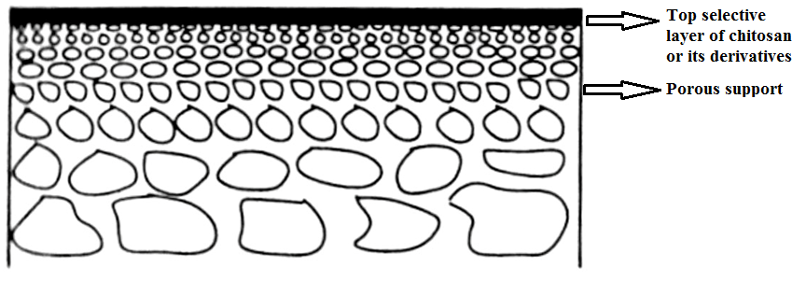
Figure 1.8 Schematic drawing of a composite membrane
1.5 CHITOSAN BASED MEMBRANE PREPARATION TECHNIQUES
Chitosan and its blends exist in various physical forms including resins, microspheres, hydrogels, membranes and fibers. The selection of one particular physical form depends mainly on the system configuration to be used for particular applications. The process of shaping chitosan blends into a desired physical form starts from mixing the blend components in the liquid form and applying the appropriate shaping method. So far in the literature there are two methods are available for the preparation of composite membranes using chitosan. Blending is the classical technique and most of the organic solvent soluble chitosan derivatives can be easily blended with other suitable polymers (Boricha et al. 2010, Padaki et al. 2011), whereas chitosan or its derivatives which are soluble in aqueous acidic solutions are blended with other water soluble polymers. The other method is the solution casting method, where dilute aqueous solution of chitosan or its derivatives will be cast on the surface of suitable porous support followed by cross linking. The support will provide the mechanical strength, whereas, chitosan acts as an active thin layer of the composite membrane. The active thin layer decides the permeation and selectivity properties of the particular membrane.
The preparation technique of the chitosan based membranes mainly depends on the type of membrane desired. Due to good film forming nature of chitosan or its derivatives, the most commonly employed method for the preparation of chitosan based nanofiltration membranes are composite membranes which are prepared by solution casting method. In a composite membrane, the top thin layer of chitosan decides the selectivity and the permeation properties of the membrane. The aqueous dilute solution of chitosan will be casted on the surface of suitable porous UF membrane (like polysulfone (PSf), polyvinylidine fluoride (PVDF), polyacrylonitrile (PAN) etc.) support or inorganic support like ceramic membranes. Such casted membranes were cured at suitable temperature and then cross-linked. The commonly used cross-linkers are glutaraldehyde (GA), epichlorohydrin (ECH), sodium tripolyphosphate (TPP), toluene diisocyanate (TDI) etc. Figure 1.9 represents the cross-linking reaction between chitosan and glutaraldehyde via Schiff base formation.
Figure 1.9 Cross-linking reaction of GA with chitosan
The cross-linking will increase the stability and the hydrophilicity of the resulting composite membrane. Ultimately, the concentration of chitosan, concentration of cross-linker and temperature at which cross-linking reaction carried out will decides performance of the resulting composite membrane.
The blending is the other technique for the preparation of chitosan based membranes. The organic soluble chitosan derivatives can be easily blended with other polymers to get membranes by phase inversion technique (Padaki et al. 2011). There are few reports on blending of aqueous solutions of chitosan or its derivatives with other polymers (Boricha et al. 2009, Boricha et al. 2010, Naim et al. 2013). However, the blending of aqueous chitosan solutions with organic soluble synthetic polymers is a difficult task. Due to difference in solubility property, the addition of one polymer to the other leads the formation of precipitate.
1.6 APPLICATIONS OF CHITOSAN BASED MEMBRANES
Chitosan has got excellent adsorption capacity towards pollutant particles like dye, organic contaminants and heavy metals. In order to achieve good separation, chitosan can be molded in several shapes like beads, microspheres, hollow fibers and membranes for water treatment application. In case of beads, physical modification increases the pollutant sorption properties and involve an expansion of the porus network. Chitosan hydrogel microspheres can improve the adsorption capacity by reducing the crystallinity through the gel formation process. On the other hand, microspheres can provide the potential for regeneration and reuse after heavy metal ion adsorption. Membrane is the other physical form of chitosan which can be further classified as hollow fiber membrane and flat sheet membranes. Hollow fibers are the preferred membrane configuration due to larger specific surface area. However, there are only a few articles in literature on design of chitosan hollow fiber membranes for adsorption of pollutants. Apart from good hydrophilicity and film forming nature, the other properties like antifouling nature, removal of phosphorous, heavy metals, turbidity and natural organic matter from aqueous waste made chitosan as an excellent membrane material. Chitosan based nano and ultrafiltration membranes are most useful in purification of contaminated water. The chitosan based nanofiltration membranes majorly find applications in water desalting, heavy metal removal and dye removal. Whereas chitosan based ultrafiltration membranes can be applied for heavy metal removal application by polymer enhanced ultrafiltration process.
Chitosan based membranes have following applications:
- Waste water treatment membranes
  - Heavy metal rejection
  - Salt rejection
  - Pesticide removal
  - Dye removal
- Pervaporation membranes
- Fuel cell membranes
- Haemodialysis membranes
1.7 CHARACTERIZATION OF MEMBRANES
Characterization of membrane surface properties is of great interest to researchers since they greatly influence separation properties. Membrane permeability, rejection ratio and solute selectivity have been related to surface properties. The hydrophobicity/ hydrophilicity (contact angle), water uptake and SEM image are mainly used for membrane surface characterization (Boussu et al. 2006). The other properties like, uniform blending of polymers in the resultant membrane can be determined by ATR-IR spectroscopy or differential scanning calorimetric studies.
1.7.1 Attenuated Total Reflectance Infra Red (ATR- IR) spectroscopy
Attenuated Total Reflectance (ATR) has in recent years revolutionized solid and liquid sample analysis because it combats the most challenging aspects of infrared analysis, namely sample preparation and spectral reproducibility. An ATR accessory operates by measuring the changes that occur in a totally internally reflected infrared beam when it comes into contact with the sample. An infrared beam is directed onto an optically dense crystal with a high refractive index at a certain angle. This internal reflectance creates an evanescent wave that extends beyond the surface of the crystal into the sample held in contact with the crystal. It can be easier to think of this evanescent wave as a bubble of infrared that sits on the surface of the crystal. This wave protrudes only a few microns (0.5 µ - 5 µ) beyond the crystal surface and into the sample. Consequently, there must be good contact between the sample and the crystal surface. In regions of the infrared spectrum where the sample absorbs energy, the evanescent wave will be attenuated or altered. The attenuated energy from each wave is passed back to the IR beam, which then exits the opposite end of the crystal and is passed to the detector in the IR spectrometer. The system then generates an infrared spectrum. In this present study, ATR-IR spectra were recorded using Nicolet Avatar FT-IR instrument in the range of 4000-400 cm⁻¹ with 64 scans. A diamond prism was used as the waveguide and membrane sample was directly pressed and fixed on the prism.
1.7.2 Morphology of membranes
The surface and cross-sectional images of the membranes were taken using Scanning Electron Microscope (SEM) and Field Emission Scanning Electron Microscope (FESEM). A SEM is a type of electron microscope that images a sample by scanning it with a beam of electrons in a raster scan pattern. The electrons interact with the atoms that make up the sample producing signals which contain information about the sample’s surface topography, composition and other properties such as electrical conductivity. SEM images of membranes were recorded using a Jeol JSM-6380LA SEM. The membrane surface was coated with gold by a sputter coating machine. Membrane samples dipped and broken in liquid nitrogen before the SEM analysis. FESEM images were recorded using FESEM Nova Nanosem 230 instrument, with resolution of 1.0 nm at 15 kV, probe current of 0.6 pA-100 nA and beam landing energy of 50 V-30 kV. Sample preparation involves, placing small membrane samples (2 mm x 2 mm) on the FESEM sample holder of which carbon tape was attached, and then spincoated for 5 minutes with a thin layer of gold.
The elemental mapping of the membrane surfaces was carried out after UF experiments in order to confirm the fixation of heavy metal ions onto the surface of membranes. The particle counting was done using ‘Image J 1.46r’ software. Particle counts through 6 divisions each measuring 50 µm×50µm in the area of a 150 µm × 100 µm domain were carried out for each of the composite membranes.

1.7.3 Water uptake study of membranes
Water uptake study includes immersion of the membrane samples in deionized water at room temperature for 24 h, followed by blot drying the wet membranes to remove surface adhering water droplets which is then quickly weighed. Finally these membranes are vacuum dried at 80 °C-100 °C and weighed again. The water uptake of the membranes can be calculated by the weight gain of the swollen membrane with reference to the dry membrane and reported as weight percent water absorption. The water uptake can be calculated as follows (Wittmann et al. 1998)
$$\% Water uptake= \left(\frac{W_{w}-W_{d}}{W_{d}}\right) X 100$$

Where, ‘W_{w}’ is the weight of wet membrane and “W_{d}’ is the weight of dry membrane.
1.7.4 Thermal properties of the membranes
The single value of glass transition temperature (T_{g}) confirms the proper blending of two components in membrane. The T_{g} of membranes was recorded using DS DSC823e, METTLER TOLEDO instrument. The changes in thermal property of PSf membranes due to the blending of chitosan or its derivatives were reported.
1.7.5 Contact angle
The contact angle is the angle at which a liquid/vapor interface meets a solid surface. The contact angle is specific for any given system and is determined by the interactions across the three interfaces. Most often the concept is illustrated with a small liquid droplet resting on a flat horizontal solid surface. The shape of the droplet is determined by Young-Laplace equation, with the contact angle playing the role of a boundary condition. Contact angle is measured using a contact angle goniometer. The contact angle is not limited to a liquid/vapor interface; it is equally applicable to the interface of two liquids. The sessile drop method is measured by a contact angle goniometer using an optical subsystem to capture the profile of a pure liquid on a solid substrate. The angle formed between the liquid/solid interface and the liquid/liquid interface is recorded.
In present investigation the contact angle of the membrane was determined to understand the surface wetting characteristic of the membrane. Hydrophilic solids have a contact angle upto 90 º. On highly hydrophilic surfaces, water droplets exhibit contact angles of 0 º to 30 º. If the solid surface is hydrophobic, the contact angle is larger than 90 º. Highly hydrophobic surfaces have water contact angle as high as ~120 º. Contact angle were measured by the sessile drop method, using a contact angle goniometer (OCA15 EC, Germany).
1.7.6 Permeation property of the membrane
All the permeation studies were carried out using self-constructed filtration unit. The permeation properties of membranes were tested using stirred dead-end filtration cell and effective membrane area was 5 cm². The feed solution will be taken in the feed tank as shown in the Figure 1.10. The feed tank contains two valves one is the inlet for nitrogen pressure and the other is outlet for feed flow. Once the nitrogen pressure applied, the feed solution will flow through the outlet and enter into the desalination unit.
Each membrane was compacted at particular pressure for 30 minutes before starting the experiment. After compacting, deionized water was passed through the membrane for 80 min at relatively lower pressure (compared to compaction pressure) to obtain beginning pure water flux J_{w1} (L/m²h). The pure water flux was calculated using the equation:
$$J_{w}= \frac{Q}{Δt A}$$
Where, pure water flux (J_{w}) is expressed in unit L/m²h and ‘Q’ is the quantity of water collected over Δt (h) of time duration using a membrane area of A (m²). The permeate was collected for every five minutes.
Figure 1.10 Schematic representation of lab scale filtration set up

1.7.7 Antifouling properties of membranes
The antifouling property of the membranes was determined using reported procedure in literature (Zhao et al. 2011).
$$FRR\left(\%\right)=\frac{J_{w2}}{J_{w1}}X 100$$
The pure water flux ‘J_{w1}’ (L/m²h) of the membrane was determined at particular pressure. Bovine serum albumin (BSA) was considered as a model protein to study the antifouling property of the membranes. The aqueous solution of BSA with concentration 0.8g/L was prepared and the solution was filtered through the membrane for 80 minutes. Then the membrane was flushed with pure water for 15 minutes and pure water flux ‘J_{w2}’ (L/m²h) was measured again. Finally the membrane antifouling property was determined by calculating flux recovery ratio (FRR) using the following equation:
To determine the rejection properties of membranes, the permeate and feed solutions were treated with Bradford reagent and kept for 10 minutes. The % BSA rejection of the membranes was calculated using the following equation:
$$\%R=\left(\frac{1-C_{p}}{C_{f}}\right)x100$$
Where ‘C_{p}’ (mg/mL) and ‘C_{f}’ (mg/mL) are the BSA concentrations in permeate and feed respectively. The concentrations were measured using UV-Spectrophotometer at a wavelength of 595 nm.
1.7.8 Transmission electron microscopy (TEM)
JEM 1230 Electron Microscope at an acceleration voltage of 80 kV was used to record the Transmission Electron Microscopy (TEM) images of synthesized nanotubes. A small amount of the sample was dispersed into acetone solution using a bath sonicator for 15 minutes. A small amount of the solution was then dropped onto a copper grid. After 5 minutes, the grid was placed into the TEM for viewing.
1.7.9 Viscosity measurement
The viscosity of the casting solutions or coagulation media was determined using Brookfield DV-III Ultra (USA) instrument at 20 rpm.
1.7.10 Salt rejection study
Concentration of the salt solution was determined by conductivity experiment. It is usually expressed as parts per million (ppm). Cations found in water usually include calcium, magnesium, potassium and sodium. Whereas, anions include bicarbonate, carbonate, chloride, nitrate and sulfate. Conductivity is a good indicator of the measure of salinity in water. It is well-known that, the conductivity of any solution is directly proportional to the concentration of its ions. In general, the conductivity of salt solutions increase as the amount of dissolved salt increases. The exact increase in conductivity, is however, complicated by the relationship between the concentration of the salt and the mobility of its charged particles. The percent salt rejections were determined by comparing the conductivity difference of feed and permeate solutions. The percent rejection was calculated using following equation:
$$\% Rejection=\left(1-\frac{C_{p}}{C_{f}}\right)X100$$
Where ‘C_{p}’ and ‘C_{f’} are the concentrations of the permeate and feed respectively.
1.7.11 Heavy metal rejection study
All the rejection experiments were carried out in lab scale ultrafiltration cell (Figure 1.10). The effective area of membrane used for rejection experiment was 5 cm² and the membrane sample was soaked in distilled water for 1 h prior to rejection test. In order to reduce the concentration polarization, a constant agitation speed of 400 rpm was maintained throughout the experiment.
For heavy metal ion rejection experiments by UF process, the solutions of copper (II), cadmium (II) and nickel (II) salts were subjected to heavy metal rejection test. 1000 ppm solutions of Cu (II), Cd (II) and Ni (II) ions were prepared in distilled water and the pH of the solutions were adjusted to 6±0.25 using 0.1N HCl or 0.1N NaOH solutions. For heavy metal ion rejection experiments by PEUF process, same concentration of solution of Cu (II), Cd (II) and Ni (II) are prepared in 1.0 wt% of polyethyleneimine (PEI) in deionized water. Solutions containing PEI and individual metal ions were thoroughly mixed and left standing for 5 days to complete binding (Juang and Chan 1996, Jarvis and Wagener 1995). The percentage rejection of the metal ions was determined by analyzing the concentrations of both feed and permeates with atomic absorption spectrophotometer (Thermo-Fischer instrument). The concentration of PEI (in the absence of metal ions) was measured using UV- visible spectrophotometer at λ_{max}= 269 nm and the percentage of heavy metal ion rejection was determined using following equation:
$$\% Rejection=\left(1-\frac{C_{p}}{C_{f}}\right)X100$$

Where ‘C_{p}’ and ‘C_{f}’ are the concentrations of the metal ions in permeate and feed respectively.
1.8 CHARACTERIZATION OF NOVEL CHITOSAN DERIVATIVE
1.8.1 X-Ray Diffracion analysis (XRD)
X-ray diffraction patterns were taken on JEOL X-ray Diffractometer equipped with monochromatized high intensity Cu Kα radiation (λ=1. 5418 Å). The accelerating voltage was set at 0.06 °/s in the 2ϴ range 10-40°.
1.8.2 Estimation of solubility
A sample was soaked in each of the various solvents as mentioned in Table 3.1 at the concentration of 10 mg/mL and the solubility was checked after standing for 24 hr at room temperature (Sugimoto et al. 1998).
1.8.3 Evaluation of cytotoxicity
1.8.3.1 Isolation, Establishment and Culture of Fibroblasts
The skin sample was carefully washed in PBS (Phosphate Buffered Saline) and antibiotic (It’s a cocktail of antibiotic solution containing streptomycin and penicillin from company Himedia). This was gently cut into small pieces. These pieces were properly spaced equidistant from each other and kept in a 6 cm plate, along with 1x DMEM with 10% FBS. After approximately 4-5 days, the fibroblasts were seen migrating from the pieces and attaching themselves onto the plate. Once this was achieved, the skin pieces were carefully removed from the plate, so as to avoid disturbing the cells. Following this, media were changed regularly at intervals of 3 days followed by passaging, once the cells were 80 - 85 % confluent.
1.8.3.2 MTT Assay
The MTT assay is a colorimetric assay for measuring the activity of enzyme that reduces MTT to formazan dye, resulting in a purple color (Price et al. 1990). The main application allows to access the viability and the proliferation of cells. It can also be used to determine cytotoxicity of potential medicinal agents and toxic materials, since these agents would stimulate or inhibit cell viability and growth.
MTT (3-(4, 5-Dimethylthiazol-2-yl)-2, 5-diphenyltetrazolium bromide), is reduced to purple formazan in living cells. A solubilization solution (usually either dimethyl sulfoxide DMSO, or HCl) is added to dissolve the insoluble purple formazan product into a colored solution. The absorbance of this solution can be quantified by measuring the absorbance at 570 nm using microplate spectrophotometer and the percentage of cell viability was calculated using the following formula:
$$Percent viability= \frac{Test absorbance-Blank absorbance}{Control absorbance-Blank absorbance} X 100$$
1.8.3.3 Cytotoxicity Studies
The cells were harvested by centrifugation at 1,000 rpm for 10 minutes at room temperature. The supernatant was removed and the pellet was resuspended in such a way that 1x10⁴ cells were seeded per well, in the 96 well plate. After 24 hours, cell culture medium was aspirated and replaced by 100 μL serial dilutions of polymer solution in MEM medium without FBS. The cells were then incubated for 24 hr at 37 ºC. Following this, medium was replaced by 200 μL MEM without FBS containing 0.5 mg/mL MTT. After 4 hours incubation at 37 ºC in the dark, medium was removed and 200 μL DMSO was added (Carmichael et al. 1988). Plates were shaken evenly for 10 min. Measurement was performed using an ELISA plate reader (Tecan) at wavelength of 570 nm. Relative viability was calculated using 0% (wells without cells) and 100% (wells with polymer-untreated cells) as controls. Each value was averaged from 5 parallel experiments.

Abstract
This chapter includes literature review of the membrane technology, scope and objectives of present research.

2.1 LITERATURE REVIEW
The derivative of natural chitin presents remarkable properties that have paved the way for the introduction of chitosan in the biomedical, pharmaceutical and membrane technology fields. Nevertheless, the properties of chitosan, such as its poor solubility in water or in organic solvents, can limit its utilization for a specific application. In order to improve or impart new properties to chitosan, chemical modification of the chitosan chains, generally by either grafting of small molecules or polymer chains onto the chitosan backbone or by quaternization of the amino groups, has been investigated. Chemical modification of chitosan has two main aims: (a) to improve the metal adsorption properties, and (b) to change the solubility properties of chitosan in water or acidic medium (Miretzky and Fernandez Cirelli 2009).
Chitosan chains possess three attractive reactive sites for chemical modification: two hydroxyl groups (primary or secondary) and one primary amine. The site of modification is dictated by the desired application of the final chitosan derivative.
Nishimura et al. (1991) synthesised novel N-phthaloyl chitosan derivative which showed excellent solubility in common organic solvent (like DMF, dimethylacetamide, DMSO and pyridine). Efficient procedure for the preparation of soluble chitosan derivatives have been established on the basis of the regioselective chemical modifications. Selective and quantitative N-phthaloylation of chitosan proceeds smoothly by the reaction of chitosan with phthalic anhydride in DMF (DMF) at 130 ºC.
Heras et al. (2001) synthesized N-methylene phosphonic chitosan a water soluble derivative without affecting much filmogenic property of chitosan. The structure was confirmed by ¹H NMR, ¹³C NMR assignments, ¹H-¹³C NMR correlation, FT-IR spectroscopy, X-ray diffraction and elemental analysis. This new derivative opens new perspectives as biomedical material.

Figure 2.1 Structure of N-methylene phosphonic chitosan
Aiping et al. (2006) reported novel biocompatible chitosan derivative N-succinyl-chitosan (NSCS) which is water soluble and can self assemble in distilled water to regular nanospheres.
Where Ac = -COCH₃
Figure 2.2 Synthetic scheme of NSCS
Wang et al. (2011) prepared novel water soluble phosphonium chitosan (WSPCS) derivative with two different degrees of substitution (3.6% and 4.2%) in a homogeneous system at 25 ºC. The chemical structures of the derivative were characterized by ³¹P NMR, ¹H NMR, FT-IR spectroscopy and WAXD (wide angle XRD). The prepared derivative has shown low toxicity to L929 cell lines.
Figure 2.3 Structure of WSPCS
Badawy et al. (2012) reported antimicrobial activity of water soluble N-(4- carboxybutyroyl) chitosans against some plant pathogenic bacteria and Fungi. In their study, chitosan was N-carboxybutyrated with glutaric anhydride under the homogeneous conditions in the presence of methanol. They concluded that one with highest degree of substitution (DS) value is more active than lowest one.
Figure 2.4 Structure of N-(carboxybutyroyl) chitosan
Due to high efficiency, easy operation and space saving, the heavy metal removal by membrane filtration playing major role from past few decades. Biopolymer like chitosan has chelation ion exchange property and remove ions of a specific size in the presence of large quantities of other ions. The amine groups are able to sorb metals through several mechanisms including chemical interactions, such as chelation, electrostatic interactions, such as ion exchange, or the formation of ion pairs (Muzzarelli et al. 1982, Inoue et al. 1993). The chitosan based membrane processes are commonly used for the removal of metal ions.
Boricha et al. (2008) prepared nanofiltration membranes by casting N, O-carboxymethyl chitosan onto the polyether sulfone (PES) ultrafilration support followed by cross-linking using glutaraldehyde, which showed excellent removal property for nickel ions from the aqueous solutions. The maximum rejection of 80% and 62% of 5 ppm, 78% and 59% of 10 ppm; and 74% and 57% of 50 ppm feed concentration of nickel sulfate-water and nickel chloride-water systems, respectively.
Boricha et al. (2009) prepared acrylonitrile butadiene styrene (ABS) and chitosan blend membranes casted on the surface of polyethersulfone (PES) ultrafiltration support. The increase in ABS content decreased the amorphous nature of the membranes resulted in decreased permeate flux of blend membranes. The membranes showed a maximum of 96.25% and 89.74% mercury and sodium ion rejections respectively for 5 ppm solution concentrations.
Further the same group in 2010, prepared N, O-carboxymethyl chitosan (NOCC) and cellulose acetate (CA) blend nanofiltration membranes for chromium and copper removal. NOCC contributed to enhanced separation performance for metal ions and CA acted as a polymer matrix, which provided high mechanical strength for the membrane. The membranes showed maximum rejection of 83.40% and 72.60% for chromium and copper respectively at 1 MPa applied pressure with feed flow rate of 16 L/m.
Jana et al. (2011) prepared chitosan based ceramic membranes by dip coating technique. Different ceramic membranes were prepared by varying chitosan concentration and dipping time and the average pore sizes were in the range of 760-13 nm. An increase in both chitosan concentration and dipping time was found to reduce the pore size. The lowest pore size ultrafiltration membrane (pore size: 13 nm) was used for the removal of mercury and arsenic from wastewater by polymer enhanced ultrafiltration (PEUF) technique using polyvinyl alcohol (PVA) as the chelating agent. Almost 100% removal was observed for both the metal ions with 500 ppm concentrations.
Jana et al. (2012) prepared chitosan impregnated ceramic membranes for the removal of mercury from synthetic waste water by polymer enhanced ultrafiltration (PEUF). The average pore size of the membrane was found to be 12 nm. Polyvinyl alcohol (PVA) was used as the chelating agent. The effects of PVA dose, mercury concentration, pH and transmembrane pressure on mercury rejection were investigated. The rejection increased with increase of PVA dose and decreased with the increase of initial mercury concentration and transmembrane pressure. The maximum rejection for mercury was found to be 85 % and the flux declination rate was less at higher pressure.
Naim et al. (2013) prepared cellulose acetate-chitosan blend membranes by the phase inversion technique. The permeation and adsorption capacity of each membrane were examined in a plexi glass two compartment diffusion cell in which the membrane was placed between the two compartments to separate the copper ion solution from an equal volume of distilled water. They concluded that blending of chitosan with cellulose acetate resulted in stronger membranes. The presence of –NH₂ group on chitosan made it as a good chelating agent for heavy metal. The membrane thickness has a profound effect on both permeability and extent of chelation of the heavy metal examined.
Salehi et al. (2013) used polyethylene glycol and amino modified MWCNTs to modify chitosan/polyvinyl alcohol (PVA) thin adsorptive membranes for copper ion adsorption. Adsorption capacity of chitosan/PVA membrane was increased from 11 to 30 mg/g by addition of 5 wt% PEG to the blend. Addition of CNTs, especially at optimal concentration of 1 wt%, improved membranes adsorption/transport behavior by creation of nanochannels and supplementary interstices in the compact chitosan/PVA matrix. Copper ion adsorption on CS/PVA membrane was elevated from 11 to 19 mg/g by introducing 1 wt% CNTs.
Chitosan based nanofiltration (NF) membranes find applications in the field of salt rejection. Most of the chitosan NF membranes are composite membranes, the good film forming and hydrophilic nature of this polymer made it as an excellent composite membrane material. In the past few decades, great efforts have been put to develop chitosan based NF membranes for salt rejection applications.
Miao et al. (2006) prepared N, O-carboxymethyl chitosan (NOCC)/polysulfone (PSf) composite nanofiltration membranes by coating of NOCC on the surface of PSf UF membrane support followed by cross-linking by glutaraldehyde. The effects of the composition of the casting solution of the active layer, the concentration of the cross-linking agent, and the membrane preparation techniques on the performance of the composite membrane were investigated. The 1000 ppm solutions of Na₂SO₄ and NaCl showed 92.7% and 30.2% rejection respectively. The rejection of this kind of membrane to the electrolyte solutions decreased in the order of Na₂SO₄, NaCl, MgSO₄ and MgCl₂.
Miao et al. (2008) prepared N, O-carboxymethyl chitosan (NOCC)/Polysulfone (PSf) composite nanofiltration membrane cross-linked with epichlorohydrin (ECH). ECH is active layer material, the base membranes and the cross-linking agent respectively. Membranes are prepared by coating NOCC solution in water on the surface of PSf ultrafiltration membranes followed by cross linking using ECH/ethanol 96.7% (0.067 M KOH) solution. The resulting membrane was characterized by infrared spectroscopy and scanning electron microscopy. The resulting membrane showed rejection of 90.4% and 27.4% for Na₂SO₄ and NaCl solutions (1000 mgL⁻¹) respectively.
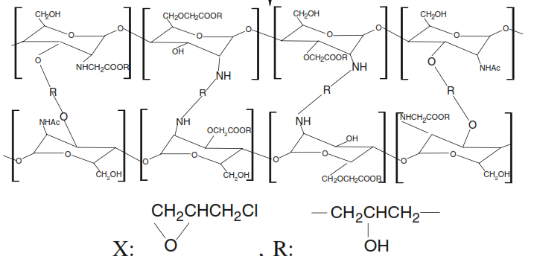

Figure 2.5 Schematic representation of the ECH cross-linked NOCC
(Source: Mio et al. 2008)
Tang et al. (2009) studied water transport behavior of chitosan porous membranes containing multi-walled carbon nanotubes (MWCNTs). They found improved water flux and control on the pore size of polymer porous membranes by using MWCNTs. This could be understood as due to the formation of MWCNTs network located among the pore network of chitosan membrane at high MWCNTs content, where the hollow nanochannel of MWCNTs and their interspaces could provide a new transport channel for water.
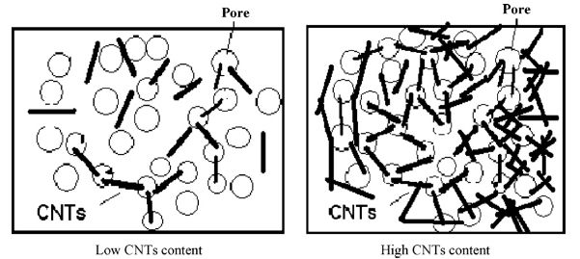
Figure 2.6 Schematic illustration of distribution of CNT on membrane at low and high concentrations. (Source: Tang et al. (2009)
Padaki et al. (2011) prepared Polysulfone/N-phthaloylchitosan (NPCS) novel composite membranes which were in the range of nano- to ultra-filtration. The hydrophilicity and porosity of the membranes increased with increase in NPCS content. The obtained membranes showed 95% of MgSO₄ rejection, 78% of Na₂SO₄ rejection and 75% of NaCl rejection, respectively.
Figure 2.7 Synthetic route for preparation of N-phthaloyl chitosan
Padaki et al. (2011) prepared new NF membrane by coating chitosan on polypropylene fiber support. Newly prepared membrane showed improved water flux, and % of rejection was highest in acidic pH and lowest in basic pH. In acidic media of 5 pH, membrane showed about 40% of salt rejection with the flux of 43 L/m²h at 0.2 MPa TMP. However in pH 11, it showed 12% of rejection with the flux of 5 L/m²h at 0.2 MPa TMP.
Chaudhari et al. (2013) prepared composite NF membranes by coating the layer of sulfated chitosan on the polyacrylonitrile (PAN) UF support membrane. The membranes were cross-linked using aqueous epichlorohydrin (ECH) solution. The results showed that the NF membrane with excellent rejection performance has 1.0 wt% of sulfated chitosan concentration, 0.4 wt% ECH concentrations, 1h cross-linking at 60 ºC. The order of rejection for various electrolytes was ZnSO₄>CuSO₄>ZnCl_{2.}
Figure 2.8 Structure of sulfated chitosan
Zhao et al. (2013) prepared composite NF membranes using zwitterionic O-carboxymethyl chitosan (O-CMC) and epichlorohydrin as cross-linking agent on the surface of polyacrylonitrile supporting layer. The optimal preparing conditions of NF membranes were as follows: casting solution concentration; 3 wt.%, cross-linking reagent concentration; 2%, cross-linking time; 12 h and cross-linking temperature; 50 ºC. The salt rejection and the permeation flux of the optimal NF membrane were 94.36% and 16.78 L/m²h for 1000 ppm Na₂SO₄ solution, respectively.

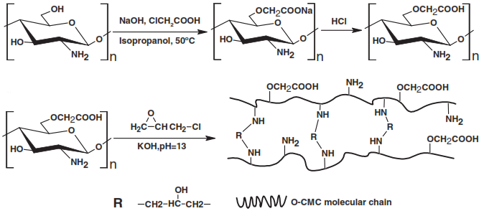
Figure 2.9 Schematic representation of synthesis of O-CMC and its cross-linking reaction with ECH. (Source: Zhao et al. 2013)
Above literatures indicates, there is a large scope for the chemical modification of chitosan in order to enhance its solubility. Further, the modified derivatives of chitosan find lots of applications in the field of membrane technology. Such membranes are much useful in heavy metal removal and salt rejection applications. However in order to overcome less mechanical strength it is better to select mechanically strong polymer like polysulfone as support or blend material during membrane preparation. So far solution casting followed by curing is the most commonly used membrane preparation technique for the preparation of chitosan based membranes due to its solubility problem. Hence there is also scope for developing a new membrane preparation processes for this polymer.

2.2 SCOPE AND OBJECTIVES
Due to presence of chemically modifiable hydroxyl and amine groups in chitosan, there is a large scope for the chemical modification of this biopolymer. These chitosan or its modified derivatives find vast applications in the field of membrane technology for water purification. The better film forming capacity and hydrophilicity made this polymer as suitable material for composite membrane preparation. However in order to overcome less mechanical strength it is better to select mechanically strong polymers like polysulfone as support or blend material during membrane preparation. Thus there is a good scope to improve chemical and mechanical stability and permeation and antifouling properties of the chitosan based membrane.
- To carry out the chemical modification of chitosan in order to enhance its solubility in water or common organic solvents like DMF, NMP or DMSO.
- To characterize the modified chitosan derivatives by NMR, FTIR and XRD studies.
- To study the cytotoxicity and solubility test for the novel modified chitosan derivatives.
- To determine the degree of substitution (DS) for the modified chitosan derivatives.
- To prepare membranes from chitosan or modified chitosan derivatives and polysulfone.
- To carry out membrane morphological study by using FESEM or SEM techniques.
- To study the salt rejection property of the prepared NF membrane.
- To study the antifouling property of selected membranes.
- To study the heavy metal rejection of chitosan based UF membranes.
- To determine the membrane hydrophilicity by water swelling and contact angle measurement.
- To study the thermal stability of the prepared membrane by DSC.
- To incorporate nanoparticles/nanotubes into membranes and study its effect on important membrane characteristics like flux, surface morphology, hydrophilicity and rejection.

Abstract

In this chapter, biocompatible and naturally occurring chitosan is used as an additive for the improvement of polysulfone ultrafiltration (UF) membrane properties. Two different compositions of polysulfone in NMP and chitosan in 1 % acetic acid were blended to prepare PSf/CS UF membranes by Diffusion Induced Phase Separation (DIPS) method. The membranes were characterized by various techniques like Attenuated Total Reflectance Infrared spectroscopy (ATR-IR), Scanning Electron Microscopy (SEM), water uptake study and contact angle measurements. The improved performance of the PSf/CS membranes compared to pristine PSf membrane was determined in terms of permeation and antifouling studies. The PSf/CS membranes showed increased hydrophilicity, flux and antifouling properties. These properties increased with increase in CS content and PSf/CS membrane prepared by blending 5% of CS showed maximum of 56% flux recovery ratio indicating its higher recycling property.
3.1 INTRODUCTION
Ultrafiltration membranes are playing major role in the separation of toxic heavy metals from polluted water from past few decades. As ultrafiltration membranes are concerned, hydrophilicity of the membrane and its porous structure play an important role in the membrane separation process. A suitable porous membrane must have high permeability, good hydrophilicity and excellent chemical resistance towards the feed solution (Lau et al. 2012). Polysulfone is an outstanding ultrafilration membrane material because of its excellent oxidative, thermal and hydrolytic stability with good flexibility, resistance to extremes of pH, good mechanical strength and film forming properties (Cho et al. 2011). Also it is widely used to prepare asymmetric membranes with different pore sizes for microfiltration and nanofiltration applications (Sikder et al. 2009, Saha et al. 2009). Despite of these benefits, the main disadvantage of this polymer is its hydrophobic nature which makes it poor in permeation and antifouling properties (Koehler et al. 2000, Rana and Matsuura 2010). Its rather hydrophobic nature is a considerable limitation in some aqueous membrane applications like heavy metal rejection. Hydrophilicity enhancement has been achieved by various physical and chemical surface treatment procedures on preformed polysulfone membranes or by blending the casting solutions of the membranes with several hydrophilic organic or inorganic additives.
Sivakumar et al. (2006) prepared polysulfone (PSf) and cellulose acetate ultrafiltration membranes by phase inversion technique using different concentrations of polyvinylpyrrolidone (PVP) as pore former. For higher content of PVP, resulted in increased porosity, finger like voids and pore size of the membranes. The membranes were subjected to protein and heavy metal separation study. The BSA rejection of the membranes decreased with increase in PVP content in casting solution from 0 to 7.5 wt%. Also the BSA rejection decreased with increase in PSf content. Polyethyleneimine (PEI) was used as metal complexing agent and among the salts tested copper has showed higher separation due to stronger ligand formation with PEI.
Hydrophilicity enhancement of polysulfone can also be achieved by its chemical modification. Arockiasamy et al. (2009) prepared cellulose acetate and aminated polysulfone (Figure 3.1) blend ultrafiltration membranes in the presence and in the absence of PEG 600 additive. The addition of PEG resulted in membrane with larger pore size, uniform pores size distribution and increased number of pores on the top surface. Among the salts tested for rejection (Cu²⁺, Ni²⁺, Zn²⁺ and Cd²⁺) Cu²⁺ has shown higher rejection due to its strong complexing nature with polyethyleneimine.
Figure 3.1 Structure of aminated polysulfone
Saljoughi et al. (2012) modified polysulfone membrane by blending with IGEPAL CO-890 surfactant (Figure 3.2). Both the hydrophilicity and cadmium removal of the prepared membranes enhanced by small addition of IGEPAL. The initial addition of IGEPAL (upto 4 wt%) in the casting solution along with increasing the coagulation bath temperature resulted in formation of membranes with high permeability and sub-layer porosity and thin top layer. The addition of IGEPAL increased the viscosity of the casting solution which resulted in greater macrovoids formation. The maximum of 98% cadmium rejection was observed for the membrane which was prepared from 6 wt% IGEPAL loading and cold coagulation bath.
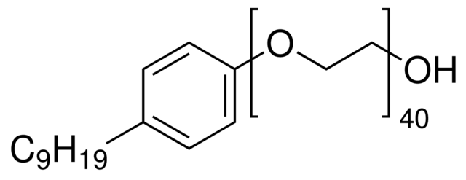
Figure 3.2 Structure of IGEPAL
Shah et al. (2013) prepared polysulfone/functionalized multiwalled carbon nanotube (fMWCNT) composite membranes by phase inversion method for heavy metal rejection applications. The PSf/fMWCNT membranes were more hydrophilic and had lower flow rate than the pure polysulfone membranes. The percentage of heavy metal rejection of fMWCNT/PSf membranes increased with increase in nanotube content and best results were obtained at a pressure of 0.49 MPa and in an acidic pH of 2.6. The addition of nanotubes resulted in reduced pore sizes and high adsorptivity of the membrane and is the reason for efficient removal of metal ions from drinking water. The amide functionalized CNT/PSf composite membranes gave 94.2% removal for Cr(VI) and 78.2% removal for Cd(II).
Chitosan is an abundant natural biopolymer which is biodegradable, hydrophilic and shows excellent film forming nature. Chitosan membranes are being used in separation processes such as nanofiltration, ultrafiltration, pervaporation and reverse osmosis (Yang et al. 1984, Wang and Spencer 1998, Huang et al. 1999, Padaki et al. 2011). Chitosan is a good antifouling agent and membranes prepared of chitosan exhibit excellent resistance towards fouling.
McCloskey et al. (2010) prepared composite membranes of chitosan by coating poly (ethylene glycol) diglycidyl ether (Figure 3.3) cross-linked chitosan onto the surface of polysulfone ultrafiltration membrane. The membranes were subjected to fouling study by filtering oil-water emulsion. These composite membranes exhibited water ﬂux values more than 5 times higher than that of uncoated membranes. The chitosan-PEG layer increased rejection and water flux, and showed increasingly higher resistance to fouling.
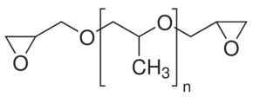
Figure 3.3 Structure of poly (ethylene glycol) diglycidyl ether
Zhao et al. (2012) prepared ultrafiltration membrane by coating chitosan on electrospun nanofibrous polyvinyledine difluoride scaffolds. Further the membrane was cross-linked using glutaraldehyde and modified using terephthaloyl chloride. The resultant UF membrane has shown excellent water-protein liquid filtration. A maximum of 98.9% BSA rejection with 70.5 L/m²h of flux was observed at 0.2 MPa pressure. The membrane showed excellent antifouling property that after 24h of operation, the flux decreased for less than 7%.
The common procedure for membrane preparation is casting the chitosan solution (either acidic or neutral media) on the surface of a support membrane to form a thin layer (sometimes cross-linking is also reported) (Feng and Huang 1996, Wang and Spencer 1998, Miao et al. 2006). Surface thin layer increases the hydrophilicity thereby enhancing the permeation property of the membrane.
Musale et al. (1999) prepared poly (acrylonitrile) (PAN)/chitosan composite ultrafiltration membranes by filtration of chitosan solution through PAN base membranes (Figure 3.4). The observed reduction in pore size was due to the formation of chitosan layer on the pore walls of PAN base membrane. The cured membranes were further treated with NaOH resulted in slight hydrolysis of nitrile groups of PAN into carboxylic acid groups. The authors concluded that the formation of composite layer of chitosan on the PAN support is due to amide type bonding between -COOH group of hydrolyzed PAN and -NH₂ group of chitosan.

Figure 3.4 Structure of polyacrylonitrile
Steenkamp et al. (2002) prepared composite membranes by coating the layer of chitosan on the surface of alumina porous support. The pore radii varied between 45 and 100 nm and porosity of the layer improved using silica as a porogen. The membranes were studied for copper removal (Cu²⁺) with 50 mg/L CuSO₄ feed concentration. The permeate had concentration below 1 mg/L with an adsorption capacity of about 0.2 g Cu²⁺/g chitosan.
Jana et al. (2011), prepared chitosan based ceramic membranes using dip coating technique. From SEM images they concluded that the effective pore size of chitosan impregnated membranes was reduced with increase in chitosan concentration and dipping time. The membranes were subjected to removal of mercury and arsenic from waste water by polymer enhanced ultrafiltration (PEUF) technique using polyvinyl alcohol (PVA) as chelating agent. Almost 100% removal was achieved for 1.0 and 0.5 % PVA up to 2h and 1h of operation, respectively.
Chitosan is a well-known solid sorbent for heavy metals. The amino groups on chitosan chain can serve as coordination sites. Due to this property, the chitosan membranes find vast applications in the field of heavy metal rejection These composite membrane prepared of chitosan will find application in heavy metal removal due to their adsorptive characteristics.
Blending is the other classical technique for membrane preparation. Similar to coating and grafting methods, blending results in a change in the pore size of the membrane. One of the blending methods is to direct mixing hydrophilic macromolecules with the host membrane matrix, which makes removal of hydrophobic material from the feed solution relatively easy (Padaki et al. 2011). Due to insolubility of chitosan in common organic solvents, the preparation of chitosan based blend membranes is quite difficult task. However, chitosan based blend membranes find vast applications in heavy metal rejection applications.
Boricha et al. (2009) prepared composite membranes using different compositions of acrylonitrile butadiene styrene (ABS, Figure 3.5) and chitosan blend on the surface of polyethersulfone (PES) ultrafiltration support. Membranes with higher content of ABS showed lower permeate flux due to the reduced amorphous nature of the membrane. For higher content of ABS, membranes showed increased rejection and for higher content of chitosan the permeate flux increased with reduction in rejection. A maximum of 96.25% and 89.74% mercury and sodium ion rejections was observed for 5 ppm solution concentrations respectively.
Acrylonitrile Butadiene Styrene
Figure 3.5 Structures of monomers of acrylonitrile butadiene styrene
Naim et al. (2013) prepared cellulose acetate-chitosan blend membranes by the phase inversion technique. The permeation and adsorption capacity of each membrane were examined in a plexi glass two compartment diffusion cell in which the membrane was placed between the two compartments to separate the copper ion solution from an equal volume of distilled water. They concluded that blending of chitosan with cellulose acetate resulted in stronger membranes. The presence of –NH₂ group on chitosan made it as a good chelating agent for heavy metal. The membrane thickness has a profound effect on both permeability and extent of chelation of the heavy metal examined.
Based on these observations, in the present work chitosan was blended with polysulfone to get PSf/CS ultrafiltration membranes which can be applied for heavy metal rejection application. Due to the insolubility of chitosan in organic solvents a modified procedure for the blending of polysulfone with chitosan was reported. Two ultrafiltration membranes with different contents of chitosan (as additive) in the blend were prepared. Furthermore, the effect of chitosan on permeation and antifouling properties of the membranes was studied.

3.2 EXPERIMENTAL
3.2.1 Preparation of PSf/CS blend membranes (M-1)
1.0 g of chitosan (CS, degree of deacetylation 75-85%, low molecular weight chitosan from Sigma-Aldrich Co. Bangalore, India) was dissolved in 50 mL of 1% aqueous acetic acid solution. Polysulfone (3.9 g, M_{w}= 35,000 Da, from Sigma-Aldrich Co. Bangalore, India) was dissolved in 15.6 mL of NMP at 60 °C over a period of 4 h to obtain a homogenous solution. 5.0 mL of chitosan solution was added to the polysulfone solution prepared above under vigorous stirring maintaining the temperature at the same level. Then, 2.5 mL of NMP was added. While chitosan was being added precipitation of chitosan took place. The resultant turbid solution was stirred vigorously at 70 °C for 12 h to obtain a homogeneous solution of high viscosity (Figure 3.6). The solution was filtered using G4 sand filter while maintaining the temperature of ca ~50 °C. Then the solution was spread uniformly on the surface of a glass plate with the help of doctor blade by maintaining gap of 0.3 mm between the plate and the blade. After the casting process, the membrane was exposed to the atmosphere at 25-26 °C for five minutes. The cast film together with the glass plate was immersed in a coagulation bath containing distilled water at 20 °C. The polymer film was solidified in the coagulation bath via the phase inversion process. The prepared membrane was washed with distilled water several times, before being dried at 30 °C. A similar procedure was employed for the preparation of the PSf/CS membrane with PSf/CS 95.0 : 5.0% composition. The details of polymer blending are presented in Table 3.1. The membranes with 97.5 : 2.5% and 95.0 : 5.0% compositions of PSf:CS were labeled as M-1 and M-2 respectively. Whereas neat polysulfone membrane was labeled as M-0.
Table 3.1 Experimental details for the PSf/CS blending.
Membr^{n} | PSf  (g) | CS  (g) | NMP  (mL) | 1% CS sol^{n} (mL) | Additional NMP (mL) | Temp.  (ºC) | % compos^{n}  (PSf:CS) | Dissolution time after addition of CS (h)
M-1 | 3.9 | 0.1 | 15.6 | 5 | 2.5 | 70 | 97.5:2.5 | 10
M-2 | 3.8 | 0.2 | 15.2 | 10 | 5 | 70 | 95.0:5.0 | 12

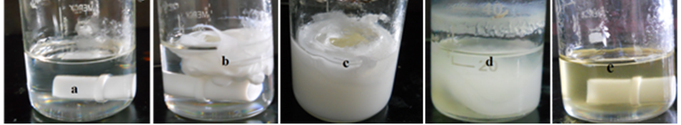
Figure 3.6 The transformations within the solution during PSf:CS 95.0:5.0% blending. a) Homogeneous solution of PSf in NMP at 60 ºC b) Turbidity after addition of CS solution c) Dispersed turbidity after 6 h at 70 °C d) Partially reduced turbidity after 10 h e) Completely blended homogeneous solution of PSf and CS after 12 h.
3. 3 RESULTS AND DISCUSSION

3.3.1 ATR-IR analysis
Figure 3.7 represents the ATR-IR spectra of chitosan, polysulfone and PSf/CS blend membrane. Both the blend membranes with 5.0 % and 2.5 % of chitosan component showed similar ATR-IR spectra. On comparison, chitosan showed characteristic peaks at 3200-3400 cm⁻¹ (-OH stretch), 2872 cm⁻¹ (aliphatic C-H stretch) and at 1650 cm⁻¹ (acetylated amine group) which are also present in the PSf/CS blend membrane. The peak at 1374 cm⁻¹ corresponding to -C-O stretching of primary alcohol group of chitosan might has been merged with peak at 1302 cm⁻¹ of PSf/CS blend membrane spectrum. The important characteristic peaks for polysulfone at 2966 cm⁻¹ (aromatic C-H stretch), 1294 cm⁻¹ (S=O asymmetric stretch), 1236 cm⁻¹ (C-O-C stretch) and at 1146 cm⁻¹ (S=O symmetric stretch) were slightly shifted to larger values (red shift) in the IR spectrum of PSf/CS blend membrane thereby confirming uniform blending of both the components.
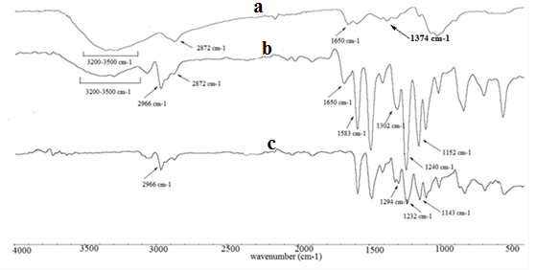
Figure 3.7. FT-IR spectra of a) chitosan, b) and c) M-2 and polysulfone membranes respectively.
3.3.2 Morphology of the membrane
Figure 3.8 represents the SEM micrographs of the PSf/CS membranes. The surface pores of the UF membranes are too small to be seen and both membranes have a typical asymmetric structure having a top layer and a support layer with finger-like projections. Addition of hydrophilic chitosan to the casting solution increased the viscosity. These factors contributed to the rapid demixing between the polymer rich solvent phase and non-solvent resulted in formation of finger-like projections below the skin layer (Figure 3.8, b). For higher loading of chitosan, the length of finger-like projections reduced with increased voids in the sub layer (Figure 3.8, c). The relatively low polymer concentration (17.3 and 13.2 w/v % for M-1 and M-2 membranes, respectively) and the blend of highly hydrophilic chitosan contributed to the formation of highly porous membrane structure compared to pristine PSf membrane.

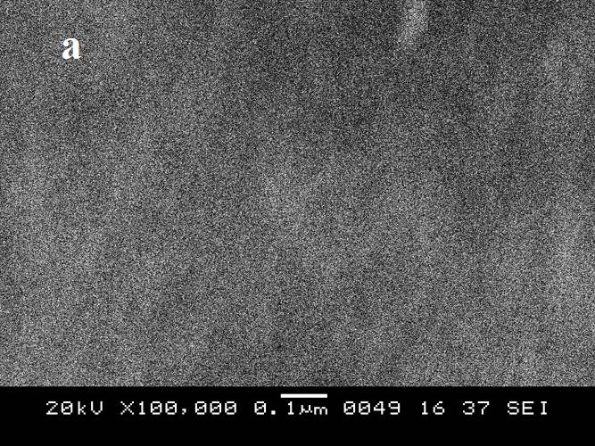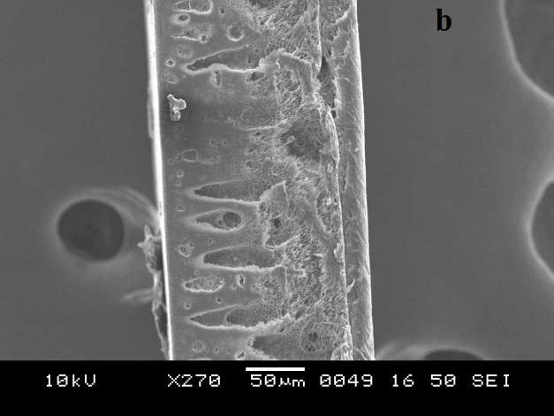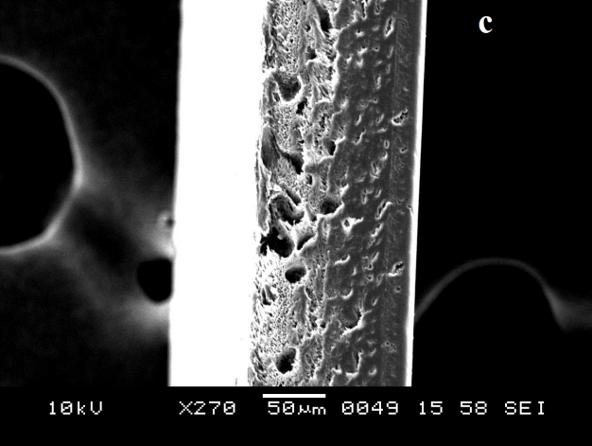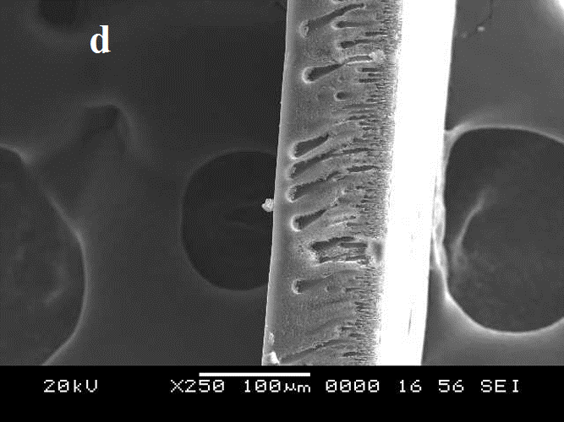
Figure 3.8 SEM micrographs of membranes; a) surface of M-2, b), c) and d) cross-sections of M-1, M-2 and pristine PSf respectively.
3.3.3 Water uptake
Water uptake is the measure of membrane hydrophilicity and porosity. Figure 3.9 represents the variation of percentage water uptake of PSf:CS membranes at different pH values. The higher the CS content in the PSf membrane matrix, higher will be the water uptake due to increased hydrophilicity as well as porosity of the membrane. The maximum value of water uptake is observed for both membranes at acidic pH, i.e. membranes with 5.0 % and 2.5 % CS content showed 78.6 % and 71.1 % water uptake, respectively, at pH = 3. This pH sensitivity of the membrane is caused by the –NH₂ group present in chitosan (Amiji 1995, Boributh et al. 2009); i.e. at low pH the –NH₂ group is protonated to –NH₃⁺ group leading to chain relaxation as a result of electrostatic repulsion between positive charges. The water uptake of both membranes decreased as pH increased.
Figure 3.9 pH dependence of the water uptake of the membranes.
3.3.4 Contact angle measurement
The contact angle is the measure of surface hydrophilicity of the membrane and in general, the smaller the contact angle, the higher is the hydrophilicity of the material. Membranes with 5.0 % and 2.5 % chitosan content showed contact angle of (67.36 ± 1) ° and (68.68 ± 1) °, respectively as shown in Figure 3.10. Since the contact angle of polysulfone membrane measured was (74 ± 2) °, blending of hydrophilic chitosan reduced the contact angle.
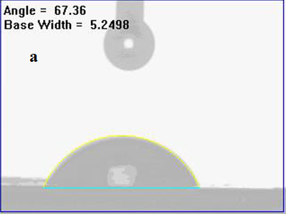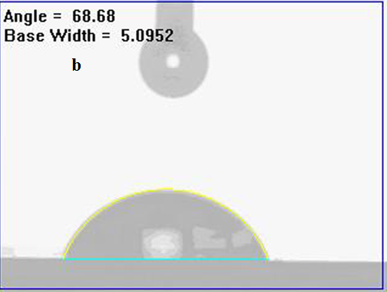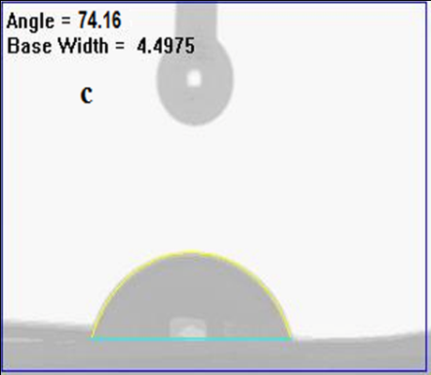
Figure 3.10 Contact angle of membranes a) M-2 b) M-1 and c) polysulfone
3.3.5 Permeation experiments
From pH dependent permeation studies (Table 3.2), both PSf/CS membranes showed the highest pure water flux at the lowest pH and the flux decreased as pH increased. This complies with the results obtained from water uptake experiments. Thus, protonation of chitosan -NH₂ at low pH resulted in maximum chain relaxation, water uptake and water flux.
Table 3.2 pH dependent pure water fluxes of membranes at 0.3 MPa TMP at 26 °C after initial compaction of membranes.
 | Pure water flux (L/m²h)
pH | M-2 | M-1
3 | 260 | 244
5 | 253 | 238
7 | 202 | 160
9 | 190 | 153

The water flux of PSf/CS ultrafiltration membranes was higher than polysulfone ultrafiltration membrane as shown in Figure 3.11. This can be explained by increased hydrophilicity of the membranes due to the presence of chitosan. Chitosan also acted as a pore forming agent during the phase inversion process. The increased chitosan content in the PSf/CS blend membrane resulted in higher flux. Both PSf/CS membranes showed decline in pure water flux during the permeation experiment. A steady value of pure water flux i.e. 194 L/m²h and 158 L/m²h for M-2 and M-1 membrane, respectively, was reached after 44 min. This decline in flux is due to the mechanical deformation of the polymeric membrane matrix (Zhao et al. 2011). For membranes with hydrophilic additives, the pure water ﬂuxes would suffer a severe decrease during membrane compaction, which might be not only due to the immiscibility between the additive and membrane material but also to the existence of a large number of macrovoids in the sub-layer (Kim et al. 2000).

Figure 3.11 Time dependent pure water fluxes of the membrane at 0.3 MPa TMP, at 26 ºC
3.3.6 Antifouling properties
It is a common phenomenon that the flux during BSA rejection declines sharply compared to the pure water flux. This is due to the adsorption or deposition of protein molecules on the surface of the membrane, which results in partial blockage of pores at the surface. The PSf/CS membranes showed remarkably higher flux than PSf membrane without CS blend even when the feed solution included protein (Figure 3.12). The protein rejection properties of two PSf/CS membranes were almost same. The BSA rejection of 97.2% and 96.5 % were observed for PSf/CS membranes with 5.0 % and 2.5 % of chitosan content respectively.

Figure 3.12 Flux of the membranes during BSA rejection at 0.3 MPa TMP and 26 ºC.
A fouling resistance ratio (FRR) means a better antifouling property of the membrane. The % FRR values of membranes decreased in the order of M-2>M-1>M-0 as represented in Figure 3.13. The M-2 membrane showed the maximum FRR value of 56%. It confirms that, introduced hydrophilic chitosan played major role in improving the polysulfone membrane antifouling property. The increased hydrogen bonding between water molecules and membrane surface resulted in more hydrophilic surface. Hence, the binding interaction between BSA protein molecules and membrane surface reduced.

Figure 3.13 FRR values of membranes

3.4 CONCLUSIONS
A new procedure for the preparation of PSf/CS blend membranes has been successfully demonstrated. A maximum of 5 % chitosan was incorporated into the PSf/CS blend. The ATR-IR spectra of membranes confirmed the presence of chitosan in the PSf/CS membranes. The FESEM micrographs proved the asymmetric nature of the membranes. The water uptake and contact angle measurements confirmed that prepared membranes are more hydrophilic than neat polysulfone membranes. The introduced chitosan not only contributed to the hydrophilicity of the membranes but also acted as a pore former during the phase inversion process. The pure water flux was the highest at the minimum pH due to the protonation of chitosan –NH₂ groups. Both PSf/CS membranes showed enhanced permeation and antifouling properties compared to polysulfone ultrafiltration membranes. As well, those properties depended on the amount of chitosan in the membrane. The maximum flux recovery ratio of 56 % was observed in M-2 membrane with 5.0 % of chitosan content. Thus biodegradable and less toxic chitosan proved as a promising additive to improve permeation and antifouling properties of polysulfone ultrafiltration. This type of membranes may find applications in the field of heavy metal rejection due to presence of sorptive chitosan within the membrane matrix.

Abstract
In this chapter, a water soluble chitosan derivative, N-Succinyl chitosan (NSCS) was synthesized using literature reported procedure. Further, the water soluble derivative was blended with polar organic solvent soluble polysulfone (PSf) in three different compositions to fabricate PSf/NSCS blend membranes. Due to the difference in solubility between NSCS and PSf, a new process was demonstrated for the homogeneous blending. A maximum of 20 % NSCS was successfully blended with polysulfone using NMP as common solvent. The blending of polymers was confirmed by ATR-IR spectroscopy. Pure water flux, water uptake, contact angle and antifouling property of the PSf/NSCS blend membranes were measured and compared with the pristine polysulfone membrane. The NSCS incorporated membranes showed enhanced flux and antifouling properties. PSf/NSCS membrane prepared by blending of 20% of NSCS showed maximum of 70% flux recovery ratio.
4.1 INTRODUCTION
Ultraﬁltration (UF) has become the main focus as a promising separation tool in separation of heavy metal from environmentally polluted water. Heavy metal separation through polymer enhanced ultrafiltration (PEUF) has attracted most of the researchers in finding suitable ultrafiltration membranes or its materials from past few decades. A membrane with appropriate hydrophilicity-hydrophobicity balance and adsorption property will be most suitable. Polysulfone (PSf) is one such material which can be widely applied for the preparation of ultrafiltration membranes. The properties like good thermal and mechanical strength, chemical resistance and stability at different pH (Ahmad et al. 2011) and good film forming nature made this polymer as an excellent membrane material. The major drawback of PSf is, it is hydrophobic in nature (Zularism et al. 2007). It has also been reported that blending of PSf with hydrophilic additive in the casting solution can enhance the membrane performance with high permeability and antifouling property (Yang and Zhang 2007, Chakrabarty et al. 2008). From previous reports, it has been observed that blending of PSf with additives like polyvinylpyrrolidone (PVP) (Han and Nam 2002) or poly (ethylene glycol) (PEG) (Chakrabarty et al. 2008) has enhanced its ultrafiltration properties. These additives impart various effects on membrane morphology and pore size depending on their content or molecular weight. They are soluble both in water and in common organic solvents such as N-methyl pyrrolidone (NMP). Thus the blending can be easily achieved between PSf and those polymers in common organic solvents.
Hydrophilically modified PSf membranes with suitable chelating groups are most suitable for heavy metal application. Mbareck et al. (2009) prepared PSf and polyacrylic acid (PAA) blend ultrafiltration membranes by a phase inversion method for removal of heavy metals. The entrapment of PAA within PSf membrane matrix was proved by ion exchange capacity and FTIR spectra. The obtained membranes showed decreased porosity, mean pore size and hydraulic permeability with an increase in PAA content. The PSf/PAA membranes showed high lead, cadmium and chromium rejection which reached 100% at pH superior than 5.7 and a low rejection at low pH. Such rejection of membranes was mainly attributed to the complexation between metal atom and carboxylate group of PAA.
Figure 4.1 Structure of poly (acrylic acid)
Han et al. (2012) prepared hyperbranched poly (amidoamine) (HYPAM) and polysulfone composite membrane for the cadmium ion rejection. The binding capacity of dendritic chelating agent HYPAM was investigated by inductively coupled plasma atomic emission spectroscopy. The composite membranes recovered 86% of cadmium ions under acidic condition. The PSf/HYPAM composite membranes showed enhanced water flux with high Bovine Serum Albumin (BSA) retention.
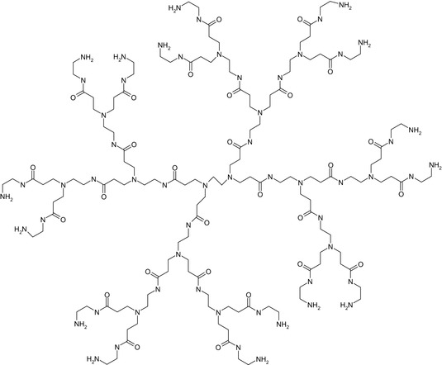
Figure 4.2 Structure of HYPAM
Chitosan is a polysaccharide formed primarily from repeating residues of D-glucosamine, having primary amino groups and obtained by N-deacetylation of the natural polymer chitin. It is the second most naturally occurring polymer which is biodegradable and non toxic in nature. Chitosan is a good chelating agent and can easily complexed with the heavy metal ions through co-ordination bond (Figure 4.3)
Figure 4.3 Schematic representation of metal ion chelation by chitosan
Such complexation property of chitosan based membranes will find applications in the field of heavy metal rejection. The nanofiltration membranes prepared by casting N, O-carboxymethyl chitosan (NOCC) onto the polyether sulfone (PES) ultrafilration support showed excellent removal property for nickel ions (Boricha et al. 2008). The stronger repulsion between carboxymethyl group of NOCC and SO₄²⁻ and Cl⁻ groups of nickel salts resulted in higher rejection. The maximum rejection of 80% and 62% of 5 ppm, 78% and 59% of 10 ppm; and 74% and 57% of 50 ppm feed concentration of nickel sulfate-water and nickel chloride-water systems, respectively.
Figure 4.4 Structure of N, O-Carboxymethyl chitosan
Further the same group, Boricha et al. (2010) prepared N,O-carboxymethyl chitosan (NOCC) and cellulose acetate (CA) nanofiltration membranes using acetone as a common solvent for blending. NOCC contributed to the enhanced separation performance for metal ions and CA provided suitable mechanical strength for the membrane. The membranes showed maximum rejection of 83.40% and 72.60% of chromium and copper respectively at 1 MPa applied pressure to feed flow rate of 16 L/m.
Keeping in view of the advantages offered by the derivative of chitosan (containing carboxylate ion) in heavy metal rejection, in current chapter, N-Succinyl chitosan (NSCS) was prepared by one pot reaction between chitosan and succinic anhydride using water and acetone as solvents.
Figure 4.5 Structure of N-Succinyl chitosan
Further, it was blended with PSf in different compositions to prepare PSf/NSCS hybrid membranes. The water soluble derivatives of chitosan are usually insoluble in organic solvents (Heras et al. 2001, Wang et al. 2011), hence a new process is demonstrated for blending of PSf with NSCS. NSCS is a biocompatible, less toxic and water soluble derivative of chitosan which contains carboxylic (-COOH) groups on its polymer backbone. Hence, NSCS is considered as one of the novel additive, which is different from the currently available organic and inorganic additives (Kim and Lee 1998, Chakrabarty et al. 2008, Qiu et al. 2009) in many aspects. The performance of the membranes was evaluated in terms of permeation and antifouling property studies.
4.2 EXPERIMENTAL
4.2.1 Synthesis of N-succinyl chitosan (NSCS)
NSCS was prepared using the reported procedure (Aiping et al. 2006). In brief, 1 g of chitosan (CS, degree of deacetylation 75-85%, low molecular weight chitosan from Sigma-Aldrich Co. Bangalore, India) was dissolved in 200 mL of 1 wt % aqueous acetic acid solution. 0.2 g of Succinic anhydride (Sigma-Aldrich Co. Bangalore, India) was dissolved in acetone (20 mL) and the solution was added to the above chitosan solution over a period of 30 min at 30 °C and then the reaction was allowed to continue at 35 °C for 4 h. The reaction product was precipitated by adding an excessive amount of acetone, filtered to remove the solvent and then washed with 30:70, 20:80 water:acetone mixtures and then with acetone sequentially. Finally, the product was dried at 35 ºC under vacuum at -100 mm Hg pressure for 24 h to obtain 1.1 g of NSCS as white powder.
4.2.2 Preparation of PSf/NSCS blend membranes
The procedure to prepare PSf/NSCS (95/05) membrane is as follows. 1.0 g of NSCS was dissolved in a 20 mL of distilled water at 30 °C. 3.8 g of polysulfone (Mw= 35,000 Da, from Sigma-Aldrich Co. Bangalore, India) was dissolved in 15.2 mL of NMP at 60 °C to obtain a homogeneous solution. 4.0 mL of NSCS solution was added to the PSf solution under vigorous stirring (addition leads to the formation of thick white precipitate in the homogeneous solution of polysulfone, followed by the addition of 2.0 mL additional NMP). The resultant turbid mixture was stirred vigorously at 70 °C for 8 h to achieve required homogeneity of the casting solution. During blending, reduction in total volume of the solution was observed (as presented in Table 4.1). The homogeneous viscous solution was filtered, while it remained hot, using a G4 sand filter and cast over a glass plate using a Doctor’s blade before being immersed in a coagulation bath that contained distilled water. The membrane was then washed with distilled water several times and dried at 30 °C. Similarly, membranes PSf/NSCS (90:10) and (80:20) were prepared with compositions as mentioned in Table 4.1. In upcoming discussions, membranes with PSf:NSCS ratios of 95:05, 90:10 and 80:20 are labeled as M-3, M-4 and M-5 respectively.
4.2.3 Preparation of PSf/PEG blend membrane (80:20 %)
3.2 g of polysulfone was taken in 12.8 mL of NMP and the mixture was heated to 60 °C for 6 h to get the homogeneous solution. Now 0.8 g of polyethylene glycol (M_{w} =600 g/mole) was added at the same temperature and the mixture was stirred for additional 2 h. The resulting homogeneous solution was sonicated for 15 minutes at 60 °C prior to casting over the glass plate. The membrane was obtained by a phase inversion process by dipping the casted glass plate in distilled water at 20 °C. So obtained membrane was several times washed with distilled water to remove the traces of NMP and dried at 30 °C before taking it for permeation experiments. A similar procedure was followed for the preparation of PSf/PEG membrane with 90:10 % composition.
Table 4.1 Compositions of PSf /NSCS blend membranes
Membrane | PSf (g) | NMP (mL) | NSCS (g) | Additional NMP (mL) | Temp (°C) | Time of dissolution | Final Vol. of casting solution
M-3 | 3.8 | 15.2 | 0.2 | 2 | 70 | 8 | 20
M-4 | 3.6 | 14.4 | 0.4 | 4 | 70 | 9 | 21
M-5 | 3.2 | 12.8 | 0.8 | 8 | 70 | 11 | 24

4.3 RESULTS AND DISCUSSION

4.3.1 Infra-Red spectroscopy
Chitosan derivative NSCS showed characteristic peaks at 3000-3500 cm⁻¹ (-OH stretch), 1158 cm⁻¹ (C-O-C bridge asymmetric stretch), 1646 cm⁻¹ (amide I) and at 1403 cm⁻¹ (amide III) which are in good agreement with the values reported for the NSCS derivative (Marchese et al. 2003).
The proper blending of PSf/NSCS membrane was confirmed by identifying the peaks corresponding to PSf and NSCS in the membrane. From Figure 4.6, membranes M-3 or M-5 showed characteristic peaks at 3000-3500 cm⁻¹ (-OH stretch), 1644 cm⁻¹ (amide I), 1156 cm⁻¹ (C-O-C bridge), 1406 cm⁻¹ (amide III) confirming the presence of NSCS in the blend. Whereas peaks at 2966 cm⁻¹ (S=O asymmetric stretch), 1239 cm⁻¹ (C-O-C stretch) and 1153 cm⁻¹ (S=O symmetric stretch) confirmed the presence of PSf in the PSf/NSCS blend membrane.

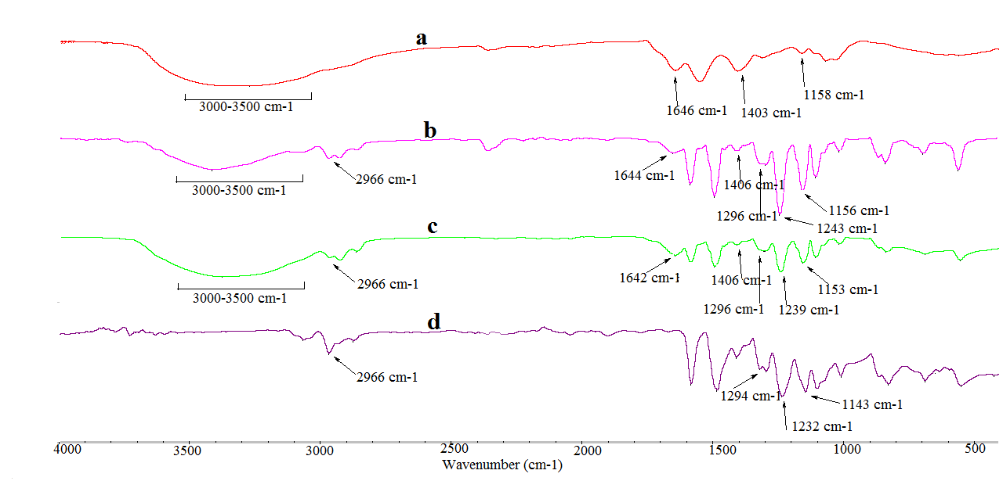
Figure 4.6 FTIR spectra of a) NSCS b) M-3 c) M-5 and d) M-0.
4.3.2 Morphology and thermal study
A top dense layer supported by a porous sublayer is the common characteristics of asymmetric membranes. Figure 4.7 (a, c, e), clearly confirms the presence of the asymmetric structure in the cross-section of the membranes. The cross-sectional image of pristine polysulfone showed larger finger-like structures in the sub-layer (Figure 4.7, f), whereas its length deceased for M-5 membrane (Figure 4.7, a). The smaller finger-like projections or formation of a sponge like structures with an increase in NSCS concentration may be attributed to the higher viscosity of the blend. Usually the water soluble additives like PVP, PEG (Yeo et al. 2000, Han et al. 2002) enhance hydrophilicity and performance of PSf membranes. These additives dissolve both in solvent (organic phase) and nonsolvent (water) and leach out of the cast polymer solution film during the membrane formation process, thereby acting as pore forming agents (Kim et al. 1998, Yeo et al. 2000, Chakrabarty et al 2008). In our current study, blending of water soluble NSCS with PSf resulted in increased solvent- nonsolvent exchange due to increased viscosity and also the partial dissolution of NSCS into the nonsolvent (water) during the phase inversion process. Both these factors contributed to the increased number of pores or highly porous structure on the membrane surface (Figure 4.7, b and d). The pore size was determined by taking the magnified surface FESEM images (Figure 4.7, g) of the membranes. For each membrane ten different locations were selected and the average value of least and maximum pore size was reported. All three membranes have a top layer with pore sizes ranging from 0.08 µm to 1.03 µm as confirmed from surface FESEM images.

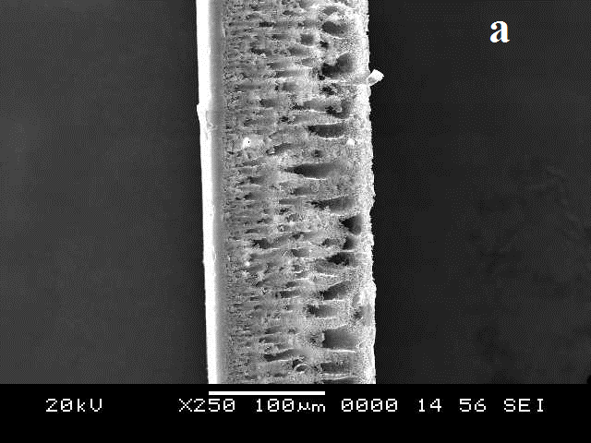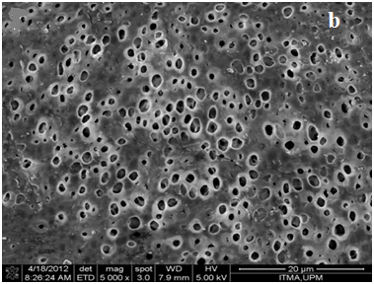
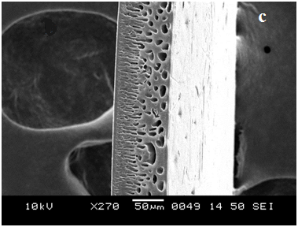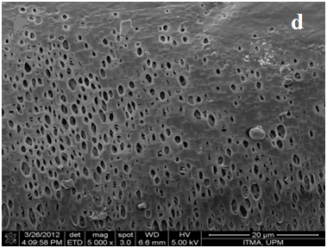
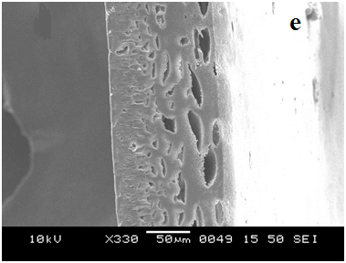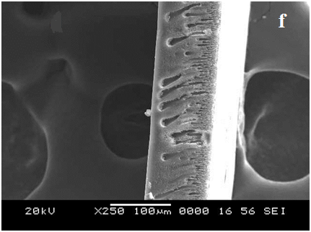
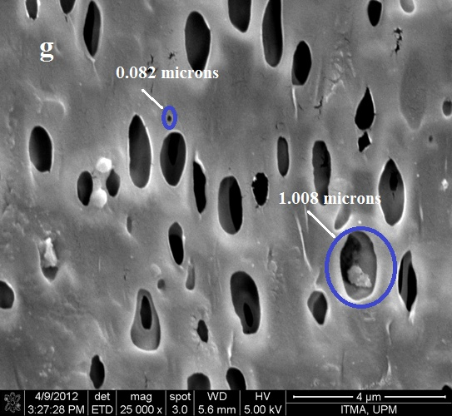

Figure 4.7 SEM and FESEM images: a) and b) Cross sectional and surface of M-5, c) and d) Cross sectional and surface of M-4 membrane, e) Cross section of M-3, f) Cross section of M-0, g) Magnified image of M-5
Differential scanning calorimetry study gives the proof for blending of two polymers in the membrane. Table 4.2 represents the T_{g} values of PSf/NSCS blend membranes with different compositions. Neat Polysulfone membrane showed T_{g} of 195 °C. The value of T_{g} decreased slightly with the increase in composition of chitosan derivative in the membrane and the trend is same as observed in case of PSf/CS blend membranes.
Table 4.2 T_{g} values of membranes
Membrane | % Composition (PSf:NSCS) | T_{g} (ºC)
M-3 | 95.0:5.0 | 175.29
M-4 | 90.0:10.0 | 172.69
M-5 | 80.0:20.0 | 166.69

4.3.3 Water swelling behavior and contact angle measurement
Good hydrophilicity and hydrophobicity balance are the characteristics of an ideal membrane. The blending of hydrophilic chitosan derivative enhanced the hydrophilicity as shown in Figure 4.8. The % swelling by water increased with an increase in the NSCS loading. As well, the maximum water uptake occurred at pH=3 due to protonation of unsubstituted –NH₂ groups of NSCS. The least swelling was observed at pH=7. The % swelling increased with further increase in pH, due to the conversion of terminal –COOH (of NSCS) into corresponding salt –COO⁻Na⁺.
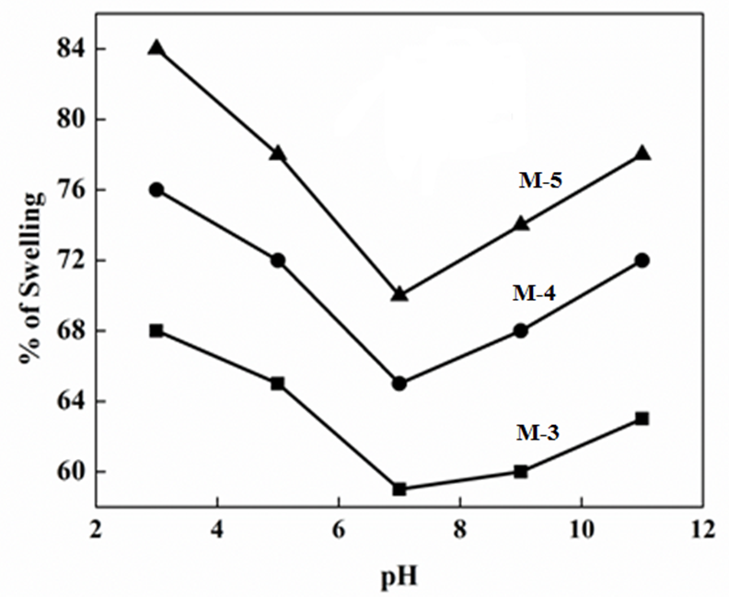
Figure 4.8 pH dependent swelling values of membranes
The contact angle is the parameter which determines surface hydrophilicity of the membrane. In general, the smaller the contact angle the higher is the hydrophilicity. PSf/NSCS membranes showed decreased contact angle with the increase in NSCS loading (Figure 4.9). The PSf/NSCS membrane with 80:20 composition showed the lowest contact angle of 60.9 º. From water swelling and contact angle measurements, it could be concluded that blending of NSCS increased the hydrophilicity of PSf membrane.

Figure 4.9 Contact angle values of membranes

4.3.4 Pressure dependent pure water flux (PWF)
The flux of the membrane depends on the surface hydrophilicity, thickness, pore size and porosity of the skin layer of the membrane. During PSf/NSCS membrane formed by the phase inversion process, NSCS is retained on the surface of the membrane, contributing to its hydrophilicity, while a part of it was leached out into the nonsolvent resulting in the formation of larger pores. Figure 4.10 represents the pressure dependence of pure water flux for the PSf/NSCS blend membranes measured at neutral pH. Pure water flux increased with an increase in NSCS loading due to increased hydrophilicity and pores. As well, the pure water flux was proportional to the applied pressure. The water flux data confirmed that all membranes were in the ultrafiltration range.
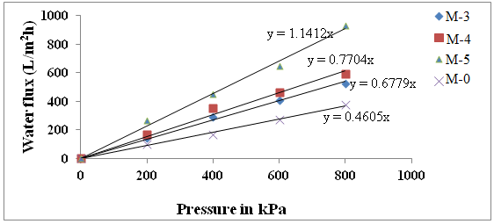
Figure 4.10 Pressure dependent pure water flux values of membranes at pH 7

4.3.5 BSA rejection study
Fouling is the major drawback of PSf ultrafiltration membranes due to the hydrophobic interaction between foulant and membrane surface. Flux decline and decrease in membrane life time are caused by membrane fouling. In general, protein-resistant surfaces are hydrophilic in nature, due to strongly bound water molecules that prevent protein molecules from binding to surfaces (Yune et al. 2011). Since in the present study, the contact angle and permeation experiments proved increased hydrophilicity of the PSf/NSCS membranes, it is expected that the latter membranes will exhibit stronger antifouling effect. Furthermore, BSA has an isoelectric point of 4.9 (Boributh et al. 2009), therefore, BSA is negatively charged in the neutral solution whose pH is equal to 7. The membrane surface is also negatively charged due to the presence of the carboxylic group of NSCS. Thus, a strong electrostatic repulsion force between both negatively charged BSA molecule and membrane surface is working, which will reduce the fouling (Huisman et al. 2000, Boributh et al. 2009).
Figure 4.11 shows the time dependence of pure water flux for the PSf/NSCS membranes. The flux increased as the NSCS loading increased and three times higher flux was observed in case M-5 membrane compared to the M-0 membrane. Figure 4.12 represents the flux decline behavior of the PSf/NSCS membranes during BSA rejection. Compared with Figure 4.11, the decrease in flux from the pure water flux is obvious. Futhermore, adsorption and desorption of protein molecules on the surface resulted in continuous decline in flux values of the membranes (Teli et al. 2012) as the BSA separation experiment proceeds, until the flux leveled off. Similar to pure water flux, the BSA flux was increased as the NSCS loading in the membrane increased. The pure water flux of PSf/PEG membranes was determined using the similar procedure as in section 2.9. Interestingly, the pure water fluxes obtained for PSf/NSCS membranes with 80:20 and 90:10 compositions were almost the same as those of the PSf/PEG membranes of the same composition (Figure 4.13). The BSA rejection values of M-3, M-4 and M-5 membranes were 90 %, 92 % and 93.5 % respectively.
Estimation of flux recovery ratio FRR is the best method to determine the antifouling property of the membrane (Vantanpour et al. 2012). From Figure 4.14, the blending of hydrophilic additive NSCS with Polysulfone, increased the membrane’s FRR value compared to the neat polysulfone membrane and FRR increases with an increase in NSCS loading. These results confirmed that NSCS contributed to the reduction of interaction between BSA and the membrane surface thereby making the hydraulic cleaning process re effect during the filtration process (Peeva et al. 2011).

Figure 4.11 Time dependent pure water flux of membranes at 0.3 MPa TMP

Figure 4.12 Flux of the membranes during BSA ultrafiltration at 0.3 MPa TMP

Figure 4.13 Flux of PSf/NSCS and PSf/PEG membranes

Figure 4.14 FRR values of membranes
4.4 CONCLUSIONS
A water soluble derivative of chitosan, N-Succinyl chitosan (NSCS), was prepared as an additive for the PSf ultrafiltration membranes. Due to insolubility of NSCS in organic solvents, a new process was developed for blending of NSCS with PSf. According to the method, the maximum blending of NSCS achieved was PSf:NSCS ratio of 80:20. The blending of NSCS with PSf was confirmed by ATR-IR. The increased hydrophilicity of the membranes with the increased NSCS loading was confirmed by contact angle and water uptake measurements. It is postulated that, NSCS resulted in increased porosity when it was leached out and increased surface hydrophilicity when it remained on the membrane surface. The membranes showed a maximum swelling in the acidic solution of pH=3 and a minimum swelling at pH=7. When the pH was further increased, swelling tends to increase. The pure water flux of the membranes increased linearly with pressure. From time dependent permeation studies, the pure water flux of PSf/NSCS membranes was three times higher than pristine PSf membrane. All PSf/NSCS membranes showed higher fluxes during BSA ultrafiltration than the pristine PSf membrane. The maximum FRR of 70% was observed for the highest PSf/NSCS ratio of 80:20 (M-5). This confirmed the enhanced antifouling property of PSf/NSCS membranes. All the membranes showed >90% rejection for BSA protein filtration.
By blending NSCS, both permeation flux and antifouling properties in PSf ultrafiltration membrane were improved significantly. Such type of membranes may find applications in the field of heavy metal rejection. Nontoxic and biodegradable derivatives of chitosan acted as a promising substitute for the hydrophilic polymeric additives like PVP, PEG or PVA.

Abstract
In this chapter, a novel water soluble chitosan derivative N-propylphosphonic chitosan (NPPCS) having a terminal phosphonic acid group was synthesized by reacting chitosan with hydroxybenzotriazole (HOBt) and propylphosphonic anhydride (T3P) ® via one pot reaction. The derivative was characterized by ¹H NMR, ATR-IR spectroscopy and XRD. Further, the derivative was blended with polysulfone with different compositions to prepare PSf/NPPCS ultrafiltration membranes. The permeation and antifouling property of the PSf/NPPCS membranes was measured by filtering Bovine Serum Albumin (BSA) protein solution and compared with pristine PSf membrane. The permeation and antifouling properties increased with increase in NPPCS content and a maximum of 74% fouling resistance ratio was observed for PSf/NPPCS membrane with 20% NPPCS content.
5.1 INTRODOCTION
Chitosan, a biomaterial obtained via alkaline N-deacetylation of chitin, has recently attracted much attention from scientists across the globe. It shows many excellent biological properties such as nontoxicity, biodegradability, antimicrobial activity and immunological activity (Rinaudo 2006, Chung and Chen 2008). Although the polymer backbone consists of hydrophilic functional groups, chitosan is normally insoluble in water and most of the common organic solvents (e.g. DMSO, DMF, NMP, organic alcohols, pyridine). Modification of chitosan is an important step towards the enhanced solubility property and further application of the polymer in membrane technology.
The chemical modification of chitosan is of interest as the modification would not change the basic framework of chitosan but bring new or improved properties. A great number of chitosan derivatives have been obtained with the aim of adsorbing metal ions by grafting new functional groups on the chitosan skeleton. As literature is concerned, the chitosan Schiff bases (Monier 2012), aklylated chitosan, N-carboxymethylated chitosan (Wang et al. 2011), chitosan salts (Spinelli et al. 2004) and cross-linked chitosan (Cesrari et al. 2001) have shown excellent metal ion chelating properties.
Chitosan Salt N-carboxymethyl chitosan N-alkylation (R= alkyl group)
Chitosan Schiff base (R= aldehyde group) Cross-linked chitosan
Figure 5.1Metal adsorbing derivatives of chitosan
The new functional groups are incorporated to increase the density of sorption sites, to change the pH range for metal sorption and to change the sorption sites in order to increase sorption selectivity for the target metal (Kurita 2006). Chemical modification of chitosan lead to: (i) improved chemical and physical properties (ii) improved metal adsorption and (iii) altered solubility properties of chitosan in water or acidic medium. The substitution chemical reactions involve the NH group in the C2 position or the OH groups in the C3 and C6 positions of acetylated and deacetylated units.
Figure 5.2 Structure of chitosan representing carbon atom positions
The derivatives of chitosan are important precursors towards the preparation of adsorptive membranes (Boricha et al. 2008). Phosphorylated derivatives of chitosan shows excellent adsorption towards transition metal ions, where the phosphoryl groups contribute much towards the adsorption at higher pH values (Nishi et al. 1987).
Figure 5.3 Phosphoryl chitosan
The synthetic polymers like polyethyleneiminemethylene phosphonic acid, containing phosphonic acid group can be used for the removal of copper ions from the aqueous solutions (Ferrah et al. 2011). The incorporation of acidic groups into the chitosan composite membranes by immobilization technique results in enhanced heavy metal removal property. Genc et al. (2003) prepared composite membranes Procion Green H-4G immobilized poly (hydroxyethylmethacrylate (HEMA)/chitosan for the removal of cadmium, lead and mercury. The immobilization of Procion Green H-4G on pHEMA/chitosan membranes increased the adsorption capacity values 6.9 times for Cd, 3.7 times for Pb and 2.6 times for Hg. The overall improvement in removal property of the membrane is due to the presence of six sulfonic acid (-SO₃H) groups on the immobilizing agent.

Figure 5.4 Procion Green H-4G
Polysulfone blend membranes with hydrophilic inorganic, organic and polymeric additives are very effective in separation of heavy metals from aqueous waste. Blending is one of the classical technique to insert hydrophilic components into the membrane matrix or internal pores. Adams et al. (2012) prepared polysulfone and β-cyclodextrin polyurethane (β-CD-polyurethane) blend membranes by phase inversion technique for the removal of cadmium from aqueous waste at pH 6.9. The FT-IR results indicated hydrogen bonding interaction between β-CD-polyurethane and PSf, which suggested that the materials are compatible. The improved hydrophilicity and water flux of membranes indicated the hydrophilic nature of β-CD-polyurethane. For higher content of β-CD-polyurethane the flux of membranes increased significantly without compromising the rejection factor.
Figure 5.5 β-CD polyurethane
Propylphosphonic anhydride (T3P) is a mild water scavenger with low toxicity and low allergenic potential (Llanes Garcia 2007). Time since the advent of T3P, it has been used as peptide coupling agent. In most recent years it has found applications in the field of synthetic organic chemistry (Zumpe et al. 2007, Augustine et al. 2009, James et al. 2009, Vasantha et al. 2010). So far the application of T3P in chemical modification of polymers has not been reported so far.
Figure 5.6 Structure of T3P
Keeping in view the contribution made by the acid derivatives of chitosan towards the effective removal of heavy metals, in current chapter a novel water soluble derivative of chitosan, N-propylphosphonic chitosan (NPPCS) was synthesized, by reacting chitosan with propylphosphonic anhydride (T3P) and hydroxybenzotriazole. The NPPCS was characterized by ATR-IR, ¹H NMR and XRD spectroscopy. The NPPCS derivative was blended with PSf with different compositions to get PSf/NPPCS membranes. Further, in current chapter the role of NPPCS in improving hydrophilicity, permeation and antifouling properties of PSf/NPPCS membrane was evaluated.
5.2 EXPERIMENTAL
5.2.1 Synthesis of N-propylphosphonyl chitosan (NPPCS)
Propylphosphonic anhydride (50% solution in ethyl acetate) and hydroxybenzotriazole (HOBt) were purchased from Sigma Aldrich Co. India. To the mixture of propylphosphonic anhydride (1.589g, 4.86 mmol) and hydroxybenzotriazole (0.372g, 2.43 mmol) added triethylamine (0.368g, 3.64 mmol) at 30 °C. The reaction mixture was stirred for 2 h to get homogeneous solution. Chitosan was added (0.5g, 2.43 mmol) at the same temperature followed by 2.0 mL of distilled water. The resulting reaction mixture was stirred at 30 °C for 24 h. The reaction mixture was precipitated by adding an excess of acetone. Further the precipitate was washed with a mixture of acetone and methanol (1:1) for three times, followed by drying under vacuum. (Yield: 0.54g)
5.2.2 Preparation of PSf/NPPCS blend membranes
Polysulfone (M_{w}= 35,000) was purchased from Sigma Aldrich Co, Bangalore, India. The preparation of PSf/NPPCS (95/5) membrane is as follows. 1.0 g of NPPCS was dissolved in a 20 mL of distilled water at 30 °C. 3.8 g of PSf was dissolved in 15.2 mL of NMP at 60 °C to obtain a homogeneous solution. 4.0 mL of NPPCS solution was added to the PSf solution under vigorous stirring (addition leads to the formation of thick white precipitate in the homogeneous solution of PSf), followed by the addition of 2 mL NMP. The resultant turbid mixture was stirred vigorously at 70 °C for 8 h to achieve required homogeneity of the casting solution. During blending, reduction in total volume of the solution was observed. The homogeneous viscous solution was filtered hot using a G4 sand filter and cast over a glass plate using a Doctor’s blade. Later it was immersed in a coagulation bath containing distilled water. The membrane was then washed with distilled water several times and dried at 30 °C. Similarly, membranes PSf/NPPCS (90:10) and (80:20) were prepared. In upcoming discussions, membranes with PSf: NPPCS ratios of 95:05, 90:10 and 80:20 are labeled as M-6, M-7 and M-8.
5.3 RESULTS AND DISCUSSION
5.3.1 Chitosan-T3P coupling mechanism
In the presence of a base (triethylamine), T3P (A) readily reacts with nucleophilic –OH group of HOBt (B) leading to the formation active ester derivative of HOBt (intermediate C) (Augastine et al. 2011, Joullie et al. 2010). In a further step, chitosan –NH₂ attacks to ester linked phosphorous atom of the intermediate ‘C’ favoring the cleavage of the weak phosphonic ester bonding P-O (Figure 5.7). The subsequent amide linkage resulted in the expulsion of NPPCS (E) and B as the byproduct.
Figure 5.7 Schematic representation of mechanism for the formation of NPPCS
5.3.2 Characterization of NPPCS
5.3.2.1 Spectral characterization
The ATR-IR spectrum of the chitosan was compared with that of modified chitosan derivative (NPPCS) as shown in Figure 5.8. The spectrum of chitosan showed -OH stretching band between 3450 cm⁻¹ and 3100 cm⁻¹ and aliphatic C-H stretching at 2869 cm⁻¹. Peak present at 1647 cm⁻¹ corresponds to acetylated amino groups inherently present in the chitosan, whereas peak at 1374 cm⁻¹ corresponds to -C-O stretch frequency of the primary alcoholic group (-CH₂-OH). When compared to chitosan, NPPCS derivative showed characteristic peaks at 2934 cm⁻¹ corresponding to symmetric –C-H stretching of propyl group. Peak between 3100-3450 cm⁻¹ corresponds to both –OH and P-OH stretching; strong absorption peak at 928 cm⁻¹ indicated the presence of –P-O-P linkage (Heras et al. 2001), 1156 cm⁻¹ of -P=O stretch and 1030 cm⁻¹ of (P-O) H stretch (Ilieva et al. 2001) thereby confirming the structure of NPPCS derivative. The peak at 1587 cm⁻¹ corresponds to N-H bending vibrations of the primary amino group of chitosan was diminished in the NPPCS spectrum. This is due to the higher degree of amidation at –NH₂ group of chitosan. Also the new peak at 1529 cm⁻¹ may be assigned to the amide II absorption bands.
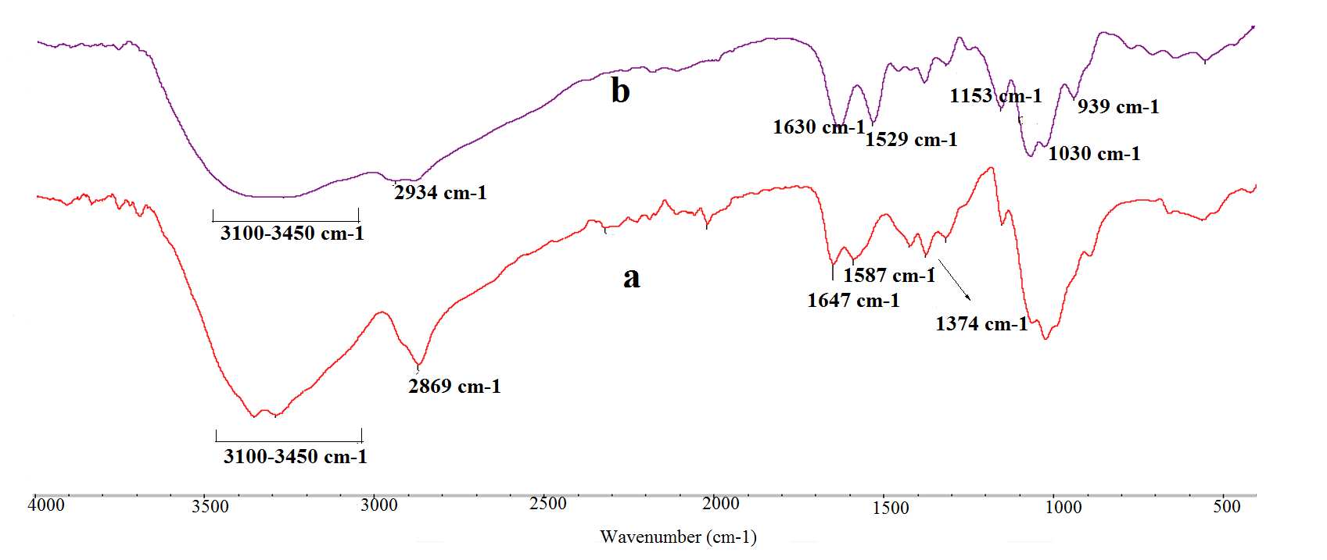
Figure 5.8 ATR-IR spectra of a) Chitosan and b) NPPCS
The ¹H NMR spectra of chitosan and NPPCS are presented in Figure 5.9. Compared to chitosan spectrum, the ¹H NMR assignments of NPPCS as follows: ¹H NMR (CF₃COOD/D₂O); the peaks attributed to amide linked propylphosphonic acid are present at δ= 0.62-0.67 ppm (H3*); δ= 1.25 ppm (H2*) and δ= 1.52 ppm (H1*). Whereas peaks at δ= 2.8 ppm (H2); δ= 3.19-3.53 ppm (H1, H3, H4, H5 and H6) and peak at δ =1.7 ppm corresponds to –(NCOCH₃) inherently present on the chitosan of NPPCS. From the ratio of the integral peak of H3* of NPPCS and H2 in chitosan structure, it was concluded that the degree of substitution (x) of propylphosphonic anhydride at H2 was 0.87. It indicates 0.87 “H” in amino group of chitosan is substituted by a propylphosphonyl group of T3P.
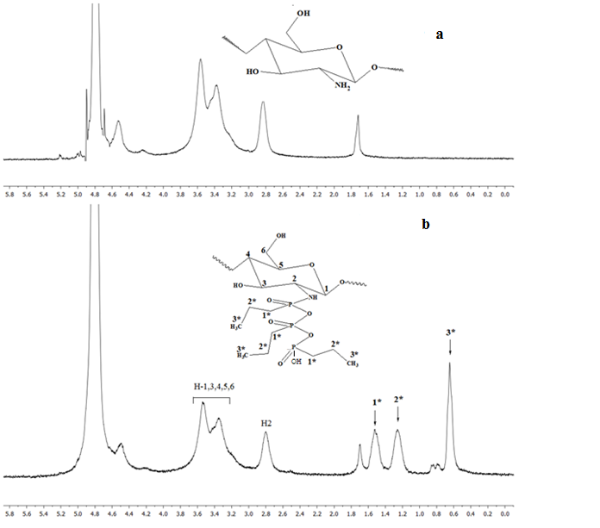
Figure 5.9 ¹H NMR spectra of a) Chitosan and b) NPPCS dissolved in 2% (w/w) CF₃COOD/D₂O with concentration 20g/l
The X-ray diffraction spectrum of chitosan showed characteristic peaks around 10-11° (Figure 5.10). Corresponding to (020) plane (Kumirska et al. 2010) and around 19-21° corresponding to (110) plane. These peaks represent the presence of inter and intra-molecular hydrogen bonds due to free –NH₂ groups of chitosan. For NPPCS derivative of chitosan, the peak in the vicinity of 10-11° seems to be disappearing and peak at 19-21° was strongly suppressed (Figure 5.9) compared to original chitosan spectrum. This is due to, the prepared derivative of chitosan NPPCS (DS=0.87) has lost inter and intra molecular hydrogen bonding greatly and also lost its crystallinity considerably. This is also the reason for solubility of the NPPCS in water.
Figure 5.10 XRD patterns of (a) Chitosan and (b) NPPCS
5.3.2.2 Solubility test
The solubility of chitosan and its NPPCS derivative in various solvents was determined and the results are listed in Table 5.1. The novel derivative of chitosan has shown enhanced solubility especially in aqueous media over a wide range of pH values.
Table 5.1 Solubility of Chitosan and NPPCS
Solvent | Chitosan | NPPCS
H₂O | Insoluble | Soluble
NaOH (1%) | Insoluble | Low viscosity gel
HCl (1%) | Swelling | Soluble
Acetic acid (1%) | Soluble | Soluble
Dimethylformamide | Swelling | High viscosity gel
Dimethylsulfoxide | Insoluble | Insoluble
Acetone | Insoluble | Low viscosity gel
N-Methyl-2-pyrrolidone | Insoluble | Insoluble

5.3.2.3 Evaluation of cytotoxicity
Chitosan is non-toxic in nature (Richardson et al. 1999) and the cytotoxicity of NPPCS was measured and the results are represented in Figure 5.11. The cytotoxicity of prepared NPPCS (DS-0.87) derivative at various concentrations was determined by MTT assay. For the concentration of 100 μg/mL of the polymer, the normal cell lines of fibroblast have showed survival of 86% and even at 1000 μg/mL concentration of the polymer the cell lines have showed survival of 60%. There may be a possible interaction of the anionic phosphonic acid group present on the NPPCS and positively charged cell proteins and components in plasma membrane. The toxicity observed in NPPCS is low over a wide range of concentration in spite of its high degree of substitution (0.87), this may be due to the less toxic nature of the homopolymers namely chitosan and T3P involved in the coupling.
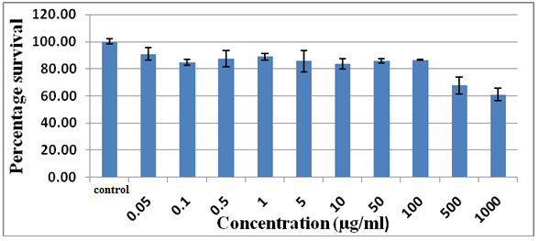
Figure 5.11 Cytotoxicity of NPPCS studied by MTT assay
5.3.3 Characterization of PSf/NPPCS blend membranes
5.3.3.1 ATR-IR spectroscopy
The PSf/NPPCS membrane spectrum showed peaks at 3000-3500 cm⁻¹ (-OH and P-OH stretch), 1156 cm⁻¹ (-P=O stretch), 1030 cm⁻¹ (P-O stretch) thereby confirming the presence of NPPCS in the blend membrane as shown in Figure 5.12. The peaks at 2966 cm⁻¹ (aromatic C-H stretch), 1296 cm⁻¹ (S=O asymmetric stretch), 1241 cm⁻¹ (C-O-C stretch) and at 1155 cm⁻¹ (S=O stretch) confirms the presence of PSf in the blend membrane.
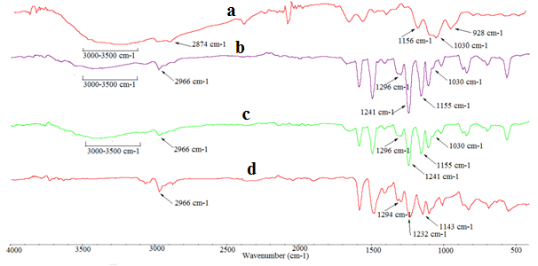
Figure 5.12 ATR-IR spectra of a) NPPCS polymer, b) M-7, c) M-8 and d) M-0
5.3.3.2 Morphology and thermal study of the membranes
From Figure 5.13, it is clear that, all the membranes exhibit dense top surface layer (skin layer), a porous sub layer (support layer) and sponge like bottom layer, confirmed the asymmetric nature in the cross section of the PSf/NPPCS membranes. NPPCS increased the viscosity of PSf/NPPCS casting solution and resulted in rapid demixing between polymer rich solvent phase and non-solvent phase during phase inversion lead to formation of finger like projections below the skin layer. However, higher composition of NPPCS resulted in shorter finger like projections and large voids formation in the sub-layer. Thus, compared to pristine PSf membrane the presence of NPPCS additive in the casting solution increased the porous nature of the membranes (Figure 5.13, d and f).
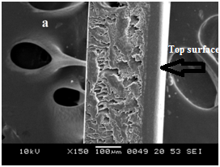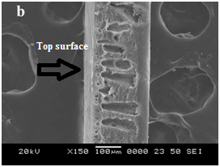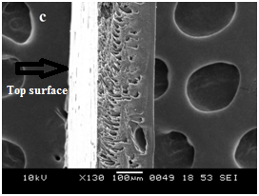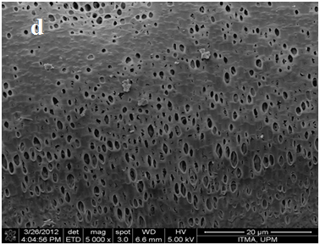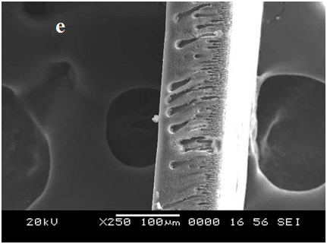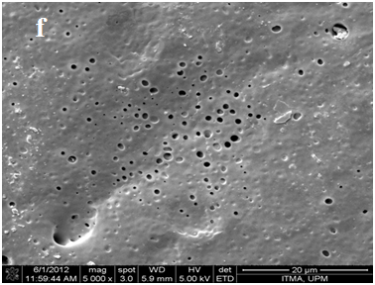
Figure 5.13 SEM and FESEM images: a) and b) Cross sections of M-6 and M-7, c) and d) Cross section and surface of M-8, e) and f) Cross section and surface of M-0.
The DSC study of membranes revealed that for higher compositions of NPPCS in the PSf/NPPCS membrane, the T_{g} values decreased as shown in Table 5.2. The M-8 membrane showed smallest T_{g} of 168.54 º which contains 20% of NPPCS.
Table 5.2 T_{g} values of membranes
Membrane | % Composition (PSf:NPPCS) | T_{g} (ºC)
M-6 | 95.0:5.0 | 175.36
M-7 | 90.0:10.0 | 173.29
M-8 | 80.0:20.0 | 168.54
Water contact angle measurements are commonly used to estimate the hydrophilicity and wetting characteristics of polymer surfaces. In general, the smaller the contact angle, the higher is the hydrophilicity of the membrane. Pristine polysulfone showed contact angle of 73 °, compared to PSf, contact angles of M-6, M-7 and M-8 membranes were 70 °, 66 ° and 58 ° respectively. Thus the addition of higher composition of NPPCS increased the hydrophilicity of PSf/NPPCS membranes due to accumulation of NPPCS molecules into the membrane matrix.
5.3.3.3 Permeation and antifouling properties
Figure 5.14 represents time dependent pure water flux nature of membranes. The initial flux (PWF) decline was observed for all the membranes due to membrane compaction. With the application of pressure, the base membrane is compressed, resulting in partial blocking of pores. However, a steady value of PWF was obtained for all the PSf/NPPCS membranes after 30 minutes of membrane compaction. For any composition of NPPCS, the PSf/NPPCS membranes showed much higher PWF compared to the pristine PSf membrane. PSf/NPPCS membrane with 20% of NPPCS loading showed a steady PWF value of 230 L/m²h and that of pristine PSf membrane remained at 40 L/m²h at the same pressure.
Fouling is the major drawback of membranes which results in flux decline and reduced life time. The initial flux decline of all the membranes during BSA rejection were due to adsorption or deposition of protein molecules on the surface of membranes as shown in Figure 5.15. To possess fouling resistance to proteins or other foulant biomolecules, the membrane should effectively hinder foulant adsorption to its surface or pore walls (Huisman et al. 2000, Beier et al. 2007). Generally speaking, membrane fouling is caused by the following three mechanisms: pore construction within the membrane pores, pore blocking at the membrane surface and cake formation on the membrane surface (Ockel et al. 1999, Katsoufidou et al. 2005). The three major factors which determine the membrane fouling are charge, hydrophilicity and roughness of the surface. The contact angle measurements proved enhanced hydrophilicity of PSf/NPPCS membranes, also the –POOH groups (of NPPCS) present on the membrane surface will strongly bind to the water molecules via hydrogen bonding. This resulted in reduced interaction between BSA protein molecules and membrane surface. BSA molecules are negatively charged at pH=7, also the membrane surface is negatively charged due to the presence of –POOH groups. Once again, this resulted in strong repulsion of BSA molecules from the membrane surface. These results indicated obviously that the introduction of the phosphonic acid groups efficiently reduces total membrane fouling, especially irreversible membrane fouling. The BSA rejection values of M-0, M-6, M-7 and M-8 membranes are 88%, 91%, 92.5% and 94% respectively.
Fouling resistance ratio (FRR) determines the fouling property of the membrane. From Figure 5.16, FRR values of membranes decreased in the order of M-8>M-7>M-6>M-0. These data confirmed the higher reversible nature of PSf/NPPCS membranes which makes their hydraulic cleaning process much easier during membrane operation.

Figure 5.14 Time dependent pure water flux of membranes during membrane compaction at 0.3 MPa trans membrane pressure at 26 °C

Figure 5.15 Flux decline behavior of membranes during BSA ultrafiltration at 0.2 MPa trans membrane pressure at 26 °C

Figure 5.16 FRR values of membranes
5.4 CONCLUSIONS
In summary, a novel water soluble derivative of chitosan NPPCS was synthesized via one-pot reaction between chitosan, T3P and HOBt at 30 ºC. ¹H NMR and ATR-IR spectral data confirmed the structure of NPPCS. The degree of substitution of prepared derivative was 0.87 as confirmed by ¹H NMR. The XRD study of the NPPCS revealed that the derivative has lost its crystallinity by losing intra and inter molecular hydrogen bonding. The derivative was less toxic in nature.
The novel derivative NPPCS was blended with polysulfone in three different compositions and new process was demonstrated for blending. The IR spectroscopy confirmed the proper blending between polysulfone and NPPCS. The contact angle measurements proved enhanced hydrophilicity of polysulfone membrane due to presence of NPPCS. The increased composition of NPPCS in casting solution resulted in a highly porous membrane structure. Highly porous and hydrophilic nature of PSf/NPPCS membranes contributed to the enhanced flux compared to pristine polysulfone membranes. From antifouling studies, the FRR values of M-6, M-7 and M-8 membranes were 61, 64 and 74 respectively. These values are much higher compared to the nascent polysulfone membrane. This study confirmed improved antifouling property of PSf/NPPCS membranes. Overall, PSf/NPPCS membranes showed enhanced hydrophilicity, permeation and antifouling properties as compared to the pristine polysulfone membranes. PSf/NPPCS membranes containing phosphonic acid group may act as an adsorptive membrane for heavy metal rejection applications.
Abstract
In the current chapter PSf/CS, PSf/NSCS and PSf/NPPCS blend membranes were subjected to heavy metal rejection study. The rejection of membranes towards the copper, cadmium and nickel ions was studied during ultrafiltration (UF) and polymer enhanced ultrafiltration (PEUF) processes. The flux change during rejection and the effect of pH on the rejection was also studied. A maximum of 78% of Cu, 73% of Ni and 68% of Cd rejection for M-5 membrane, 75% of Cu, 71% of Ni and 66% of Cd rejection for M-8 membrane and 76% of Cu, 69% of Ni and 66% of Cd rejection for M-2 membrane with good flux was observed. Further improvement in heavy metal ion rejection was achieved by PEUF process. Membrane M-5 showed maximum of 98%, 95% and 92% rejection for Cu, Ni and Cd respectively with steady state flux of 117 L/m²h.
6.1 INTRODUCTION
Heavy metals are the toxic pollutants which would cause severe problems to public health and the environment. The heavy metals are non biodegradable and tend to accumulate in living organisms and many heavy metal ions are known to be toxic or carcinogenic. Effective removal of heavy metal ions from aqueous solution is important for the protection of environment and public health. Chemical precipitation, ion-exchange, adsorption, membrane filtration and electrochemical treatment are the efficient methods for the removal of heavy metal ions. Membrane filtration technologies with different types of membranes show great promise for heavy metal removal for their high efficiency, easy operation and space saving. The membrane processes used to remove metals from the wastewater are UF, RO, NF and electrodialysis.
UF is a membrane technique working at low transmembrane pressures for the removal of dissolved and colloidal material. Jayalakshmi et al. (2012) prepared epoxy functionalized poly(ether sulfone) (EPES) incorporated cellulose acetate (CA) UF membranes for the removal of chromium (Cr) ions. Porosity of the CA/EPES blend membranes increased and mean pore radii decreased compared to those of the pure CA membranes. A maximum of 98.3% removal of Cr was achieved for 80/20 composition of CA/EPES.
Figure 6.1 Epoxidated polyethersulfone
Since the pore sizes of UF membranes are larger than dissolved metal ions in the form of hydrated ions or as low molecular weight complexes, these ions would pass easily through UF membranes. Complexation-ultrafiltration, proves to be a new promising technology for separation of heavy metals from effluents. The use of water-soluble metal-binding polymers in combination with UF is known as polymer enhanced ultrafiltration (PEUF) process and it is a hybrid approach for the removal of heavy metals. The commonly used metal binding polymers are polyacrylic acid (PAA) (Labanda et al. 2009), polyethyleneimine (PEI) (Aroua et al. 2007), humic acid (Kim et al. 2005) and diethylaminoethyl cellulose (Trivunac and Stevanovic 2006).
Vijayalakshmi et al. (2008) used cellulose acetate and polycarbonate blend UF membranes for the separation of copper, nickel, zinc and cadmium from aqueous solutions using PEI as metal complexing agent. The complexation reaction between metal ion and PEI results in macromolecular structure. General complexation mechanism between metal ion and PEI molecules is represented in Figure 6.2.
Figure 6.2 Metal complexation by PEI
Modification of ultrafiltration membrane is the other technique to make it applicable for heavy metal removal. Magnenet et al. (2013) modified polyethersulfone ultrafiltration membranes by alternate deposition of thin polyelectrolyte films of poly(allylamine hydrochloride) and poly(acrylic acid). The good retention of the copper ions by the modified membranes was due to electrostatic interaction between polymer films and copper ions and chelation of copper ions by amino groups contained in the film.
Figure 6.3 Structure of poly(allylamine hydrochloride)
Also metal complexing membranes will show good heavy metal ion adsorption without using any complexing agent. Bessbousse et al. (2012) prepared novel chelating membranes by the semi interpenetrated polymer network technique. The membrane matrix was composed of cross-linked network of poly(vinyl alcohol) and poly(ethyleneimine) as chelating polymer. The membranes showed maximum sorption of 0.729 mmolg⁻¹ for Pb(II), 0.692 mmolg⁻¹ for Cu and 0.525 mmolg⁻¹ for Cd(II).
The adsorptive UF membranes provide the advantages of high retaining efficiency for metal ions, together with the benefits of low energy consumption and high permeate flux. The presence of reactive functional groups on the membrane is much essential for the binding of heavy metal ions. Biopolymer like chitosan has chelation ion exchange property and remove ions of a specific size in the presence of large quantities of other ions. The amine groups are able to sorb metals through several mechanisms including chemical interactions, such as chelation, electrostatic interactions, ion exchange or the formation of ion pairs (Muzzarelli et al. 1982, Inoue et al. 1993). The chitosan based membrane processes are commonly used for the adsorption of metal ions from aqueous medium.
Vieira and Beppu (2005) studied the adsorption and desorption of Hg(II) ions onto natural and cross-linked chitosan membranes. The maximum adsorption was observed on glutaraldehyde cross-linked chitosan, at pH 6.0. Besides having a greater adsorption capacity, it is chemically stable at low values of pH, allowing its use in acidic solution.
Liu et al. (2009) prepared adsorptive membrane using chitosan as the functional polymer and some additive blend solutions by solution casting method. They concluded that copper ion removal from aqueous solution using chitosan membrane is a low cost process. The pH value was the determinant factor for the removal of copper ions and the optimum pH was 5-6. At lower temperature maximum uptake capacity and removal efficiency was observed.
The chitosan or its derivatives which contains carboxylic or phosphonic acid functionality on their backbone are suitable precursors for the preparation of adsorptive membranes for heavy metal rejection (Nishi et al. 1987, Boricha et al. 2010, Naim et al. 2013). Sun and Wang (2006) studied the adsorption properties of N-Succinyl chitosan (NSCS) with Pb(II) ions. The results revealed that the carboxyl groups of the NSCS group and nitrogen atom of amide (II) are participated in the adsorption process. Whereas oxygen atoms in the hydroxyl groups in NSCS were not involved in Pb(II) adsorption. It can be schematically represented as shown in Figure 6.4.
Figure 6.4 Proposed mechanism for NSCS binding to metal ion
In the current chapter, PSf/CS, PSf/NSCS and PSf/NPPCS blend membranes prepared in chapters 3, 4 and 5 respectively are subjected to heavy metal rejection study. The well performed membranes from the three series were subjected to polymer enhanced ultrafiltration (PEUF) process using poly(ethyleneimine) as metal complexing agent.
6.2 EXPERIMENTAL
6.2.1 Preparation of PSf/CS, PSf/NSCS and PSf/NPPCS membrane
The PSf/CS, PSf/NSCS and PSf/NPPCS membranes were prepared using the procedure described in Chapters 3, 4 and 5. The compositions of the membranes prepared are given in Table 6.1.
Table 6.1 Membrane codes and compositions
Membrane code | Polymers | Composition (%)
M-1 | PSf:CS | 97.5:2.5
M-2 | PSf:CS | 95.0:5.0
M-3 | PSf:NSCS | 95.0:5.0
M-4 | PSf:NSCS | 90.0:10.0
M-5 | PSf:NSCS | 80.0:20.0
M-6 | PSf:NPPCS | 95.0:5.0
M-7 | PSf:NPPCS | 90.0:10.0
M-8 | PSf:NPPCS | 80.0:20.0
M-0 | PSf | 100

6.2.2 Preparation of metal ion solutions
Copper (II) sulphate, Cadmium (II) sulphate and Nickel (II) sulphate were purchased from Sigma Aldrich Co. Bangalore, India. The required solutions for heavy metal ion rejection experiments were prepared according to the procedure given in section 1.7.11 of Chapter 1.
6.3 RESULTS AND DISCUSSION
6.3.1 Rejection properties of membranes during UF process
6.3.1.1 Cd, Ni and Cu rejection during UF process at pH 6±0.25
Figure 6.5 represents the rejection showed by PSf/CS, PSf/NSCS and PSf/NPPCS membranes during the filtration of Cd, Ni and Cu ion solutions at pressure of 0.3 MPa, and at 1000 ppm metal ion concentration. The first 10 mL of the permeate sample was discarded and subsequent volumes (another 10 mL) of sample was collected for the analysis. From Figure 6.5 it is clear that, higher loading of CS, NSCS or NPPCS into the PSf blend resulted in increased retention of heavy metals. For PSf/NSCS and PSf/NPPCS membranes, these results prove that, NPPCS and NSCS polymers are well immobilized in the PSf matrix in spite of its water solubility. Although the PSf matrix is not chemically cross-linked CS, NSCS or NPPCS, the interactions in the matrix are strong enough to maintain the matrix in a physically cross-linked state that practically immobilizes NSCS or NPPCS chains. Such immobilization resulted in highly porous membrane structure with reduced pore size and which is the reason for increased rejection due to sieving effect (steric effect). Due to sieving effect charged solutes smaller than the membrane pore size will be rejected along with the bigger neutral solutes and salts. The quantity of immobilized CS, NSCS or NPPCS in the membrane increased with the increase of its content in the casting dope. Also increased content of CS, NSCS and NPPCS reduces the pore size of the resultant membrane formed due to increased viscosity. This inturn increased the heavy metal ion rejection property of membranes by sieving mechanism.
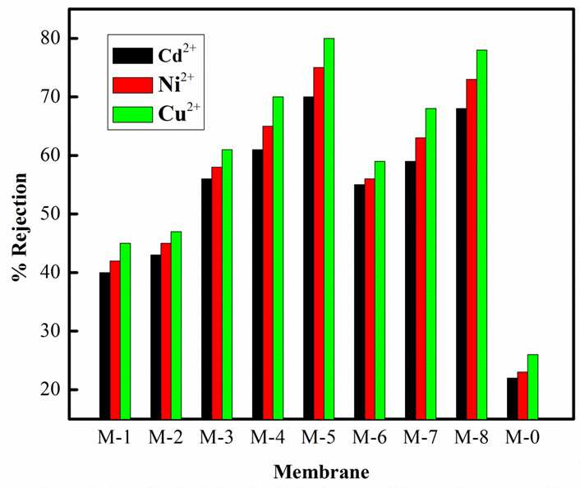
Figure 6.5 Rejection properties of membranes during UF process
The maximum rejection values of M-2, M-3 and M-6 membranes for Cd²⁺ are 43%, 56% and 55% respectively at 0.3 MPa and 1000 ppm concentration. Although these three membranes contains 5% each of CS, NSCS and NPPCS respectively, the comparatively smaller rejection for PSf/CS membrane compared to PSf/NSCS and PSf/NPPCS membranes can be explained as follows: NSCS and NPPCS derivatives of chitosan contains carboxylic (-COOH) and phosphonic acid (-POOH) terminal groups. These carboxylate and phosphonate groups have higher tendency to chelate metal ions compared to –NH₂ group of chitosan (Sun and Wang 2006). Thus, when aqueous heavy metal ion solution comes in contact with such membranes, the maximum metal chelation effect was observed on or within PSf/NSCS and PSf/NPPCS membrane matrix compared to PSf/CS membrane. Such a mechanism may be a fixation of metal ions on the membrane by interactions with the chelating groups.
6.3.1.2 SEM study of membrane surface
The fixation of heavy metal ion on to the skin of the PSf/CS, PSf/NSCS and PSf/NPPCS membranes was determined by SEM-EDX analysis. SEM-EDX topographic images of the top surface of M-2 and M-5 membranes after ultrafiltration of a CdSO₄ solution were taken after washing for 2 h (with distilled water). According to Casuccio et al. 2004, elements with higher atomic number generate more backscattered electrons, thus appear in SEM-EDX images brighter than those of low atomic number. The bright zones on the surface of the washed membrane correspond to the complexed cadmium -ions, that a thorough washing was not able to remove it from the surface (Mbareck et al. 2009). Figure 6.6 represents the SEM-EDX data obtained for M-2 and M-5 membranes, it clearly indicated the fixation of cadmium ions on the membrane surface via complexation with –NH₂, -COOH and –POOH groups.
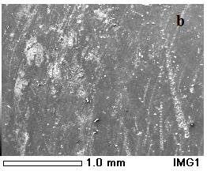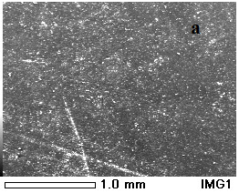
Figure 6.6 SEM-EDX topographic images of top surfaces of a) M-2 and b) M-5
The elemental mapping also confirmed the fixation of heavy metal ions on to the surface of membranes. Figure 6.7 represents the uniform fixation of cadmium ions onto the surface of M-2 and M-8 membranes.
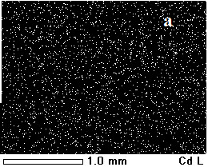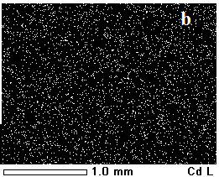
Figure 6.7 SEM images of elemental mapping of cadmium on membrane surfaces a) M-2 and b) M-8
Also, the less rejection of PSf/CS membrane is due to the Donnan effect. PSf/NSCS and PSf/NPPCS membrane surfaces are partly negatively charged due to the presence of carboxylic and phosphonic acid groups. According to Donnan effect, coions are excluded and cations are also rejected to ensure electrical neutrality near the membrane surface (Peeters et al. 1998). During filtration process, the positively charged heavymetal ions are attracted towars the negatively charged membrane surface whereas the negative ions are more repelled back into the feed solution. However, in order to maintain the electrical neutrality near the membrane surface equal number of heavy metal ions (positively charged) is also repelled into the solution. Thus both sieving and Donnan effects resulted in enhanced heavy metal rejection during ultrafiltraion process of chitosan based membranes.
6.3.1.3 pH dependent rejection study
The influence of the pH of feed solution on membrane performance was determined at pH 3.5 and pH 5.5 at 0.3 MPa. At these two pH values, the –NH₂ group of chitosan will show different protonation effects, also the acid groups of NSCS and NPPCS obey distinct ionization states. Table 6.2 represents the Cd, Cu and Ni retention showed by membranes at two pH values. At low pH, the membranes containing chitosan showed higher retention, whereas NPPCS and NSCS showed less retention at low pH. This is due to, at low pH the acid groups (-COOH or -POOH) of NSCS and NPPCS are involved in hydrogen bonding which reduces their ion-ion interactions with metal ions, whereas at low pH –NH₂ group of chitosan protonates and favors complexataion.
At high pH 5.5, high metal rejection was observed for PSf/NSCS and PSf/NPPCS membranes. Since, at this pH complexation between metal ion and acid groups is much favored. This leads to the electrostatic repulsion between the complexed and non-complexed metal ions on the inner surface of pores and membrane matrix (Mbareck et al. 2009). However, rejection was slightly decreased for PSf/CS membranes at higher pH, since the extent of complexation between chitosan and metal ions was less at this pH.

Table 6.2 Metal ion rejection of membranes at pH 3.5 and pH 5.5
Membrane | % Rejection at
 | pH 3.5 |  |  | pH 5.5
 | Cd²⁺ | Ni²⁺ | Cu²⁺ | Cd²⁺ | Ni²⁺ | Cu²⁺
M-1 | 56 | 58 | 61 | 42 | 43 | 46
M-2 | 66 | 69 | 76 | 44 | 47 | 49
M-3 | 36 | 39 | 41 | 54 | 57 | 59
M-4 | 44 | 46 | 48 | 60 | 63 | 69
M-5 | 48 | 52 | 56 | 68 | 73 | 78
M-6 | 32 | 35 | 38 | 52 | 54 | 58
M-7 | 41 | 43 | 46 | 58 | 61 | 67
M-8 | 45 | 46 | 51 | 66 | 71 | 75
M-0 | 22 | 23 | 25 | 21 | 24 | 25

6.3.1.4 Flux of membranes during CuSO₄ rejection
The flux of the well performed membranes, i.e. M-2, M-5 and M-8 during 1000 ppm CuSO₄ rejection was determined at pH 3.5 and 5.5. Figure 6.8 represents the flux behavior of membranes during 120 min of filtration. A sharp decline in flux was observed for all the three membranes during initial 30 min of filtration and a steady state flux was attained after ≈ 60 min. The initial flux decline again confirmed the complexation between the metal ions and chelating groups (-NH₂, -COOH and -POOH) accumulated in the pores or on the surface of membrane matrix. However, equilibrium in complexation reaction reached after 60 minutes for all the membranes and is the reason for attaining the steady state flux at that time.

Figure 6.8 Flux of membranes during CuSO₄ rejection
The steady state flux of M-2, M-5 and M-8 membranes are 145 L/m²h, 131 L/m²h and 137 L/m²h respectively at pH 3.5 for 1000 ppm CuSO₄ solutions. Whereas at high pH5.5, the steady state flux of M-2, M-5 and M-8 membranes are 126 L/m²h, 110 L/m²h and 114 L/m²h respectively for 1000 ppm CuSO₄ solutions. At low pH, higher flux of PSf/CS (M-2) membrane was due to the protonation of –NH₂ group of chitosan in the membrane ensuring chain relaxation and leading to efficient solvent diffusion (Padaki et al. 2011). However, for M-2 membrane, the effect due to complexation at low pH has less effect on flux. For M-5 and M-8 membranes at lower pH acid groups are involved in hydrogen bonding, leading to the expansion of pore diameter. As a consequence, the permeation flux was higher at lower pH.
6.3.2 Rejection properties of membranes during PEUF process
6.3.2.1 Cd, Ni and Cu rejection during PEUF process
M-2, M-5, M-8 and M-0 membranes were subjected to polymer enhanced ultrafiltration (PEUF) process using 1000 ppm solutions of Cu, Cd and Ni at 0.3 MPa. The rejection experiment was carried out at pH 3.5 and pH 5.5, Figure 6.9 represents data obtained during metal ion filtration experiments at pH 5.5, and membrane M-5 showed maximum of 98%, 95% and 92% rejection for Cu, Ni and Cd respectively. At low pH also, membrane M-5 showed maximum rejection for three metal ions. Its rejection values were 95%, 93% and 89% for Cu, Ni and Cd ions respectively.
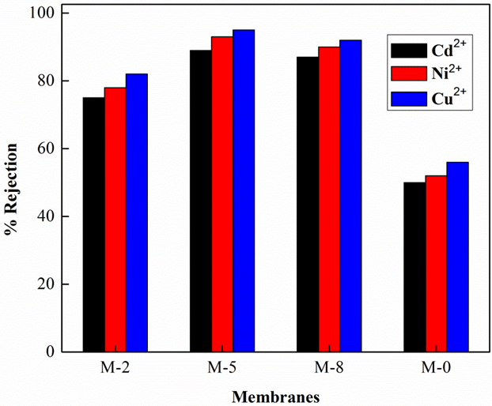
Figure 6.9 Rejection of membranes during PEUF process
These data confirmed that the metal ion rejection of membranes at pH 3.5 and pH 5.5 are almost comparable. This was due to the stability of metal ion and PEI complex (M---PEI) over the pH range of 3.5 to 5.5 (Chen et al. 2011, Camarillo et al. 2012). Thus, pH has less effect on metal ion rejection performance of membranes during PEUF process, whereas it played major role during UF process of membranes. However, the heavy metal ion rejection properties of PSf/CS (M-2), PSf/NSCS (M-5) and PSf/NPPCS (M-8) membranes increased by PEUF process.
6.3.2.1 Flux of membranes during PEUF process
Figure 6.10 represents the flux of the M-2, M-5 and M-8 membranes during the filtration of 1000 ppm solution of CuSO₄. A sharp decline in the flux for all the membranes was observed during PEUF process. This flux was ≈ 2.5 times lesser than the corresponding pure water fluxes of the membranes. The initial flux declination was due to the concentration polarization and the second stage gradual decrease was due to gel formation over the membrane surface (Jonsson and Tragardh 1990). The membranes M-2, M-5 and M-8 showed steady state flux of 92 L/m²h, 117 L/m²h and 118 L/m²h after 20-30 min of filtration. However, the flux during the CuSO₄ filtration was less compared to flux during NiSO₄ and CdSO₄ filtration. The lower flux of Cu²⁺ is due to larger size of Cu-PEI compared to Ni and Cd (Vijayalakshmi et al. 2008). The size of metal chelates are in the order of Cu-PEI> Ni-PEI>Cd-PEI.
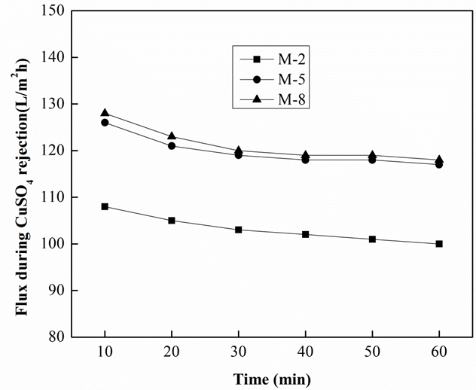
Figure 6.10 Flux of membranes during CuSO₄ rejection (PEUF)
The flux decline during UF process is due to complexation of metal ions with chelating sites (present on the membrane surface or within the pore walls). However, flux decline during PEUF process is due to larger size of M-PEI complexes compared to free metal ion. This is the reason for attaining of almost same steady state flux during PEUF and UF processes. The steady state flux of membranes M-2, M-5 and M-8 are 92 L/m²h, 117 L/m²h and 118 L/m²h during PEUF process (at pH 6.25) and 126 L/m²h, 110 L/m²h and 114 L/m²h respectively for 1000 ppm CuSO₄ solutions at pH 5.5.
It was seen that the membrane surfaces became very smooth after the removal experiments. This was due to the deposition of gel layer of chelate complex (between metal ion and PEI) over the membrane surface. The membrane recycling property was studied by washing the membranes thoroughly with distilled water for 20 minutes at 300 rpm. Then the distilled water was passed through the membrane for about 30 minute and the membrane compaction was done at 0.3 MPa. The pure water flux (PWF) of the membranes determined further and it was found that the reduction in flux was in the range of 2-4 % from their original PWF. Such recycling property of the membranes is attributed to the CS, NSCS and NPPCS trapped within the membrane matrix resulted in hydrophilic membrane surface.
6.4 CONCLUSIONS
The heavy metal removal efficiency of polysulfone ultrafiltration membrane can be improved by blending it with chitosan or its derivatives. PSf/CS, PSf/NSCS and PSf/NPPCS membranes consisting of chitosan or its acid derivatives will serve as adsorptive membranes. The heavy metal rejection properties of these membranes are distinct due to complexation reaction between metal ions and chelating groups of CS, NSCS or NPPCS on membrane surface or its pore structures. The incorporation of higher content of chitosan or its derivatives resulted in increased metal ion rejection. The metal ion rejection by ultrafiltration process resulted in a maximum of 78% of Cu, 73% of Ni and 68% of Cd rejection for M-5 membrane, 75% of Cu, 71% of Ni and 66% of Cd rejection for M-8 membrane and 76% of Cu, 69% of Ni and 66% of Cd rejection for M-2 membrane with good flux.
The polymer enhanced ultrafiltration process for heavy metal rejection using PSf/CS, PSf/NSCS and PSf/NPPCS membranes resulted in further improvement in rejection results. Membrane M-5 showed maximum of 98%, 95% and 92% rejection for Cu, Ni and Cd respectively with steady state flux of 117 L/m²h. The enhanced permeation and antifouling property of PSf/CS, PSf/NSCS and PSf/NPPCS membranes resulted in achieving high flux during rejection and good recycling property. Therefore, the use of PEUF using chitosan based ultrafiltration membrane may play a superior role over RO and NF process where they need high pressure.

Abstract
This chapter deals with modification of polysulfone (PSf)/Poly (isobutylene-alt-maleic anhydride) (PIAM) nanofiltration membranes by changing the coagulation bath with various concentrations of glutaraldehyde cross-linked chitosan solutions. Further the membranes were treated with 0.1N NaOH solution in order to achieve the hydrolysis of PIAM. The resulting nanofiltration membranes were characterized by ATR-IR and SEM to study the morphological changes. The performance of the membranes was studied by subjecting them to permeation, antifouling and electrolyte rejection studies. All the modified membranes showed higher electrolyte rejection than a PSf / PIAM membrane. Membranes M-13 and M-10 showed maximum rejection of 78% and 44% respectively for Na₂SO₄ at a minimum pressure of 0.2 MPa. M-13 membrane showed maximum of 44% NaCl rejection compared to other membranes.
7.1 INTRODUCTION
The need of pure water across the globe for potable and industrial uses has accelerated the development of membrane technology for more than two and half decades. NF membranes which show separation characteristics in the intermediate range between RO and UF are playing major role in the water purification (Bruggen et al. 2001, Nguyen et al. 2003, Saitfia et al. 2005).
Polysulfone (PSf) is an excellent UF membrane material, which can be converted into nanofiltration membrane by blending with suitable polymers. Usually such blending polymers are hydrophilic in nature and impart hydrophilicity to the membrane. Their presence in the casting solution brings about the morphological changes in the membrane resulting in altered membrane performance (Arthanareeswaran et al. 2009). Bowen et al. (2001) prepared polysulfone and sulfonated poly (ether ether ketone) blend ultra to nanofiltration membranes by varying the sulfonated polyether ether ketone (SPEEK) (Figure 7.1) content from 0.5 to 5 wt %. All the PSf/SPEEK membranes had substantially higher water flux, salt rejection, porosity and greatly reduced particle adhesion. Rejection of NaCl increased substantially and systematically as the SPEEK content was increased.
Figure 7.1 Structure of SPEEK
Ganesh et al. (2012) prepared polysulfone and modified poly isobutylene-alt-maleic anhydride (PIAM) blend NF membrane for salt rejection applications. PIAM was modified by inserting p-amino benzoic acid group (Figure 7.2). The membranes showed enhanced hydrophilicity and membrane with 70:30 (PSf:modified PIAM) composition has shown good salt rejection of 96% at 0.2 MPa for 3500 ppm of NaCl.
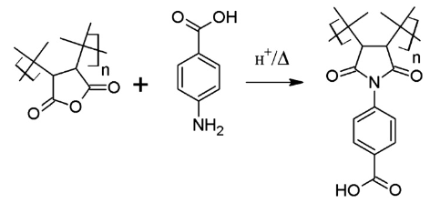
Figure 7.2 Modification of PIAM
Padaki et al. (2012) prepared poly sulphonyl amino benzamide (PSAB)/PSf and methylated poly sulphonyl amino benzamide (mPSAB) (Figure 7.3)/PSf blend NF membranes for salt rejection applications. Water uptake of the membranes was more in acidic and basic pH as compared to distilled water due to instability of amide and sulfonamide bond leads to more porosity or increase in the pore size. The salt rejection decreased in acidic and basic pH and there is a decrease in the rejection rate with dilution of feed samples.
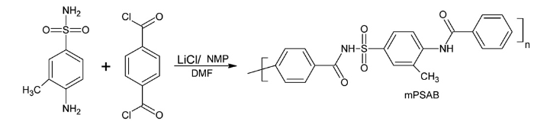
Figure 7.3 Preparation of mPSAB
At the same time, coagulation medium plays an important role in the membrane morphology and porosity formation of the membrane by the phase inversion process. In general, the fast coagulation rate results in a formation of large finger-like macrovoids and cavities like structures, whereas the slow coagulation rate results in a porous sponge-like structure (Kesting 1991). Any changes in coagulation medium other than water will greatly affect the resultant membrane morphology and porosity. Yao et al. (1998) studied the effect of protic solvent (ammonia solution) on polyamide membrane formation during the phase inversion process. They observed, by increasing ammonia in coagulation bath the membrane structure changed from sponge-structured microfilters to finger structured ultrafilters.
Kuo et al. 2008 prepared poly(methyl methacrylate) (PMMA) membranes using n-propanol in coagulation bath. The PMMA polymer concentration in the top layer of nascent membrane decreased when the casting film was immersed into n-propanol bath. The weak non-solvent (n-propanol) was beneficial to lower the polymer concentration at the interface of casting film and non-solvent. The bicontinuous structure could be formed in the n-propanol bath resulted from the composition of dilute PMMA polymer (Figure 7.4) solution in the top layer was entered into the unstable region. It was also found that as increasing the immersed time in n-propanol bath, the bicontinuous structure would be broken up to nodules structure due to capillarity effect or led to a matrix/disperse domain morphology by coalescence effect.
Figure 7.4 Structure of PMMA
Deshmukh and Li (1998) studied the effect of coagulation medium consisting of ethanol and water on the morphology of the polyvinylidene difluoride hollow fiber membrane. As the ethanol concentration in water bath was increased from 0% to 50%, the long finger-like structure near the outer wall of the fiber slowly changed through a short finger-like structure to a sponge-like structure. However, the long finger-like structures near the inner wall are retained. The gas permeation study reveals that the effective porosity of the resulting membranes decreases as ethanol concentration in the coagulation bath is increased.
The exposure of casting solution to humidity conditions also has got great influence on resultant membrane morphology and permeation rate. Gao et al. (2009) prepared charged asymmetrical membrane from brominated polyphenylene oxide (BPPO) via in situ amination with triethanolamine and dry-wet phase inversion. The casting solution was exposed to humid surroundings before immersing into the coagulation bath. The symmetric membrane was obtained while the exposure time to the humid surroundings was more than 12 h. The increase of the relative humidity could make pure water flux increase. This was because of the slower NMP evaporation as well as the slower and longer phase separation when the relative humidity became higher.
The coagulation bath temperature will also play major role in deciding resultant membrane structure. Amirilargani et al. (2010) studied the effects of coagulation bath temperature (CBT) on morphology and performance of asymmetric polyethersulfone (PES) membranes. They concluded that, increasing CBT results in macrovoid formation in the membrane structure and increases the membrane permeability and decreases the protein rejection.
Mohammadi and Saljoughi (2009) prepared cellulose acetate and polyethylene glycol blend membranes at different distilled water bath temperatures. Increasing PEG concentration and distilled water bath temperature resulted in more thermodynamic instability and rather mutual diffusivities between components in the coagulation bath during solidification of the casting solution. Such process resulted in increased thickness of the prepared membranes and their porosities.
Chitosan, a biomaterial which is the second highest naturally occurring polymer after cellulose acetate. It is biodegradable, hydrophilic and shows excellent film forming nature. Due to the insolubility of chitosan in common organic solvents, incorporation of chitosan into pore structure or membrane matrix is the difficult task. Solution casting over the mechanically strong porous support is the well known method for the preparation of chitosan based composite membranes. Such membranes can be applied for salt rejection applications.
Padaki et al. (2011) prepared chitosan composite membrane on the polypropylene support. The membrane showed maximum of 40 % of NaCl rejection at pH 5 with the flux of 43 L/m²h. However in pH 11, it showed 12% of rejection with the flux of 5 L/m²h. This is due to the fact that at acidic pH the presence of positive charge on the membrane surface facilitates for the exchange of cations.
Chitosan solutions can be used for the modification of membranes in order to enhance the antifouling property. Boributh et al. (2009) used chitosan solution for the modification of PVDF membrane via immersion method, flow through method and combined immersion and flow through method in order to achieve better antifouling property. However, with the increase in chitosan concentration the permeate flux was reduced due to higher deposition of chitosan in the pores.
Based on these properties of chitosan, in our current work polysulfone/poly (isobutylene-alt-maleic anhydride) NF membranes (earlier reported work, Padaki et al. 2011) were modified using different concentrations of chitosan in coagulation bath. During the phase inversion process solvent and nonsolvent (chitosan) exchange takes place. Chitosan is hydrophilic and good antifouling agent, the main aim of replacing chitosan in coagulation bath is insertion of chitosan into the pore walls or membrane matrix. The well performed composition of PSf and PIAM, i.e. 70:30 % were selected for membrane preparation. The inserted chitosan into the membrane matrix was confirmed by ATR-IR spectroscopy. Before cross-linking, the membrane was treated with an alkali solution to convert anhydride groups of PIAM into dicarboxylic functionality. The difference in morphology and hydrophilicity of the membranes due to different concentrations of chitosan in the coagulation bath was determined by SEM and contact angle analyzer. The performance of the modified membranes was measured in terms of flux and electrolyte rejection. The antifouling property of the membranes was determined using BSA rejection studies.
7.2 EXPERIMENTAL
7.2.1 Preparation of PSf/PIAM/CS membrane
Udel polysulfone (PSf) with molecular weight 35,000 Da, medium molecular weight chitosan (degree of deacetylation 75-85%) and Poly (isobutylene-alt-maleic anhydride) (PIAM) (M_{w}= 3000Da) were purchased from Sigma Aldrich, (India). Glutaraldehyde (GA) (25% aqueous solution) and NMP were purchased from Merck India, Ltd. Chitosan solution was prepared by dissolving it in 1 wt.% aqueous acetic acid solution at 28-30 °C. The resultant solution was filtered through G3 sand filter and then mixed with 0.12 wt% aqueous glutaraldehyde (GA) solution in the ratio 50/50 (v/v) and stirred for 1 min. This resulted in cross-linking reaction between the amino group of chitosan and aldehyde group of GA by Schiff reaction (Tsai et al. 2006). The resultant cross-linked chitosan solution was diluted by 1% acetic acid solution to get 0.2 wt.%, 0.4 wt%, 0.6 wt% and 0.8 wt.% chitosan solutions. These solutions were stored at 20 °C and used as nonsolvent during coagulation process. 2.8 g of polysulfone and 1.2 g of poly (isobutylene-alt-maleic anhydride) were taken in 16 mL of NMP and stirred at 60 °C for 16 h. So obtained homogeneous solution was cast over a glass plate using Doctor’s blade at room temperature and dipped in a coagulation bath containing chitosan solution (with one particular concentration) at 20 °C for 24 h, to ensure the complete phase inversion. The membranes were washed with distilled water several times and dipped in 0.1% NaOH solution for 20 h to hydrolyze anhydride group of PIAM. Alkali treated membranes were washed several times with distilled water and dried before further characterizations (Padaki et al. 2011). The codes of the membranes prepared from different concentrations of chitosan solution and their viscosity are given in Table 7.1.
Table 7.1 Properties of coagulation medium
Membrane code | Chitosan concentration in coagulation bath (wt %) | Viscosity of coagulation medium (mPaS)
M-9 | 0 | 1.0 (water)
M-10 | 0.2 | 2.57
M-11 | 0.4 | 3.12
M-12 | 0.6 | 9.28
M-13 | 0.8 | 12.5
7.3 RESULTS AND DISCUSSION

7.3.1 FTIR analysis
ATR-IR spectra of polysulfone, chitosan, PIAM, PSf/PIAM/CS membrane (without alkali treatment) and PSf/PIAM/CS membrane (with alkali treatment) were recorded to confirm: proper blending of PIAM with PSf, incorporation of chitosan into the membrane matrix and hydrolysis of PIAM after alkali treatment. PSf/PIAM/CS membrane (after hydrolysis) (Figure 7.5, ‘e’) showed characteristic peaks corresponding to polysulfone at 1297 cm⁻¹ (S=O asymmetric stretch), 1237 cm⁻¹ (C-O-O stretch), 1152 cm⁻¹ (O=S=O stretch), characteristic peaks corresponding to chitosan at 3200-3400 cm⁻¹ (-OH stretch), 1632 cm⁻¹ (acetylated amine groups), 2931 cm⁻¹ (aliphatic C-H stretch). IR spectrum of pure PIAM (Figure 7.5, ‘c’) showed strong doublet at 1777 cm⁻¹ and 1716 cm⁻¹ (characteristic of anhydride), whereas in PSf/PIAM/CS membrane these peaks disappeared after alkali treatment and new peak at 1714 cm⁻¹ attributed to –C=O stretching of carboxylic acid groups formed after hydrolysis of anhydride.
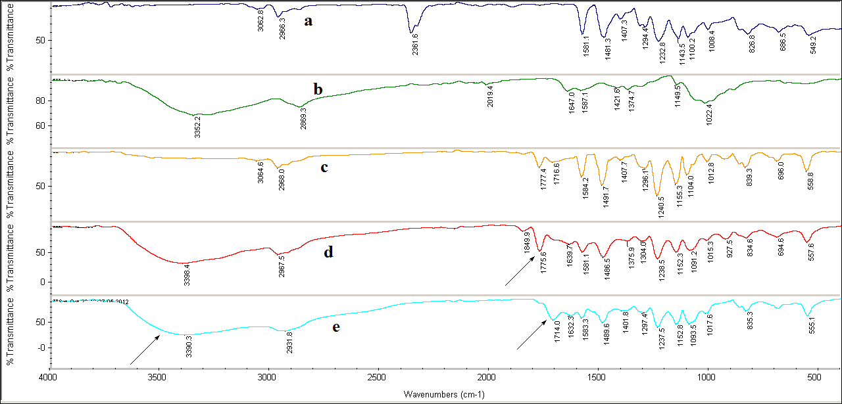
Figure 7.5 Stacked ATR-IR images of : a) PSf b) chitosan c) PIAM d) PSf/PIAM/CS membrane (before alkali treatment) e) PSf/PIAM/CS membrane (after alkali treatment).
7.3.2 Morphology of the membrane
In the phase inversion process induced by a nonsolvent, a homogeneous polymeric solution is initially demixed into two liquid phases because of the exchange of the solvent and nonsolvent. The polymer rich phase forms the solid membrane; the phase with a lower polymer concentration forms the pores of the membrane. The combination of the thermodynamic miscibility of the polymer dope in the coagulation bath and kinetic effect of the dope viscosity controls the ultimate membrane structure (Fontananova et al. 2006). The viscosity of both dope solution and coagulation bath played major role in the formation of final membrane structure. Obviously, the presence of acetic acid in coagulating media is effective to induce pore formation in a skin layer (Chuang et al. 2000). In current membrane preparation, the viscosity of the coagulation bath was increased by increasing the concentration of chitosan (Table 7.1). Figure 7.6, ‘a’ represents the cross section image of PSf/PIAM (M-9) membrane prepared from water coagulation bath. It showed larger finger-like projections extended from the active skin layer. In general, the large fingers like projections lead to formation of large pore sizes on the outer skin layer (Mansourizadeh et al. 2012). Thus, M-11 and M-12 membranes top surface possess larger pores and larger finger like projections in the bottom layer (Figure 7.6, a and b). This is attributed to the instantaneous demixing of the solvent (NMP) and less viscous nonsolvent (chitosan solution). For membranes M-12 and M-13, due to the considerably higher viscosity of chitosan in coagulation bath, the cross-sectional morphology changed from finger like projection to sponge like structure (Figure 7.6, d and e). This is due to delayed demixing between solvent and non-solvent also resulted in smaller pores on the top surface.
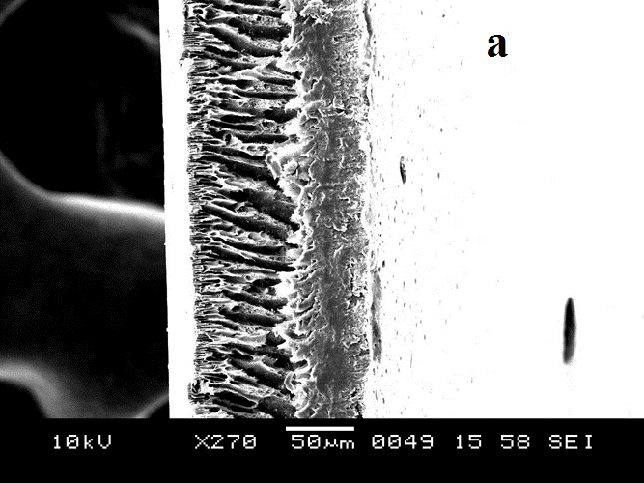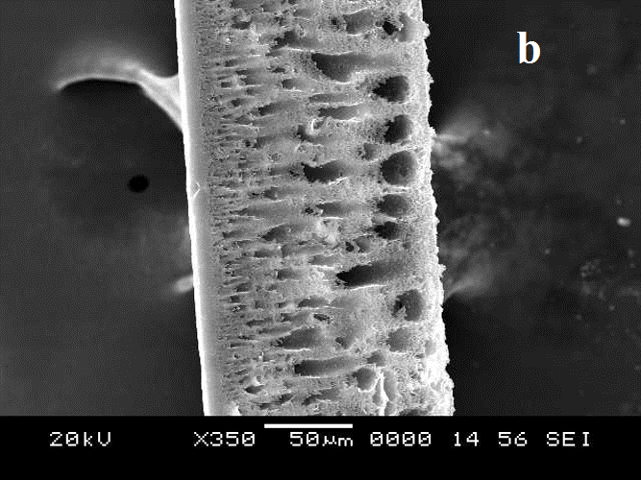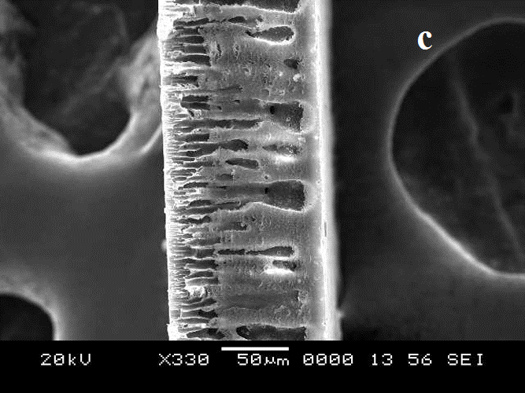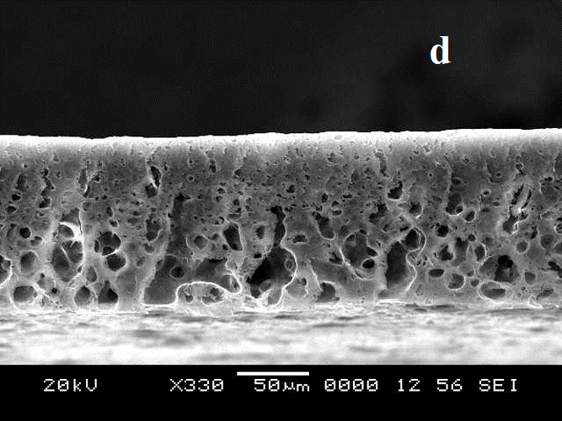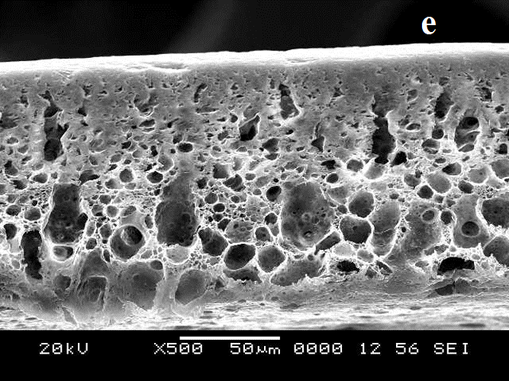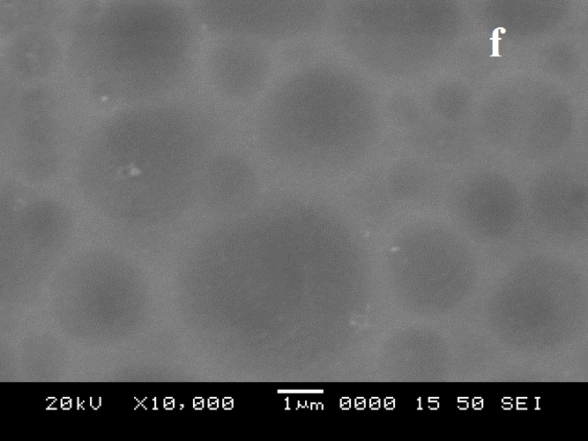
Figure 7.6 SEM images of membranes: a), b), c), d) and e) cross-sections of M-9, M-10, M-11, M-12 and M-13 respectively, f) surface of M-13.
7.3.3 Contact angle measurement
The contact angle is the measure of surface hydrophilicity of the membrane. In general, the smaller value of contact angle indicates higher hydrophilicity of the membrane. M-9 membrane showed contact angle of 51 °, whereas contact angles of M-10, M-11, M-12 and M-13 membranes decreased in the order 49 °, 47 °, 44 °, 41 ° respectively. Thus, membranes prepared with higher concentration of chitosan in the coagulation bath showed smaller contact angle values. Thus increased concentration of chitosan in the coagulation bath resulted in higher accumulation of chitosan in the membrane which in turn resulted in improved hydrophilicity of the membranes.
Table 7.2 Properties of different membranes
Membrane | Contact angle (°) | Flux (L/m²h) at 0.6 MPa TMP | % NaCl rejection | % Na₂SO₄ rejection | % MgSO₄ rejection | FRR (%)
M-9 | 51 | 28 | 8 | 46 | 38 | 52
M-10 | 49 | 49 | 18 | 54 | 44 | 58
M-11 | 47 | 56 | 20 | 58 | 50 | 60
M-12 | 44 | 45 | 35 | 68 | 60 | 68
M-13 | 41 | 36 | 44 | 78 | 65 | 74

7.3.4 Permeation and antifouling property
Hydrophilicity and pore size are the factors which determine the flux of the membrane. Figure 7.7 represents the pure water flux of membranes measured at 0.6 MPa TMP and it revealed that the flux of membranes is very much affected by the concentration of chitosan in the coagulation bath during the phase inversion process. All the membranes exhibited much higher flux when compared to M-9 membrane. The flux of membranes decreased in the order of M-11˂M-10˂M-12˂M-13˂M-9. When chitosan content in the coagulation bath till 0.4 wt % the increased flux of the membranes are due to increased porosity or pore size of the membranes. Further increase in chitosan concentration resulted in decreased porosity or pore size of M-12 and M-13 membranes. Thus, for membrane prepared from 0.4 wt% of chitosan (M-11) in the coagulation bath the maximum flux of 56 L/m²h was observed due to higher porosity of the membrane. Also, the decreased flux of M-12 and M-13 membranes compared to M-11 is due to the increased viscosity of chitosan solution in the coagulation bath which resulted in smaller pores. As pore size is concerned, increasing chitosan concentration in coagulation bath has a similar effect like increasing additive concentration in the casting solution (Rahimpour et al. 2012). This resulted in reduction in flux of M-12 and M-13 membranes. However increased hydrophilicity has less effect on the flux of the membranes when compared to reduced pore size.
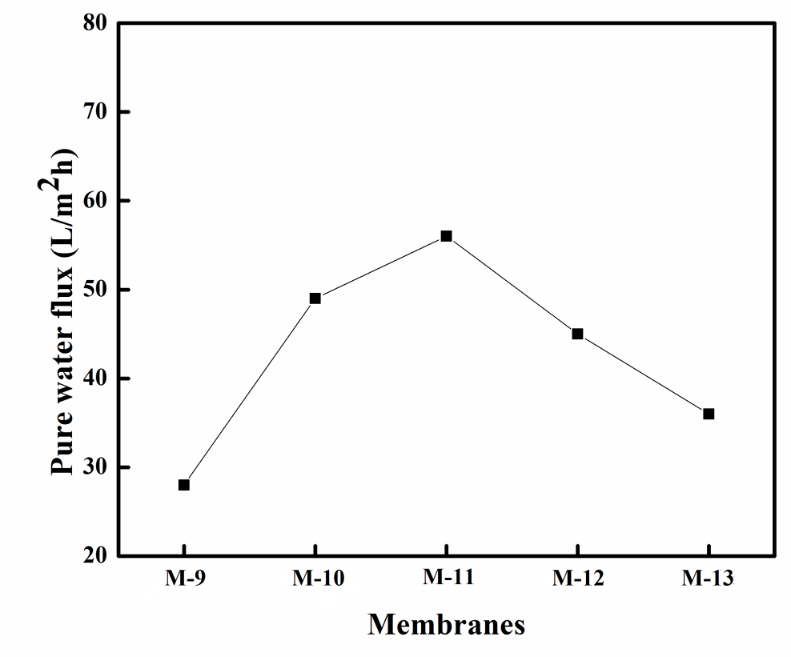
Figure 7.7 Pure water flux of membranes at 0.6 MPa TMP
Fouling is the major drawback of NF membranes which result in drastic reduction in membrane performance. The adsorbed particulates (foulants) change the membrane surface characteristics which result in severe flux decline and affect the rejection pattern of the targets (Agenson et al. 2007). BSA was purchased from the central drug house, Delhi, India. Current prepared membranes are subjected to antifouling study using BSA as standard protein. Figures 7.8 and 7.9 represents the pure water flux and flux during BSA filtration of the membranes respectively at 0.6 MPa TMP and 26 ºC. The initial flux decline in all the membranes is due to mechanical deformation of polymeric membrane matrix (Reinsch et al. 2000). When the feed tank was replaced by BSA solution, drastic reduction in the flux was observed due to the BSA blocking of pores and adsorption on the membrane surface. In general, hydrophilic membrane surfaces are less viable for fouling due to less affinity shown by them towards protein binding. The presence of dicarboxylic functionality and chitosan in the membrane structure has made all the modified membranes relatively more hydrophilic when compared to M-9. The presence of negative charge (due to -COOH group) on the membrane surface is another reason for enhanced antifouling property of the membranes. The BSA protein molecules are negatively charged at pH =7, and the repulsive forces between carboxylate anions and BSA molecules near the surface of membranes resulted in less adsorption or deposition of protein molecules on the surface of membranes. The flux recovery ratio (FRR) of mebranes prepared from chitosan coagulation bath are much higher compared to the M-9 membrane (Figure 7.10). M-11 membrane showed the maximum flux recovery value of 74%, and all the membranes showed relatively higher % of BSA rejection. This indicates that the modified membranes have high recycling property. The BSA rejection values of M-9, M-10, M-11, M-12 and M-13 membranes are 85%, 93%, 90%, 94% and 95% respectively.

Figure 7.8 Pure water flux of membranes at 0.6 MPa trans membrane pressure

Figure 7.9 Flux during BSA filtration at 0.6 MPa trans membrane pressure

Figure 7.10 FRR values of membranes
7.3.5 Salt rejection studies
1000 ppm solutions of NaCl, Na₂SO₄ and MgSO₄ solutions were used as feed solutions for rejection studies. All the membranes were subjected to Na₂SO₄ rejection at different pressure (Figure 7.11). Membranes M-13 and M-10 showed maximum rejection of 78% and 44% respectively at a minimum pressure of 0.2 MPa TMP. This clearly indicates the formation of smaller pores in former membrane due to increased concentration of chitosan in coagulation bath. Na₂SO₄ rejection slightly decreased with increase in pressure it might be due to some convection flow, leading to an increase in permeate salt concentration (Padaki et al. 2011).
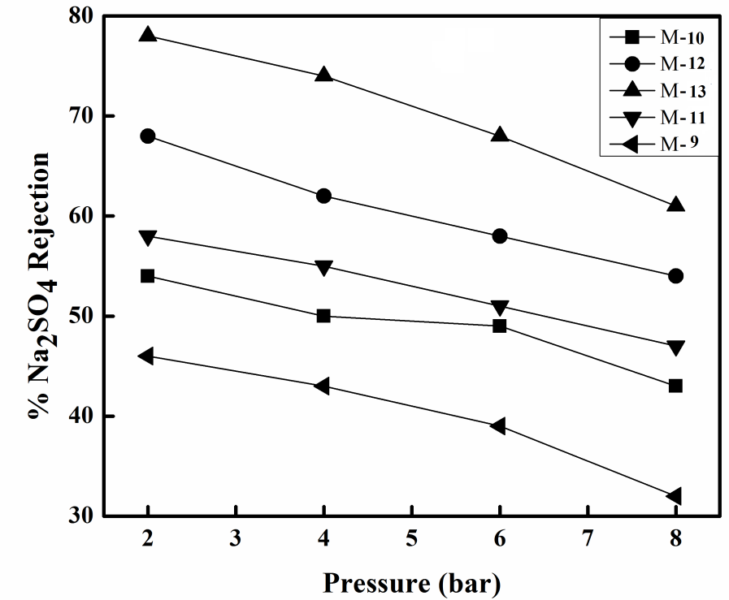
Figure 7.11 Na₂SO₄ rejections of membranes at different pressures
Figure 7.12 Salt rejection of M-13 membrane at different pressures
Figure 7.12 represents the rejection shown by M-13 membrane for NaCl, Na₂SO₄ and MgSO₄ electrolytes at different pressure. The rejection decreased in the order of Na₂SO₄>MgSO₄>NaCl. In general, the rejection of nanofiltration membrane can be explained by two factors like size exclusion and electrostatic repulsion. Due to the presence of carboxylic functionality on the membrane backbone, the membrane will possess negative charge. When such a membrane comes in contact with electrolyte solution the concentration of co-ions (-ve ions) in the membrane will be lower than that in solution. Whereas counter-ions (+ve ions) have higher concentrations in the membrane than in the solution. This results in generation of potential difference between membrane surface and electrolyte solution. Thus on the membrane surface more counter ions are attracted, whereas co-ions get repelled (Peeters et al. 1998). In order to maintain electrical neutrality equal amount of counter ions will be repelled from the membrane surface. The higher rejection of MgSO₄ and Na₂SO₄ over NaCl is due to, SO4²⁻ is divalent negative ion and Cl⁻ is monovalent. Whereas membrane is negatively charged and stronger repulsion force works between membrane and SO₄² ions. For a membrane, the rejection of electrolyte solution depends on the charge present on the ions and divalent sulfate salts shows higher rejection than monovalent chloride ions (Labbez et al. 2003). Also, the rejection of electrolyte is not governed by the effect of size and the main mechanism responsible for the rejection of the salt is the electrostatic interactions between ions and the membrane surface (Narong et al. 2006). Higher rejection of Na₂SO₄ over MgSO₄ is attributed to divalent Mg²⁺ cation, which is attracted more towards the negatively charged membrane compared to monovalent Na⁺ ion. Overall, the higher rejection shown by modifying PSf/PIAM/CS membranes when compared to PSf/PIAM membranes may be due to: i) Chitosan present in the coagulation bath resulted in the formation of hydrophilic membranes with smaller pores ii) there may be a possibility of amide type linkage (Musale et al. 1999) (difficult to detect in IR spectroscopy due to the presence of amide functionality in chitosan molecular chain) or cross-linking (Wang et al. 1996) between the –NH₂ group of chitosan and –COOH group of hydrolyzed PIAM within the membrane matrix resulted reduced pore size.
7.4 CONCLUSIONS
PSf/PIAM membranes were modified by DIPS method using different concentrations of cross-linked chitosan solution in coagulation bath. The alkali treatment of the membranes resulted in conversion of anhydride groups into dicarboxylic acid groups. The incorporated chitosan and hydrolysis of the membranes resulted in reduced pore size and increased hydrophilicity of the membranes. The morphological study of the membranes revealed that, for the higher concentrations (0.6 wt% and 0.8 wt%) of chitosan in coagulation bath: there is a reduction in pore size due to delayed demixing between solvent and nonsolvent, the membrane morphology changed from finger like to sponge like structure in the sub-layer. The flux of modified PSf/PIAM/CS membranes was improved compared to PSf/PIAM membrane. The membrane M-11 showed a maximum FRR value and tend to possess maximum antifouling property compared to other modified membranes. The increased antifouling property of modified membranes is due to the increased hydrophilicity and presence of charge on the membrane. All the modified membranes showed higher electrolyte rejection than a PSf/PIAM membrane. The M-13 membrane showed maximum rejection for electrolytes and the order of rejection was Na₂SO₄>MgSO₄>NaCl at lowest pressure. Thus, the presence of chitosan in coagulation bath showed much effect on morphology of membranes thereby enhancing hydrophilicity, flux, rejection and antifouling property of the membranes.

Abstract
Polysulfone (PSf) and chitosan (CS) blend membranes were prepared by incorporating titanium dioxide nanotubes (TiO₂NT) in different compositions. The membranes were characterized by ATR-IR spectroscopy, FESEM, Transmission Electron Microscope (TEM), water uptake studies and contact angle measurements. The performance of the membranes was determined in terms of permeation and antifouling property studies. The maximum FRR of 76 % was observed in PSf/CS membrane with 3.0 % of TiO₂NT. Membranes prepared well above rheological percolation threshold acted as NF membranes and subjected to salt rejection study. The membranes prepared from 6.0 wt% TiO₂NT and 8.0 wt% TiO₂NT showed maximum of 34% and 46% NaCl rejection respectively at pH=5.
8.1 INTRODUCTION
Polysulfone based membranes are most useful in water purification applications. However, due to hydrophobic nature, polysulfone ultrafiltration membrane has low permeability and suffers from serious membrane fouling, which limits its application and minimizes membrane life (Toyomoto and Higuchi 1992, Dong et al. 2009). Generally, low permeability results from small membrane surface pore size, low porosity and surface hydrophobicity. Poor antifouling property is mainly caused by the hydrophobic surface of the membrane (Cho et al. 2011). In order to improve membrane permeability and antifouling property, many efforts have been devoted to membrane modification, including material modification, polymer blend and surface modification (Yeo et al. 2000). Among these approaches, polysulfone blend with inorganic additives is considered as an effective and convenient approach due to its excellent modification efficiency and facile operation.
The incorporation of inorganic additives like functionalized multiwalled carbon nanotubes (fMWCNTs) improves hydrophilicity and permeation properties of the polysulfone UF membrane (Celik et al. 2011). The hydrophilic fMWCNTs creates new tracks or channels within the membrane matrix for the feed flow. The morphology of such membranes dependent on the amount of fMWCNTs present in the casting solution. These nanotubes will also contribute to the reduced fouling property of the membranes. Choi et al. (2006) prepared fMWCNT/PSf blend membranes by a phase inversion process. The nanotubes were functionalized by introducing carboxylic acid groups as shown in Figure 8.1 and the fMWCNT/PSf membranes were more hydrophilic than a neat PSf membrane. The morphology and permeation properties of the blend membranes were also found to be dependent on the amount of fMWCNTs used. The pore size of the blend membranes increased along with the contents of fMWCNTs up to 1.5%, then decreased, and at 4.0% of fMWCNTs, it became even smaller than PSf membrane.
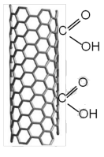
Figure 8.1 Representation of carboxylated MWCNT
Daraei et al. (2013) modified acid functionalized multi walled carbon nanotube (MWCNT) by three hydrophilic polymers during an in situ polymerization reaction. Citric acid, acrylic acid and acrylamide were polymerized on functionalized MWCNT to achieve greater number of functional groups on MWCNT. Mixed matrix membranes were prepared by introducing 0.1 wt% of acid functionalized and polymer modified MWCNTs into polyethersulfone (PES) membranes. The mixed matrix membranes showed higher pure water flux and antifouling properties. The modification of MWCNT led to efficient dispersion of nanotubes in membrane matrix and its surface.
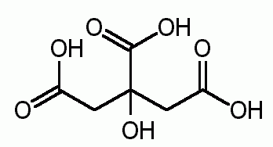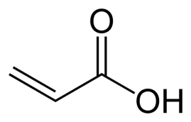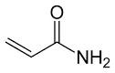
- b) c)
Figure 8.2 Structures of a) Citric acid, b) acrylic acid and c) acrylamide
However, the particle agglomeration in the dope solution results in non uniform distribution of nanotubes or nanoparticles on the membrane surface. This can be avoided either by chemical modification of nanoparticles by hydrophilic groups or by addition of hydrophilic polymeric additives to the dope solution.
The addition of hydrophilic polymeric additive to the dope solution will increase the uniform dispersion of inorganic additives. Ma et al. (2012) prepared polysulfone/clay nanocomposite membranes using polyethylene glycol (PEG 400) as pore forming additive. All the membranes exhibited asymmetric structure and clay has a good dispersion in the form of exfoliated platelets in the PSf matrix due to hydrophilic PEG. The addition of clay contributed to the larger pores in the skin layer and had little effect on membrane hydrophilicity.
Figure 8.3 Structure of polyethylene glycol
Also, the hydrophilic polymeric additives acts as a pore former during phase inversion process. Rahimpour et al. (2012) prepared amine functionalized MWCNT/polyethersulfone (PES) membranes by phase inversion technique using polyvinylpyrrolidone as pore former.
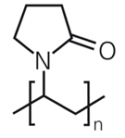
Figure 8.4 Structure of polyvinylpyrrolidone
Titania (TiO₂) nanoparticles find applications in the preparation of mixed matrix membranes due to its hydrophilic nature. Zhang et al. 2013 prepared polysulfone and TiO₂ nanoparticle hybrid membranes, which showed enhanced properties such as high permselectivity, good hydrophilicity and excellent fouling resistance. In order to overcome the agglomeration of nanoparticles in membranes, the polymer chains of 2-hydroxyethyl methacrylate (HEMA) were grafted on TiO₂ nanoparticles by atom transfer radical polymerization method. The finger-like macrovoids were suppressed in the PSf/HEMA-g-TiO₂ membranes. The addition of nanoparticles resulted in the increase of pore size and porosity compared with PSF membranes.
Figure 8.5 Structure of HEMA-g-TiO₂ particles
TiO₂ nanotube (TiO₂NT) is the other morphological form of TiO₂ nanoparticles. The biocompatible TiO₂NT find application in the field of drug delivery system. The composites of TiO₂NT have potential applications in polymer based photovoltaic materials, solar panels and UV-protective materials for space applications due to their good mechanical properties.
Chitosan is N-deacetylated derivative of chitin which is a biodegradable, hydrophilic material and shows excellent film forming nature (Chung and Chen et al. 2008). From earlier study we have concluded that, blending of chitosan with polysulfone results in increased hydrophilicity, permeation and antifouling properties of the PSf UF membrane. Also chitosan acts as a pore former during phase inversion process and play a typical additive role. The TiO₂ nanoparticles can be homogeneously dispersed in chitosan solution.
Yang et al. 2009 prepared chitosan (CS)/TiO₂ nanoparticle nanocomposite membranes using tetrabutyl titanate (TBT) and acetyl acetone as chelating agent by in situ sol-gel process. The characterization results demonstrated that nano-sized TiO₂ particles dispersed homogeneously within the CS matrix, which could be assigned to the hydrogen and titanoxane bonds formed between CS and TiO_{2.}
In the current chapter, TiO₂NT were incorporated into PSf ultrafiltration membrane using chitosan as an additive. The combined effect of chitosan and nanotubes on the permeation and antifouling properties of the membranes was comparatively discussed. In further study, two more PSf/CS/TiO₂NT membranes were prepared well above rheological percolation threshold of the solutions. Due to drastic reduction in pore size these two membranes were subjected to NaCl rejection studies at different pH.
8.2 EXPERIMENTAL
8.2.1 Preparation of TiO₂NT
TiO₂ nanoparticles are obtained as gift sample from Dr. Amir Al Ahmed, Centre of Research Excellence in Renewable Energy, King Fahd University of Petroleum and Minerals, Saudi Arabia. 50 mL of 10 M NaOH solution was taken in a round bottom flask connected to a condenser with chilling set up. The solution was heated to 120 °C and 2.0 g of TiO₂ anatase powder was added in one portion and the solution was refluxed for 48 h at 120 °C with continuous stirring. The mixture was cooled to 30 °C and poured into 500 mL of deionized water. After some time the white nanotubes were settled down at the bottom of the beaker. The water layer was decanted and washing was repeated for 2 more times. 150 mL of 0.1 M HCl solution was added and the solution was stirred for 12 h at 60 °C and after that again washed with deionized water until neutral pH. Then tubes were centrifuged and calcinated at 450 ºC for 4 h. Yield: 1.9 g. Figure 8.6 represents the TEM image of the prepared TiO₂ nanotubes.
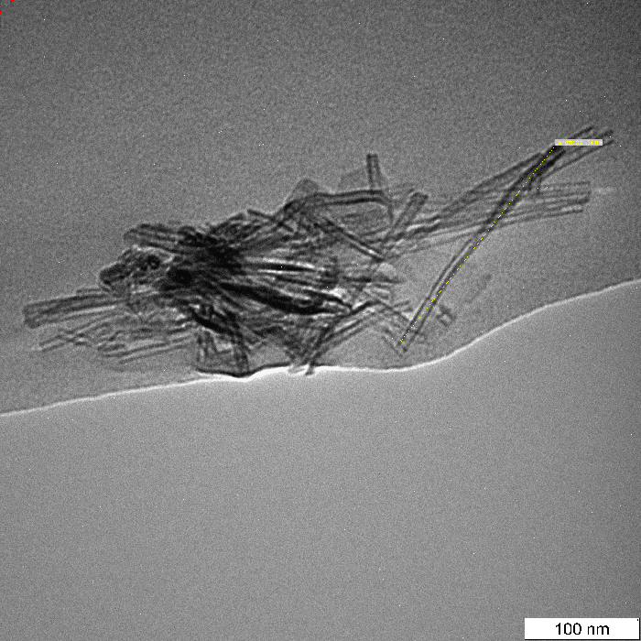
Figure 8.6 TEM images of TiO₂ nanotubes.

8.2.2 Preparation of PSf/CS/TiO₂ (M-16) membrane
Polysulfone (PSf) (M_{w}= 35,000 Da) and low molecular weight chitosan (degree of deacetylation 75-85%) were purchased from Sigma-Aldrich Co, Bangalore, India. 1.0 g of chitosan (CS) was dissolved in 50 mL of 1% aqueous acetic acid solution. 3.8 g of polysulfone was dissolved in 15.2 mL of NMP at 60 °C over a period of 4 h to obtain a homogenous solution. 10 mL of chitosan solution was added to the above prepared polysulfone solution under vigorous stirring and maintaining the temperature at the same level. Then, additional 5 mL of NMP was added. While chitosan was being added, chitosan gets precipitated. The resultant turbid solution was stirred vigorously at 70 °C for 12 h to obtain a homogeneous solution of high viscosity (Figure 8.7). The solution was filtered using G4 sand filter while maintaining the temperature of ca ~50 °C. 1.0 wt % (0.240 g) of TiO₂NT was added and stirred for 30 minutes followed by sonication for 1 h (resulted in uniform dispersion of the nanotubes in the dope solution) at the same temperature. The viscous solution was cast over a glass plate using a doctor’s knife and immersed in distilled water (at 20 °C) for phase inversion. The prepared membranes were washed with distilled water for several times and dried at 30 °C. A similar procedure was followed for the preparation other membranes with compositions as shown in Table 8.1.
Table 8.1 Blending compositions of membranes
Membranes | PSf (wt%) | CS (wt%) | TiO₂ NT (wt%) | NMP (wt%)
M-14 | 15.70 | 0.82 | 0.2 | 83.28
M-15 | 15.70 | 0.82 | 0.5 | 82.98
M-16 | 15.70 | 0.82 | 1.0 | 82.48
M-17 | 15.70 | 0.82 | 1.5 | 81.98
M-18  M-19*  M-20* | 15.70  15.70  15.70 | 0.82  0.82  0.82 | 3.0  6.0  8.0 | 80.48  77.48  75.48
M-21 | 15.70 | 0.82 | 0 | 83.47
M-0 | 15.70 | 0 | 0 | 84.30
M-19* and M-20*: Membranes prepared well above rheological percolation threshold of solutions.
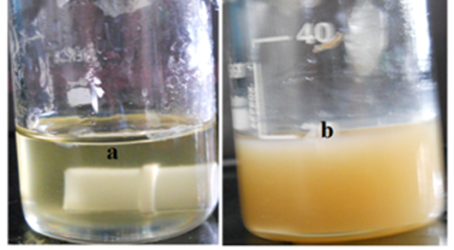
Figure 8.7 (a) Homogeneous solution of PSf/CS blend after 12h (b) PSf/CS casting solution with uniformly dispersed TiO₂ NTs (1.0 %).
8.3 RESULTS AND DISCUSSION
8.3.1 ATR-IR analysis
Compared to polysulfone and chitosan FTIR spectra, PSf/CS/TiO₂NT membranes showed characteristic peaks at 3200-3400 cm⁻¹ correspond to -OH stretch, at 2872 cm⁻¹ correspond to C-H stretch and at 1650 cm⁻¹ correspond to acetylated amine group of chitosan. Whereas peaks corresponding to polysulfone are appeared at 1302 cm⁻¹ (S=O asymmetric stretch), 1240 cm⁻¹ (C-O-C stretch), 1152 cm⁻¹ (S=O symmetric stretch) in the PSf/CS/TiO₂NT membranes. Thus IR spectroscopy confirmed the proper blending of polysulfone and chitosan in the membranes. However, the blended chitosan content was too less to get it prominent peaks in PSf/CS/TiO₂NT membrane or which might have been merged with PSf peaks. The same has been presented in Figure 8.8.
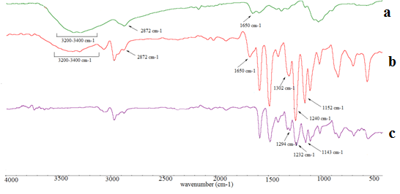
Figure 8.8 FTIR spectra of a) Chitosan b) PSf/CS/TiO₂NT membrane c) Polysulfone.
8.3.2 Analysis of TiO₂NT
The formation of TiO₂NT from TiO₂ nanoparticles was confirmed from TEM analysis and the image is presented in Figure 8.6. The synthesized nanotubes were in the average range of 40-45 nm width and 220-250 nm length.
8.3.3 Rheology of casting solutions
The rheology of casting solution will play a major role during the membrane remixing process. These rheological properties are dependent on the viscosity of solutions, which in turn determines the exchange rate of solvent and non solvent during phase inversion. Finally, this exchange rate between solvent and non solvent determines the morphology, pore size and permeation properties of the membrane. Rheological percolation threshold it that viscosity of the dope solution above which there is reduction in porosity along with pore size reduction of the resulting membrane formed. The viscosity of PSf/CS/TiO₂NT casting solutions increased with increase in TiO₂NT content (Table 8.2). A sharp increase in viscosity was observed when TiO₂NT content was in between 1.0 and 1.5 wt %, which also corresponds to rheological percolation threshold point. The presence of hydrophilic –NH₂ group of chitosan has resulted in increased interaction between TiO₂NT and PSf macromolecules (Nan et al. 2008). From Table 8.2, the viscosity values of PSf/CS/TiO₂NT solutions prepared well above rheological conditions are very high. This resulted in drastic reduction of pore size of M-19 and M-20 membranes due to delayed demixing between solvent and non-solvent during the phase inversion process.
Table 8.2 Viscosity of solutions
Membranes | M-14 | M-15 | M-16 | M-17 | M-18 | M-19 | M-20
Viscosity (mPaS) | 440 | 530 | 650 | 1400 | 2300 | 5026 | 8094

8.3.4 Morphology of the membrane
Figure 8.9 represents the FESEM images of PSf/CS membranes incorporated with different compositions of TiO₂NT. Dense top layer, porous sublayer and fully developed macro pores at the bottom are the common characteristics of the asymmetric membranes. All the membranes (Figure 8.9., Images a, b, c and d) exhibited a typical asymmetric membrane structure. The increased concentration of TiO₂NT in the casting solution resulted in increased finger like projections and higher pores in the sublayer. The presence of hydrophilic chitosan and TiO₂NT resulted in fast exchange of solvent and non solvent during the phase inversion process (Wienk et al. 1996). Therefore the pore size of PSf/CS/TiO₂NT membranes should be higher compared to PSf/CS or PSf ultrafiltration membranes.
However the incorporation of higher composition of nanotubes (>1.0%) in the membrane resulted in a denser structure in sublayer and lesser finger like projections. Such structures of the membranes directly affected the permeation properties of the PSf/CS/TiO₂NT membranes. Similar kind of observation was made by Rahimpour et al. (2012) in case of PES/F-MWCNTs blend membranes and Choi et al. (2006) for the PSf/MWCNTs blend membranes. This may be due to the combined effect of increased viscosity and lowered thermodynamic stability of the blend solutions by the addition hydrophilic TiO₂NT. The image ‘e’ clearly shows the higher accumulation of nanotubes on the membrane surface for the 6.0 % incorporation of TiO₂NT resulted in reduced pore size. The average pore size of this membrane ranged from 30-50 nm (image g). The increased composition of TiO₂NT increased the viscosity of the blend solution above rheological percolation threshold, which resulted in the lesser diffusion of the chitosan and TiO₂NT into the nonsolvent during membrane formation.
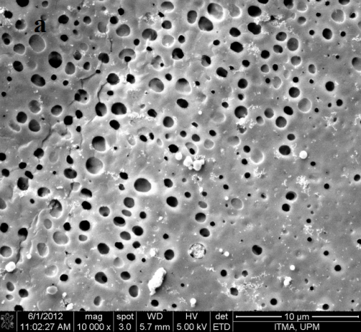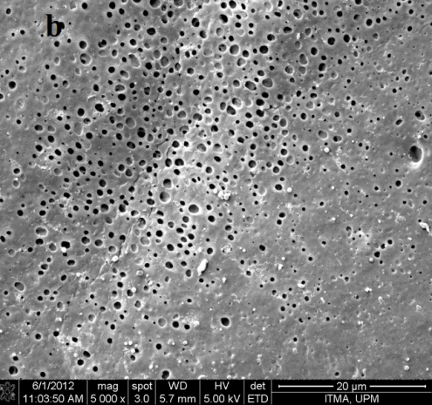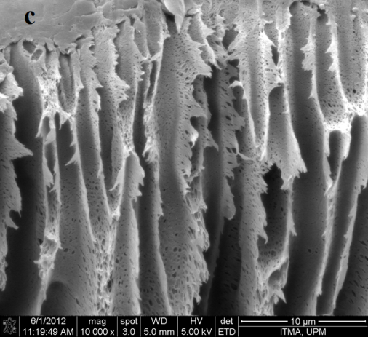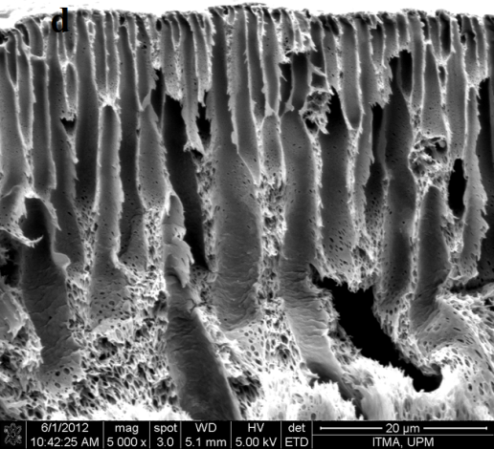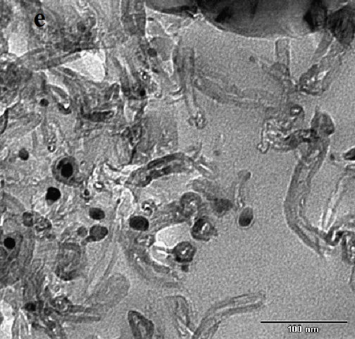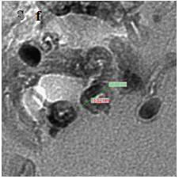
Figure 8.9 FESEM images of membranes. (a) and (b) surface images of M-14 and M-16, (c) and (d) cross-sections of M-17 and M-18, (e) Surface TEM images of M-19 membrane representing TiO₂NT and pore distribution, (f) Surface of M-20
8.3.5 Water swelling behavior and contact angle measurement
The hydrophilicity of all the membrane surfaces was determined by measuring water uptake and contact angle. The water uptake properties of PSf/CS/TiO₂NT membranes were highly pH dependent as given in Table 8.3. At pH=3, maximum water uptake of 84% was obtained for PSf/CS/TiO₂ membranes with 3.0 % TiO₂NT (M-18) content. Thus, water uptake values of membranes are dependent on higher composition of TiO₂ content and also on acidic conditions due to protonation of –NH₂ group of chitosan (Padaki et al. 2011). However, water uptake values of M-17 and M-18 membranes are almost in the same range of M-16 membrane. This may be due to reduced pore size of former ones with increased TiO₂NT content.
Table 8.3 pH dependent water uptake of membranes
 | % Water uptake of membranes
pH | M-21 | M-14 | M-15 | M-16 | M-17 | M-18
3 | 78.6 | 79.1 | 81.3 | 83.0 | 83.8 | 84.3
5 | 60.1 | 61.6 | 64.1 | 66.3 | 67.4 | 68.5
7 | 52.7 | 53.4 | 55.8 | 58.0 | 59.1 | 60.5
9 | 51.6 | 53.1 | 55.3 | 56.2 | 57.0 | 57.9
11 | 50.1 | 51.4 | 53.7 | 54.5 | 55.3 | 56.4

The contact angle is the measure of surface hydrophilicity of the membrane and Figure 8.10 represents the schematic representation of the contact angle measurement. The nascent polysulfone membrane has contact angle of 73 °, where as PSf/CS membrane with 3.0 % TiO₂NT (M-18) content showed contact angle of 58 ° as shown in Figure 8.11. The remarkably reduced contact angle indicated the entrapment of TiO₂NT on membrane could result in hydrophilicity enhancement.
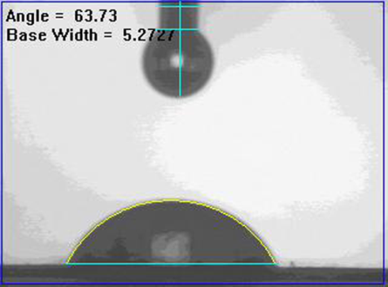
Figure 8.10 Schematic representation of contact angle measurement

Figure 8.11 Contact angle of membranes
8.3.6 Permeation properties
The time dependent pure water fluxes of the membranes were measured and Figure 8.12 represents the flux behavior of PSf/CS/TiO₂NT membranes compared with PSf/CS and neat PSf membranes. Initially gradual decrease in pure water flux was observed for all the membranes during membrane compaction due to mechanical deformation of polymeric membrane matrix (Susanto et al. 2009). TiO₂ content had more effect on the pure water flux of the membranes. Up to 1.0 % composition of TiO₂NT, the pure water flux of PSf/CS membranes increased and above which, flux reduced dramatically as shown in Figure 8.12. However, the higher concentration of nanotubes might result to more compact membrane structures which consequently block the pores and lead to reduction in flux. Usually the membranes with smaller content of TiO₂NT possess relatively smaller pores than that of PSf membranes. Overall, the higher flux of these membranes compared to PSf membrane is due to enhanced surface hydrophilicity and porosity.

Figure 8.12 Time dependent pure water flux of membranes at 0.3 MPa and 26 °C
8.3.7 Salt rejection properties
It will be interesting to study the salt rejection of PSf/CS/TiO₂NT membranes well above rheological conditions due to drastic reduction in pore size. The reason for pore size reduction can be explained as follows. Higher content of hydrophilic TiO₂NT above rheological percolation threshold of the solution results in: increased viscosity of the system, lowered thermodynamic stability and slow demixing between solvent and non-solvent (Han et al. 2002). This resulted in diffusion of more amount of solvent from the cast solution and lesser diffusion of non-solvent during phase separation process. Due to this, small pores are formed and M-19 and M-20 membranes acted as nanofiltration membranes as confirmed from surface TEM images. The average pore size of M-19 and M-20 membranes is 60 nm and 40 nm respectively. However considerably higher flux of the M-19 membrane compared to M-20 was due to its larger pore size. Thus, above rheological conditions the reduced pore size decides the flux of the membrane even though there is hydrophilicity enhancement. This indicated that with an increase in the TiO₂NT content above rheological conditions, pore size and flux decreased whereas hydrophilicity of the membranes increased. Both membranes showed maximum rejection at acidic pH (Figure 8.13), and at this pH membrane surface attained slight positive charge due to protonation of –NH₂ to –NH₃⁺ (Jahanshahi et al. 2012). This facilitates the exchange of cations and membranes M-19 and M-20 showed a maximum of 34% and 46% NaCl rejection respectively at pH=5. However there is no drastic change in NaCl rejection for both M-19 and M-20 at different pH, this may be due to the lesser content of chitosan present in the membranes. Both the membranes showed maximum flux at acidic pH during NaCl rejection as shown in Figure 8.13. At lower pH, maximum swelling or partial dissolution of protonated chitosan resulted in chian relaxation leading to efficient solvent diffusion (Padaki et al. 2011). At higher pH, there will be less amount of the protonated positively charged groups in chitosan molecules. This gives small repulsion forces between chitosan molecules, enhancing polymer aggregation (Volchek et al. 1993). A continued increase in pH may cause the ‘more flexible’ chitosan aggregates which enter into the pores or make the deposited cake more compressible, resulting in lower flux (Juang et al. 2000).
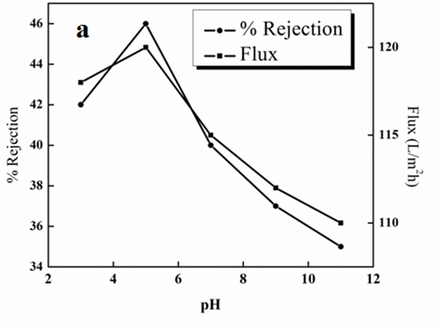
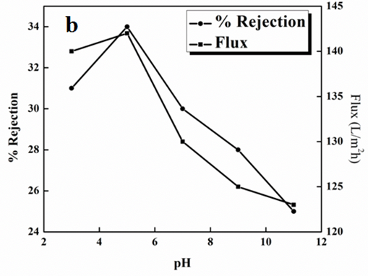
Figure 8.13 pH dependent flux and NaCl rejection of a) M-20 and b) M-19 membranes at 0.3 MPa TMP
8.3.8 Antifouling properties
Fouling is due to hydrophobic interaction between plant and membrane surface is the major drawback of the membrane. Declined flux and shortening of membrane life time is the main outcomes of fouling. From Figure 8.14, the flux decline behavior of all the membranes was same during BSA rejection. Whereas nascent PSf membrane showed greater flux decline compared to PSf/CS or PSf/CS/TiO₂NT membranes. Since fouling study of all the membranes assessed under similar hydrodynamic conditions, the difference in fouling behavior was due to difference in TiO₂NT content present in the membranes. The fouling resistance ratio (FRR) is the measure of antifouling property of the membranes (Teli et al. 2012). All TiO₂NT incorporated membranes showed higher FRR values as given in Figure 8.15 than PSf membranes. The maximum FRR of 76 % was observed in PSf/CS membrane with 3.0 % of TiO₂NT (M-18). All the membranes showed good FRR values compared to bare PSf membrane (Figure 8.15). This indicated, there is a weak interaction between foulant BSA and membrane surface and membranes have high recycling property.

Figure 8.14 Flux behaviors of membranes during BSA filtration

Figure 8.15 FRR values of membranes
8.4 CONCLUSIONS
The hydrophilic TiO₂NT in different compositions were successfully introduced into Polysulfone/Chitosan blend membranes. The added chitosan increased membrane hydrophilicity, acted as pore former and also resulted in uniform dispersion of TiO₂NT in blend or membrane. The blending between chitosan and polysulfone in the PSf/CS/TiO₂NT membranes was confirmed by ATR-IR spectral analysis. The synthesized TiO₂NTs and PSf/CS/TiO₂NT membranes were characterized by TEM images. The prepared nanotubes had 40-50 nm width and distributed uniformly on the membrane surface. The asymmetric membrane structures were confirmed by FESEM images. The contact angle and water uptake studies revealed increased hydrophilicity of PSf/CS/TiO₂NT membranes over nascent PSf membranes. PSf/CS/TiO₂NT membranes containing >1.0% of TiO₂NT showed reduced pore size which was reflected in their permeation properties. The pure water flux of PSf/CS/TiO₂NT membranes 2-3 times more than that of PSf ultrafiltration membranes. The BSA rejection studies showed enhanced antifouling properties of PSf/CS/TiO₂NT membranes compared to PSf membranes due to hydrophilic TiO₂NT content. The maximum fouling resistance ratio of 76 % was observed, whereas the BSA rejection values for all PSf/CS/TiO₂NT membranes remained almost same.
From viscosity measurements, the rheological point of PSf/CS/TiO₂NT solution lies in between 1.0 to 1.5wt %. Thus, incorporation of TiO₂NT well above rheological threshold percolation of the solutions is the suitable method for pore size reduction of the membrane along with hydrophilicity enhancement. Membranes prepared well above rheological conditions of PSF/CS/TiO₂NT solutions are nanofiltration membranes and can be applied for desalination applications. Further, the detailed study about antifouling and permeation properties of PSf/CS/TiO₂NT membranes prepared above rheological conditions are under investigation.

Abstract
This provides the summary of the work presented in the thesis along with the conclusions and scope for further development in the field of membrane filtration.
9.1 SUMMARY AND CONCLUSIONS
The present work mainly focuses on the preparation of chitosan based ultra and nanofiltration membranes. The work also covers the chemical modification of chitosan and their applications in the field of membrane technology. The permeation and antifouling properties of the membranes were determined in order to ensure the improved performance. The prepared ultra and nanofiltration membranes were subjected to heavy metal rejection and salt rejection studies respectively. Three series of chitosan based ultrafiltration membranes were prepared for heavy metal removal application.
Chitosan was blended with polysulfone to prepare PSf/CS UF membranes. Due to insolubility of chitosan in organic solvents, a new process was demonstrated for blending. Chitosan acted as additive by increasing the hydrophilicity and number of pores on the membrane surface. The blending of chitosan was effective in improving the permeation and antifouling property of the membrane. The added chitosan partly retained within the membrane matrix as confirmed by ATR-IR results. Such membranes are adsorptive membranes due to metal chelating property of chitosan and subjected to heavy metal rejection study.
In the second series N-succinyl chitosan (NSCS) was synthesized and blended with polysulfone to prepare PSf/NSCS ultrafiltration membranes. NSCS was prepared according to the literature reported procedure and characterized by ATR-IR spectroscopy. The contact angle measurements and water uptake studies revealed that addition of NSCS resulted in increased hydrophilicity of the membranes. Also, PSf/NSCS membranes showed enhanced permeation and antifouling properties compared to neat polysulfone membrane.
In the third series, a novel derivative of chitosan, N-propylphosphonic chitosan (NPPCS) having a terminal phosphonic acid group was synthesized by reacting chitosan with hydroxybenzotriazole (HOBt) and propylphosphonic anhydride (T3P) via one pot reaction. The derivative was characterized by ¹H NMR, ATR-IR spectroscopy and XRD. NPPCS was blended with polysulfone in three different compositions to prepare PSf/NPPCS ultrafiltration membranes. NPPCS also played similar role like NSCS in improving overall performance of the polysulfone ultrafiltration membrane.
Figure 9.1 Synthetic scheme of NPPCS
PSf/CS, PSf/NSCS and PSf/NPPCS membranes were subjected to copper, cadmium and nickel rejection by ultrafiltration (UF) and polymer enhanced ultrafiltration (PEUF) process. The rejection by UF process resulted in effective removal of heavy metal ions from aqueous solutions due to complexation reaction between metal ions and chelating groups of CS, NSCS or NPPCS on membrane surface or its pore structures. The metal ion rejection by ultrafiltration process resulted in a maximum of 78% of Cu, 73% of Ni and 68% of Cd rejection for M-5 membrane, 75% of Cu, 71% of Ni and 66% of Cd rejection for M-8 membrane and 76% of Cu, 69% of Ni and 66% of Cd rejection for M-2 membrane with good flux. The metal ion rejection was further increased during PEUF process for PSf/CS, PSf/NSCS and PSf/NPPCS membranes. PSf/NSCS membrane with 20% of NSCS (M-5) showed maximum of 98%, 95% and 92% rejection for Cu, Ni and Cd respectively with steady state flux of 117 L/m²h. Thus, increased permeation and antifouling property of PSf/CS, PSf/NSCS and PSf/NPPCS membranes resulted in achieving high flux during rejection and good membrane recycling property.
Two series of chitosan based nanofiltration membranes were prepared and subjected to salt rejection study. Polysulfone (PSf)/poly (isobutylene-alt-maleic anhydride) (PIAM) nanofiltration membranes were modified by changing the coagulation bath with various concentrations of glutaraldehyde cross-linked chitosan (CS) solutions. Further, the alkali treatment of the membranes resulted in hydrolysis of PIAM, which resulted in introduction of carboxylic groups in the membrane. The modified membranes showed reduced pore size, increased porosity and hydrophilicity. The membrane prepared from 0.8 wt% of chitosan solution showed maximum of 78%, 65% and 44% rejections for Na₂SO₄, MgSO₄ and NaCl electrolytes respectively. Thus by replacing coagulation bath with chitosan solution resulted in enhanced permeation, salt rejection and antifouling properties of PSf/PIAM membranes.
Polysulfone (PSf) and chitosan (CS) blend membranes were prepared by incorporating titanium dioxide nanotubes (TiO₂NT). Chitosan acted as a pore former and also resulted in well dispersion of TiO₂NT on the membrane surface. The trapped chitosan and well dispersed TiO₂NT in PSf/CS/TiO₂ membrane matrix resulted in increased hydrophilicity, permeation and antifouling properties of the membranes. The membranes prepared well above the rheological percolation threshold of the casting solution acted as nanofiltration membranes. The membrane with 8% of TiO₂NT content showed maximum of 46% NaCl rejection.
Below Table summarises comparitive details of the commercially available NF270 membrane and chitosan based NF membranes prepared in our research work in terms of rejection and flux for 1000 ppm NaCl solution at 0.6 MPa.
Table 9.1 Comparision of Flux and Rejection data of NF270 and chitosan based NF membranes
Membrane | Material | Flux (L/m²h) | % R
NF270 | Polyamide | 17.5 | 82
M-9 | PSf/PIAM/CS (0.0) | 28 | 8
M-10 | PSf/PIAM/CS (0.2) | 49 | 18
M-11 | PSf/PIAM/CS (0.4) | 56 | 20
M-12 | PSf/PIAM/CS (0.6) | 45 | 35
M-13 | PSf/PIAM/CS (0.8) | 36 | 44
M-19 | PSf/CS/TiO₂NT (6.0wt%) | 48 | 33
M-21 | PSf/CS/TiO₂NT (8.0wt%) | 62 | 44.5

Although M-13 and M-21 showed less NaCl rejection than NF270, the flux values of former ones are comparatively high. NF membranes are considered as “pretreatment membranes” for the RO process of water purification by desalination process. Such treatment rejects most of the mono and divalent salts from the feed. From Table 9.1, the novel chitosan based NF membranes, especially M-13 and M-21 showed >40 % rejection for monovalent NaCl solution. Salt rejection study of such NF membranes revealed that these membranes can be applied for desalination application.
9.2 SCOPE FOR THE FUTURE WORK
Keeping in view of the performance results obtained for the chitosan based ultrafiltration and nanofiltration membrane, the following scopes are presented for the future work:
- To study the effect of cross-linking on the heavy metal rejection properties of the chitosan based UF membranes (PSf/CS, PSf/NSCS and PSf/NPPCS).
- Application of chitosan based UF membranes for treatment of industrial waste water containing dye as major pollutant.
- Application of PSf/CS/TiO₂ membranes in heavy metal and dye removal.
- Application of chitosan based UF membranes for protein separation.
- The NF membranes can be physically modified by physical vapour phase deposition (PVD) method for further enhancement of salt rejection.

REFERENCES

Adams, F.V., Nxumalo, E.N., Krause, R.W.M., Hoek, E.M.V. and Mamba, B.B. (2012). “Preparation and characterization of polysulfone/β-cyclodextrin polyurethane composite nanofiltration membranes.” J. Membr. Sci., 405-406, 291-299.
Agenson, K.O. and Urase, T. (2007). “Change in membrane performance due to organic fouling in nanoﬁltration (NF)/reverse osmosis (RO) applications.” Sep. Purif. Technol., 55, 147-156.
Ahmad, A.L., Majid, M.A. and Ooi, B.S. (2011). “Functionalized PSf/SiO₂ nanocomposite membrane for oil-in-water emulsion separation.” Desalination, 268, 266-269.
Aiping, Z., Tian, C., Lanhua, Y., Hao, W. and Ping, L. (2006). “Synthesis and characterization of N-succinyl-chitosan and its self-assembly of nanospheres.” Carbohydr. Polym., 66, 274-279.
Amiji, M. (1995). “Permeability and blood compatibility properties of chitosanpoly (ethylene oxide) blend membranes for hemodialysis.” Biomaterials, 16, 593-599.
Amirilargani, M., Saljoughi, E., Mohammadi, T. and Moghbeli, M.R. (2010). “Effect of coagulation bath temperature and polyvinylpyrrolidone content on flat sheet asymmetric polyether sulfone membranes.” Polym. Eng. Sci. 50, 885-893.
Arockiasamy, D.L., Nagendran, A., Shobana, K.H. and Mohan, D. (2009). “Preparation and Characterization of Cellulose Acetate/Aminated Polysulfone Blend Ultrafiltration Membranes and their Application Studies.” Sep. Sci. Technol., 44, 398-421.
Aroon, M.A., Ismail, A.F. and Montazer-Rahmati, M.M. (2010). “Morphology and permeation properties of polysulfone membranes for gas separation: effects of non-solvent additives and co-solvent.” Sep. Purif. Technol. 72, 194-202.
Aroua, M.K., Zuki, F.M., Sulaiman, N.M. (2007). “Removal of chromium ions from aqueous solutions by polymer-enhanced ultraﬁltration.” J. Hazard. Mater. 147, 752-758.
Arthanareeswaran, G., Sriyamuna Devi, T.K. and Mohan, D. (2009). “Development, characterization and separation performance of organic-inorganic membranes Part II. Effect of additives.” Sep. Purif. Technol., 67, 271-281.
Augastine, J.K., Kumar, R., Bombrun, A. and Mandal, A.B. (2011). “An efﬁcient catalytic method for the Beckmann rearrangement of ketoximes to amides and aldoximes to nitriles mediated by propylphosphonic anhydride (T3P).” Tetrahedron Lett., 52, 1074-1077.
Augustine, J.K., Atta, R.N., Ramappa, B.K. and Boodappa, C. (2009). “Propylphosphonic anhydride (T3P®): A remarkably efficient reagent for the one-pot transformation of aromatic, heteroaromatic, and aliphatic aldehydes to nitriles.” Synlett, 3378-3382.
Badawy, M.E.I. and Rabea, E.I. (2012). “Characterization and antimicrobial activity of water-soluble N-(4-carboxybutyroyl) chitosans against some plant pathogenic bacteria and fungi.” Carbohyd. Polym., 87, 250-256.
Barnett, T.P., Adam, J.C. and Lettenmaier, D.P. (2005). “Potential impacts of a warming climate on water availability in snow-dominated regions.” Nature, 438, 303-309.
Beier, S.P., Enevoldsen, A.D., Kontogeorgis, G.M., Hansen E.B. and Jonsson, G. (2007). “Adsorption of amylase enzyme on ultrafiltration membranes.” Langmuir 23 (2007) 9341-9351.
Bessbousse, H., Verchere, J-F. and Lebrun, L. (2012). “Characterisation of metal-complexing membranes prepared by the semi-interpenetrating polymer networks technique. Application to the removal of heavy metal ions from aqueous solutions.” Chem. Eng. J., 187, 16-18.
Boom, R.M., Wienk, I.M., Boomgaard, T.V. and Smolders, C.A. (1992). “Microstructures in phase inversion membranes. Part 2. The role of a polymeric additive.” J. Membr. Sci., 73, 277-292.
Boributh, S., Chanachai, A. and Jiraratananon, R. (2009). “Modification of PVDF membrane by chitosan solution for reducing protein fouling.” J. Membr. Sci., 342, 97-104.
Boricha, A.G. and Murthy, Z.V.P. (2008). Preparation and performance of N,O-carboxymethyl chitosan-polyether sulfone composite nanofiltration membrane in the separation of nickel ions from aqueous solutions. J. Appl. Polym. Sci. 110, 3596-3605.
Boricha, A.G. and Murthy, Z.V.P. (2009). “Acrylonitrile butadiene styrene/chitosan blend membranes: Preparation, characterization and performance for the separation of heavy metals”. J. Membr. Sci. 339, 239-249.
Boricha, A.G. and Murthy, Z.V.P. (2010). “Preparation of N,O-carboxymethyl chitosan/cellulose acetate blend nanofiltration membrane and testing its performance in treating industrial wastewater”. Chem. Eng. J. 157: 393-400.
Boussu, K., Vandecasteele, C. and Van der Bruggen, B. (2006). “Study of the characteristics and the performance of self-made nanoporous polyethersulfone membranes.” Polymer, 47, 3464–3476.
Bowen, W.R., Doneva, T.A. and Yin, H.B. (2001). “Polysulfone- sulfonated poly(ether ether) ketone blend membranes: systematic synthesis and characterization.” J. Membr. Sci., 181, 253-263.
Bruggen, B.V., Evemert, K., Wilms, D. and Vandecasteele, C. (2001). “Application of nanoﬁltration for removal of pesticides, nitrate and hardness from ground water: rejection properties and economic evaluation.” J. Membr. Sci., 193, 239-248.
Camarillo, R., Perez, A., Canizares, P. and Lucas, A. (2012). “Removal of heavy metal ions by polymer enhanced ultrafiltration Batch process modeling and thermodynamics of complexation reactions.” Desalination, 286, 193-199.
Cao, X., Zhang, T., Nguyen, Q.T., Zhang, Y. and Ping, Z. (2008). A novel hydrophilic polymer ceramic composite membrane. 1. Acrylic acid grafting membrane. J. Membr. Sci. 312: 15-22.
Carmichael, J., Mitchell, J.B., DeGraff, W.G., Gamson, J., Gazdar, A.F., Johnson, B.E., Glatstein. E. and Minna, J.D. (1988). “Chemosensitivity testing of human lung cancer cell lines using the MTT assay.” Br. J. Cancer. 57, 540.
Casuccio, G.S., Schlaegle, S.F., Lersch, T.L., Huffman, G.P., Chen, Y. and Shah, N. (2004). “Measurement of fine particulate matter using electron microscopy techniques.” Fuel Process. Technol. 85, 763-779.
Celik, E., Park, H., Choi, H. and Choi, H. (2011). “Carbon nanotube blended polyethersulfone membranes for fouling control in water treatment.” Water Res., 45, 274-282.
Cesrari, A.R., Vieira, E.F.S., de Oliveira, I.A. and Bruns, R.E. (2007). “The removal of Cu (II) and Co (II) from aqueous solutions using cross-linked chitosan- Evaluation by the factorial design methodology.” J. Hazar. Mater., 143, 8-16.
Chakrabarthy, B., Ghoshal, A.K. and Purkait, M.K. (2008). “Preparation, characterization and performance studies of Polysulfone membranes using PVP as an additive.” J. Membr. Sci., 315, 36-47.
Chakrabarty, B., Ghoshal, A.K. and Purkait, M.K. (2008). “Effect of molecular weight of PEG on membrane morphology and transport properties.” J. Membr. Sci., 309, 209-221.
Chaudhari, L.B. and Murthy, Z.V.P. (2013). “Preparation, Characterization and Performance of Sulfated Chitosan/Polyacrylonitrile Composite Nanofiltration Membranes.” J. Dispersion Sci. Technol., 34, 389-399.
Chen, Y., Pan, B., Zhang, S., Li, H., Lv, L. and Zhang, W. (2011). “Immobilization of polyethylenimine nanoclusters onto a cation exchange resin through self-crosslinking for selective Cu(II) removal.” J. Hazard. Mater., 190, 1037-1044.
Cho, Y.H., Kim, H.W., Nam, S.Y. and Park, H.B. (2011). “Fouling-tolerant polysulfone-poly(ethylene oxide) random copolymer ultrafiltration membranes.” J. Membr. Sci., 379, 296-306.
Choi, J.H., Jegal, J. and Kim, W. (2006). “Fabrication and characterization of multi-walled carbon nanotubes/polymer blend membranes.” J. Membr. Sci., 284, 406-415.
Chuang, W.Y., Young, T.H. and Chiu, W.Y. (2000). “The effect of acetic acid on the structure and filtration properties of poly (vinyl alcohol) membranes.” J. Membr. Sci., 172, 241-251.
Chung, Y.C. and Chen, C.Y. (2008). “Antibacterial characteristics and activity of acid-soluble chitosan.” Bioresour. Technol., 99, 2806-2814.
Daraei, P., Madaeni, S.S., Astinchap, B., Ghaemi, N., Moradian, R. and Khadivi, M.A. (2013). “Enhancing antifouling capability of PES membrane via mixing with various types of polymer modified multi walled carbon nanotube.” J. Membr. Sci., 444, 184-191.
Deshmukh, S.P. and Li, K. (1998). “Effect of ethanol composition in water coagulation bath on morphology of PVDF hollow fibre membranes.” J. Membr. Sci., 150, 75-85.
Dong, H.B., Xu, Y.Y., Yi, Z. and Shi, J.L. (2009). “Modification of polysulfone membranes via surface-initiated atom transfer radical polymerization.” Appl. Surf. Sci., 255, 8860-8866.
Feng, X. and Huang, R.Y.M. (1996). “Pervaporation with chitosan membranes. Separation of water from ethylene glycol by chitosan/polysulfone composite membrane.” J. Membr. Sci., 116, 67-76.
Ferrah, N., Abderrahim, O., Didi, M.A. and Villemin, D. (2011). Removal of copper ions from aqueous solutions by a new sorbent: Polyethyleneimine methylene phosphonic acid.” Desalination, 269, 17-24.
Fontananova, E., Jansen, J.C., Cristiano, A., Curcio, E. and Drioli, E. (2006). “Effect of additives in the casting solution on the formation of PVDF membranes. Desalination, 192, 190-197.
Fujii, S., Kumagai, H., Noda, M. (1980). “Preparation of poly(acyl)chitosans.” Carbohydr. Res., 83, 389-93.
Ganesh, B.M., Isloor, A.M. and Padaki, M. (2012). “Preparation and characterization of polysulfone and modiﬁed poly isobutylene-alt-maleic anhydride blend NF membrane.” Desalination, 287, 103-108.
Gao, L., Tang, B and Wu, P. (2009). “An experimental investigation of evaporation time and the relative humidity on a novel positively charged ultrafiltration membrane via dry-wet phase inversion.” J. Membr. Sci. 326 168-177.
Genc, O., Soysal, L., Bayramoglu, G., Arica, M.Y. and Bekta, S. (2003). Procion Green H-4G immobilized poly (hydroxyethylmethacrylate/chitosan) composite membranes for heavy metal removal.” J. Hazard. Mater. B, 97, 111-125.
Han, M.J. and Nam, S.T. (2002). “Thermodynamic and rheological variation in Polysulfone solution by PVP and its effect in the preparation of phase inversion membrane.” J. Membr. Sci., 202, 55-61.
Harino, S., Saino, H., Akiyama, Y. and Nonaka, I. (1990). “Progress in Biomedical Polymers.” Plenum Press, New York.
Hayes, E.R., Davies, D.H. and Munroe, V.G. (1978). Organic acid solvent systems for chitosan, Dep. Chem., Acadia Univ.,Wolfville, NS, Can. p 103-106.
Heras, A., Rodriguez, N.M., Ramos, V.M. and Agullo, E. (2001). “N-methylene phosphonic chitosan: a novel soluble derivative.” Carbhydr. Polym. 44, 1-8.
Holappa, J., Nevalainen, T., Safin, R., Soininen, P., Asplund, T., Luttikhedde, T., Masson, M. and Jarvinen, T. (2006). “Novel water-soluble quaternary piperazine derivatives of chitosan: synthesis and characterization.” Macromol. Biosci., 6, 139-44.
Holappa, J., Nevalainen, T., Savolainen, J., Soininen, P., Elomaa, M., Safin, R., Suvanto, S., Pakkanen, T., Masson, M., Loftsson, T., and Jaervinen, T. (2004). “Synthesis and characterization of chitosan N-Betainates having various degrees of substitution.” Macromolecules, 37, 2784-2789.
Huang, R.Y.M., Pal, R. and Moon, G.Y. (1999). “Crosslinked chitosan composite membrane for the pervaporation dehydration of alcohol mixtures and enhancement of structural stability of chitosan/polysulfone composite membranes.” J. Membr. Sci., 160, 17-30.
Huisman, J.H., Pradanos, P. and Hermandez, A. (2000). “The effect of protein-protein and protein-membrane interactions on membrane fouling in ultrafiltration.” J. Membr. Sci., 179, 79-90.
Ilieva, D., Jivov, B., Bogachev, Petkov, G.C., Penkov, I.Y. and Dimitriev, J. (2001). “Infrared and Raman spectra of Ga2O3-P2O5 glasses.” Non-Cryst. Solids., 283, 195-202.
Inoue, K., Baba, Y. and Yoshizuka, K. (1993). “Adsorption of metal ions on chitosan and crosslinked copper (II)-complexed chitosan”. Bull. Chem. Soc. Jpn., 66, 2915-2921.
Jahanshahi, M., Khalili, S., Mollahosseini, A., Zirepour, A. and Rajaeian, B. (2012). “Novel functionalized carbon nanotubes for improving the surface properties and performance of polyethersulfone (PES) membrane.” Desalination, 286, 99-107.
James, M., Crawforth, J.M. and Paoletti. M. (2009). A one-pot synthesis of imidazo [1,5-a] pyridines.” Tetrahedron Lett., 50, 4916-4918.
Jana, S., Purkait, M.K. and Mohanty, K. (2012). “Polymer enhanced ultrafiltration of mercury using chitosan impregnated ceramic membrane.” Desalin. Water Treat., 37, 321-330.
Jana, S., Saikia, A., Purkait, M.K. and Mohanty, K. (2011). “Chitosan based ceramic ultraﬁltration membrane: Preparation, characterization and application to remove Hg (II) and As(III) using polymer enhanced ultrafiltration.” Chem. Eng. J., 170, 209-219.
Jarvis, N.V. and Wagener, J.M. (1995). “Mechanistic studies of metal ion binding to water soluble polymers using potentiometry.” Talanta, 42, 219-226.
Jayalakshmi, A., Rajesh, S., Senthilkumar, S. and Mohan, D. (2012). “Epoxy fuctionalized poly(ether sulfone) (EPES) incorporated cellulose acetate (CA) ultrafiltration membranes for the removal of chromium ions.” Sep. Purif. Technol. 90, 120-132.
Jegal, J. and Lee, K.H. (1999). “Nanofiltration membranes based on poly(vinyl alcohol) and ionic polymers.” J. Membr. Sci., 72, 1755-1762.
Jing, M., Chen, G. and Gao, C. (2005). A novel kind of amphoteric composite nanofiltration membrane prepared from sulfated chitosan.” Desalination, 181, 173-183.
Jonsson, A-S. and Tragardh. (1990). “Ultrafiltration applications.” Desalination, 77, 135-179.
Joullie, M.M. and Lassen, K.M. (2010). Evolution of amide bond formation.” ARKIVOC, (viii), 189-250.
Juang, R.S. and Chan, M.N. (1996). “Measurement of binding constants of poly(ethyleneimine) with metal ions and metal chelates in aqueaous media by ultraﬁltration.” Ind. Eng. Chem. Res. 35, 1935.
Juang, R.S. and Shiau, R.C. (2000). “Metal removal from aqueous solutions using chitosan-enhanced membrane filtration.” J. Membr. Sci. 165, 159-167.
Katsoufidou, K., Yiantsios, S.G. and Karabelas, A.J. (2005). “A study of ultrafiltration membrane fouling by humic acids and flux recovery by backwashing: Experiments and modeling.” J. Membr. Sci., 266, 40-50.
Kesting, R.E. (1991). “Synthetic Polymeric Membranes.” McGrawHill, New York.
Kim, H.J., Baek, K., Kim, B.K., Yang, J.W. (2005). “Humic substance-enhanced ultrafiltration for removal of cobalt.” J. Hazard. Mater. 122, 31-36.
Kim, J-H. and Lee, K-H. (1998). “Effect of PEG additive on membrane formation by phase inversion.” J. Membr. Sci., 138, 153-163.
Kim, S.Y., Cho, S.M., Lee, Y.M. and Kim, S.J. (2000). Thermo- and pH responsive behaviors of graft copolymer and blend based on Chitosan and N-isopropyl acrylamide.” J. Appl. Pollym. Sci., 78, 1381-1391.
Koehler, J.A., Ulbricht, M. and Belfort, G. (2000). “Intermolecular forces between a protein and a hydrophilic modified polysulfone film with relevance to filtration.” Langmuir, 16, 10419-10427.
Kohgo, O., Ishii, S., Nishimura, S., Kurita, K. (1992). “Amphilic polysaccharides from chitosan by regioselective chemical modifications”. Adv. Chitin Chitosan, [Proc. Int. Conf.], 5th, Brine, C. J., Sanford, P. A., Zikakis, J. P., Ed. Elsevier, London, UK, p 526-532.
Kumirska, J., Czerwicka, M., Kaczynski, Z., Bychowska, A., Brzozowski, K., Thoming, J., and Stepnowski, P. (2010). “Application of spectroscopic methods for structural analysis of chitin and chitosan.” Mar. Drugs, 8, 1567-1636.
Kuo, C.Y., Su, S.L., Tsai, H.A., Su, Y.S., Wang, D.M. and Lai, J.Y. (2008). “Formation and evolution of bicontinuous structure of PMMA membrane during wet immersion process.” J. Membr. Sci., 315, 187-194.
Kurita, K. (2006). Chitin and chitosan: functional biopolymers from marine crustaceans.” Mar. Biotechnol., 8, 203-226.
Kurita, K., Kobayashi, M., Munakata, T., Akao, H., Ishii, S., Nishimura, S.I. and Shimojo, M. (1996). Advances in Chitin Science, 1, 222-229.
Labanda, J., Khaidar, M.S., Llorens, J. (2009). “Feasibility study on the recovery of chromium (III) by polymer enhanced ultraﬁltration.” Desalination, 249, 577-581.
Labbez, C., Fievet, P., Szymczyk, A., Vidonne, A., Foissy, A. and Pagetti, J. (2003). “Retention of mineral salts by a polyamide nanoﬁltration membrane.” Sep. Purif. Technol., 30, 47-55.
Lau, W.J., Ismail, A.F., Misdan, N. and Kassim, M.A. (2012). “A recent progress in thin film composite membrane: A review.” Desalination, 287, 190-199.
Lee, Y.M. (1993). “Modified chitosan membranes for pervaporation”. Desalination, 90, 277-290.
Li, N., Liu, Z.Z. and Xu, S.G. (2000). “Dynamically formed poly (vinyl alcohol) ultrafiltration membranes with good anti-fouling characteristics.” J. Membr. Sci., 169, 17-28.
Liu, X., Cheng, Z. and Ma, W. (2009). “Removal of copper by modified chitosan adsorptive Membrane.” Front. Chem. Eng. China 3, 102-106.
Llanes Garcia, A.L. (2007). “T3P: A convenient and useful reagent in organic synthesis.” Synlett, 1328-1329.
Ma, Y., Shi, F., Wang, Z., Wu, M., Ma, J. and Gao, C. (2012). “Preparation and characterization of PSf/clay nanocomposite membranes with PEG 400 as a pore forming additive.” Desalination, 286, 131-137.
Magnenet, C., Jurin, F.E., Lakard, S., Buron, C.C. and Lakard, B. (2013). “Polyelectrolyte modification of ultrafiltration membrane for removal of Copper ions.” Colloids and Srfaces A: Physicochem. Eng. Aspects, (http://dx.doi.org/10.1016/j.colsurfa.2012.12.028).
Mansourizadeh, A. and Ismail, A.F. (2012). “Inﬂuence of membrane morphology on characteristics of porous hydrophobic PVDF hollow fiber contactors for CO₂ stripping from water.” Desalination, 287, 220-227.
Mbareck, C., Nguyen, Q.T., Alaoui, O.T. and Barillier, D. (2009). “Elaboration, characterization and application of polysulfone and polyacrylic acid blends as ultraﬁltration membranes for removal of some heavy metals from water.” J. Hazard. Mater., 171, 93-101.
McCloskey, B.D., Ju, H. and Freeman, B.D. (2010). “Composite membranes based on a selective chitosan-poly(ethylene glycol) hybrid layer: Synthesis, characterization and performance in oil-water purification. Ind. Eng. Chem. Res., 49, 366-373.
Miao, J., Chen, G. and Gao, C. (2006). “Preparation and characterization of N,O-carboxymethyl chitosan (NOCC)/polysulfone (PS) composite nanofiltration membranes.” J. Membr. Sci., 280, 478-484.
Miao, J., Chen, G., Gao, C. and Dong, S. (2008). “Preparation and characterization of N, O-carboxymethyl Chitosan /Polysulfone composite nanofiltration membrane cross-linked with epichlorohydrin.” Desalination 233, 147-156.
Miretzky, P. and Fernandez, C.A. (2009). “Hg(II) removal from water by chitosan and chitosan derivatives: A review.” J. Hazard. Mater., 167, 10-23.
Mohammadi, T. and Saljoughi, E. (2009). “Effect of production conditions on morphology and permeability of asymmetric cellulose acetate membranes.” Desalination, 243, 1-7.
Monier, M. (2012). “Adsorption of Hg²⁺, Cu²⁺ and Zn²⁺ ions from aqueous solution using formaldehyde cross-linked modified chitosan-thioglyceraldehyde Schiff's base.” Int. J. Biol. Macromol., 50, 773-781.
Musale, D.A., Kumar, A. and Pleizier, G. (1999). “Formation and characterization of poly(acrylonitrile)/chitosan composite ultrafiltration membranes.” J. Membr. Sci., 154, 163-173.
Muzzarelli, R.A.A. and Tanfani, F. (1982). “N-(O-carboxybenzyl chitosan), N-carboxymethyl chitosan and dithiocarbamate chitosan: new chelating derivative of chitosan”. Pure Appl. Chem. 54, 2141-2150.
Naim, M.M. and Andel Razek, H.E.M. (2013). “Chelation and permeation of heavy metals using affinity membranes from cellulose acetate-chitosan blends.” Desalin. Water Treat., 51, 644-657.
Nan, Y.Y., Jun, W., Zhu, Z.Q., Si, C.X. and Xuan, Z.H. (2008). “The research of rheology and thermodynamics of organic-inorganic hybrid membrane during the membrane formation.” J. Membr. Sci., 311, 200-207.
Nandi, B.K., Uppaluri, R. and Purkait, M.K. (2009). Effects of dip coating parameters on the morphology and transport properties of cellulose acetate-ceramic composite membranes. J. Membr. Sci. 330: 246-258.
Narong, P. and James, A.E. (2006). “Sodium chloride rejection by a UF ceramic membrane in relation.” Sep. Purif. Technol., 49, 122-129.
Nguyen, M., Reynolds, N. and Vigneswaran, S. (2003). “Treatment of textile dye effluent using a polyamide based nanofiltration membrane.” J. Cleaner Prod., 11, 803-807.
Nishi, N., Maekita, Y., Nishimura, S., Hasegawa, O. and Tokura, S. (1987). “Highly phosphorylated derivatives of chitin, partially deacetylated chitin and chitosan as new functional polymers: metal binding property of the insolubilized materials.” Int. J. Biol. Macromol., 9, 109-114.
Nishimura, S., Kohgo, O. Kuritha, K. and Kuzuhara, H. (1991). “Chemospecific Manipulations of a Rigid Polysaccharide: Syntheses of Novel Chitosan Derivatives with Excellent Solubility in Common Organic Solvents by Regioselective Chemical Modifications.” Macromolecules, 24, 4745-4748.
Ockel, D.M., Staude, E. and Guiver, M.D. (1999). Static protein adsorption, ultrafiltration behavior and cleanability of hydrophilized polysulfone membranes.” J. Membr. Sci., 158, 63-75.
Ohya, Y., Marushashi, S., Shizuno, K., Mano, S., Murata, J. and Ouchi, T. (1999). “Graft polymerization of styrene on chitosan and the characteristics of the polymer”. J. Macromol. Sci., Part-A 36, 339-353.
Oki, T. and Kanea, S. (2006). “Global hydrological cycles and cold water resources.” Science, 313, 1068-1072.
Padaki, M., Isloor, A.M. and Wanichaichart, P. (2011). “Polysulfone/N-phthaloylchitosan novel composite membranes for salt rejection application.” Desalination, 279, 409-414.
Padaki, M., Isloor, A.M., Belavadi, G. and Prabhu, K.N. (2011). “Preparation, characterization and performance study of Poly (isobutylene-alt-maleic anhydride) (PIAM) and Polysulfone (PSF) composite membranes before and after alkali treatment.” Ind. Eng. Chem. Res., 50, 6528-6534.
Padaki, M., Isloor, A.M., Fernandes, J. and Prabhu, K.N. (2011). New polypropylene supported Chitosan NF-membranes for desalination application.” Desalination, 280, 419-423.
Padaki, M., Isloor, A.M., Ismail, A.F. and Abdullah, M.S. (2012). “Synthesis, characterization and desalination study of novel PSAB and mPSAB blend membranes with Polysulfone (PSf).” Desalination, 295, 35-42.
Peeters, J.M.M., Boom, J.P., Mulder, M.H.V. and Strathmann, H. (1998). “Retention measurements of nanofiltration membranes with electrolyte solutions.” J. Membr. Sci., 145, 199-209.
Peeva, P.D., Palupi, A.E. and Ulbricht, M. (2011). “Ultraﬁltration of humic acid solutions through unmodiﬁed and surface functionalized low-fouling polyethersulfone membranes effects of feed properties, molecular weight cut-off and membrane chemistry on fouling behavior and cleanability.” Sep. Sci. Technol., 81, 124-133.
Price, P. and McMillan, T.J. (1990). “Use of the tetrazolium assay in measuring the response of human tumor cells to ionizing radiation.” Cancer Res. 5, 1392.
Pruss-Ustun, A., Bos, R., Gore, F. and Bartram, J. (2008) in World Health Organization Reports, Geneva.
Qiu, S., Wu, L.G., Pan, X.J., Zhang, L., Chen, H.L. and Gao, C.J. (2009). “Preparation and properties of functionalized carbon nanotube/PSF blend ultraﬁltration membranes.” J. Membr. Sci., 342, 165-172.
Rahimpour, A., Jahanshahi, M., Khalili, S., Mollahosseini, A., Zirepour, A. and Rajaeian, B. (2012). “Novel functionalized carbon nanotubes for improving the surface properties and performance of polyethersulfone (PES) membrane.” Desalination, 286, 99-107.
Rana, D. and Matsuura, T. (2010). “Surface modifications for antifouling membranes.” Chem. Rev., 110, 2448-2471.
Reinsch, V.E., Greenberg, A.R., Kelley, S.S., Peterson, R. and Bond, L.J. (2000). “A technique for the simultaneous, real-time measurement of membrane new compaction and performance during exposure to high-pressure gas.” J. Membr. Sci., 171, 217-228.
Richardson, S.C.W., Kolbe, H.V.J. and Duncan, R. (1999). “Potential of low molecular mass chitosan as a DNA delivery system: biocompatibility, body distribution and ability to complex and protect DNA.” Int. J. Pharm. 178, 231-243.
Rinaudo, M. (2006). “Chitin and chitosan: Properties and applications.” Prog. Polym. Sci., 31, 603-632.
Roux, I.L., Krieg, H.M., Yeates, C.A. and Breytenbach, J.C. (2005). “Use of chitosan as an antifouling agent in a membrane bioreactor.” J. Membr. Sci., 248, 127-136.
Saha, N.K., Balakrishnan, M. and Ulbricht, M. (2009). “Fouling control in sugarcane juice ultraﬁltration with surface modiﬁed polysulfone and polyethersulfone membranes.” Desalination, 249, 1124-1131.
Saitfia, H., Campderrosa, M., Cerutti, S. and Padilla, A.P. (2005). “Effect of operating conditions in removal of arsenic from water by nanoﬁltration membrane.” Desalination, 172, 173-180.
Salehi, E., Madaeni, S.S., Rajabi, L., Derakshan, A.A., Daraei, S. and vatanpour. (2013). “Static and dynamic adsorption of copper ions on chitosan/polyvinyl alcohol thin adsorptive membranes: Combined effect of polyethylene glycol and aminated multi-walled carbon nanotubes.” Chem. Eng. J. 215-216: 791-801.
Saljoughi, E and Mousavi, S.M. (2012). “Preparation and characterization of novel polysulfone nanoﬁltration membranes for removal of cadmium from contaminated water.” Sep. Purif. Technol., 90, 22-30.
Shah, P. and Murthy, C.N. (2013). “Studies on the porosity control of MWCNT/polysulfone composite membrane and its effect on metal removal.” J. Membr. Sci., 437, 90-98.
Sikder, J., Pereira, C., Palchoudhury, S., Vohra, K., Basumatary, D. and Pal, P. (2009). “Synthesis and characterization of cellulose acetate-polysulfone blend microﬁltration membrane for separation of microbial cells from lactic acid fermentation broth.” Desalination, 249, 802-808.
Sivakumar, M., Mohan, D.R. and Rangarajan, R. (2006). “Studies on cellulose acetate-polysulfone ultrafiltration membranes II. Effect of additive concentration.” J. Membr. Sci., 268, 208-219.
Song, K.M. and Hong, W.H. (1997). Dehydration of ethanol and isopropanol using tubular type cellulose acetate membrane with ceramic support in pervaporation process. J. Membr. Sci. 123, 27-33.
Spinelli, V.A., Laranjeira, M.C.M. and Favere, V.T. (2004). “Preparation and characterization of quaternary chitosan salt: adsorption equilibrium of chromium (VI) ion.” React. Funct. Polym., 61, 347-352.
Steenkamp, G.C., Keizer, K., Neomagus, H.W.J.P. and Krieg, H.M. 2002. Copper(II) removal from polluted water with alumina/chitosan composite membranes. J. Membr. Sci., 197: 147-156.
Sugimoto, M., Morimoto, M., Sashiwa, H., Saimoto, H. and Shigemasa, Y. (1998). “Preparation and characterization of water-soluble chitin and chitosan derivatives.” Carbohydr. Polym. 36, 49-59.
Sun S. and Wang, A. (2006). “Adsorption properties of N-succinyl-chitosan and cross-linked N-succinyl-chitosan resin with Pb(II) as template ions.” Sep. Purif. Technol. 51, 409-415.
Susanto, H. and Ulbricht, M. (2009). “Characteristics, performance and stability of polyethersulfone ultraﬁltration membranes prepared by phase separation method using different macromolecular additives.” J. Membr. Sci., 327, 125-135.
Tan, S., Chen, Z. and Chen, Z. (2002). “Preparation of polyacrylonitrile nanofiltration membrane and its separation property in the treatment of papermaking effluent”. Zhongguo Zaozhi Xuebao/Transactions of China Pulp and Paper, 17, 63-66.
Tang, C., Zhang, Q., Wang, K., Fu, Q. and Zhang, C. (2009). “Water transport behavior of chitosan porous membranes containing multi-walled carbon nanotubes (MWNTs).” J. Membr. Sci., 337, 240-247.
Teli, S.B., Molina, S., Calvo, E.G. and Lozano, A.E. (2012). “Preparation, characterization and antifouling property of polyethersulfone-PANI/PMA ultrafiltration membranes.” Desalination, 299, 113-122.
Toyomoto, K. and Higuchi, A. (1992). “Microfiltration and Ultrafiltration.” Marcel Dekker, New York, p. 289.
Trivunac, K., Stevanovic, S. (2006). “Removal of heavy metal ions from water by complexation-assisted ultraﬁltration.” Chemosphere 64, 486-491.
Tsai, H.A., Chen, H.C., Lee, K.R. and J.Y. Lai, J.Y. (2006). “Study of the separation properties of chitosan/polysulfone composite hollow-fiber membranes.” Desalination, 193, 129-136.
Vantanpour, V., Madaeni, S.S., Moradian, R., Zinadini, S. and Astinchap, B. (2012). “Novel antibifouling nanoﬁltration polyethersulfone membrane fabricated from embedding TiO₂ coated multiwalled carbon nanotubes.” J. Membr. Sci., 90, 69-82.
Vasantha, B., Hemantha, H.P. and Sureshbabu, V.V. (2010). “Propanephosphonic acid cyclic anhydride (T3P) as efficient promoter for the Lossen rearrangement: Application to the synthesis of urea and carbamate derivatives.” Synthesis, 2990-2996.
Vieira, R.S. and Beppu, M.M. (2005). “Mercury Ion Recovery Using Natural and Crosslinked Chitosan Membranes.” Adsorption 11, 731-736.
Vijayalakshmi, A., Lawrence Arockiasamy, D., Nagendran, A. and Mohan, D. (2008). “Separation of proteins and toxic heavy metal ions from aqueous solution by CA/PC blend ultraﬁltration membranes.” Sep. Purif. Technol. 62, 32-38.
Volchek, K., Krentsel, E., Zhilin, Yu., Shtereva, G. and Dytnersky, Y. (1993). “Polymer binding/ultraﬁltration as a method for concentration and separation of metals.” J. Membr. Sci., 79, 253-272.
Vourch, M., Balannec, B., Chaufer, B. and Dorange, G. (2005). “Nanofiltration and reverse osmosis of model process waters from the dairy industry to produce water for reuse”. Desalination, 172, 245-256.
Wang, C., Yang, F., Meng, F., Zhang, H., Xue, Y. and Fu, G. (2010). “High flux and antifouling filtration membrane based on non-woven fabric with chitosan coating for membrane bioreactors.” Bioresour. Technol., 101, 5469-5474.
Wang, L., Xu, X., Guoa, S., Peng, Z. and Tang, T. (2011). “Novel water soluble phosphonium chitosan derivatives: Synthesis, characterization and cytotoxicity studies.” Int. J. Biol. Macromol., 48, 375-380.
Wang, S., Xu, X., Yang, J. and Gao, J. (2011). “Effect of the carboxymethyl chitosan on removal of nickel and vanadium from crude oil in the presence of microwave irradiation.” Fuel Process. Technol., 92, 486-492.
Wang, X. and Spencer, H.G. (1998). “Formation and characterization of chitosan formed-in-place ultrafiltration membranes”. J. Appl. Polym. Sci., 67, 513.
Wang, X.P., Shen, Z.Q., Zhang, F.Y. and Zhang, Y.F. (1996). “A novel composite chitosan membrane for the separation of alcohol-water mixtures.” J. Membr. Sci., 119, 191-198.
Wang, X., Yumin, D. Fan, L., Liu, H. and Hu, Y. (2005). “Chitosan- metal complexes as antimicrobial agent: synthesis, characterization and Structure-activity study”. Polym. Bull., 55, 105-113.
Watanabe, K. and Kyo, S. (1992). “Pervaporation Performance of Hollow-Fiber Chitosan-Polyacrylonitrile Composite Membrane in Dehydration of Ethanol.” J. Chem. Eng. Jpn., 25 (1) 17.
Wienk, I.M., Boom, R.M. and M.A.M. Beerlage, M.A.M. (1996). “Recent advances in the formation of phase inversion membranes made from amorphous or semicrystalline polymers.” J. Membr. Sci., 113, 361.
Wittmann, E., Cote, P., Medici, C., Leech, J. and Turner, A.G. (1998). “Treatment of a hard bore hole water containing low levels of pesticide by nanofiltration.” Desalination, 119 (1-3), 347-35.
Yanagishita, H., Kitamoto, D., Haraya, K., Nakane, T., Tsuchiya, T. and Koura, N. (1997). Preparation and pervaporation performance of polyimide composite membrane by vapor deposition and polymerization (VDP). J. Membr. Sci. 136: 121-126.
Yang, T., and Zall, R. (1984). “Chitosan membrane for reverse osmosis application”. J. Food Sci., 49, 91-93.
Yang, Y.N. and Zhang, H.X. (2007). “The inﬂuence of nano-sized TiO₂ ﬁllers on the morphologies and properties of PSf UF membrane.” J. Membr. Sci., 288, 231-238.
Yao, C.W., Burford, R.P., Fane, A.G. and Fell, C.J.D. (1998). “Effect of coagulations conditions on structure and properties of membranes from aliphatic polyamides.” J. Membr. Sci., 38, 113-125.
Yeo, H.T., Lee, S.T. and Han, M.J. (2000). “Role of polymer additive in casting solution in preparation of phase inversion polysulfone membranes.” J. Chem. Eng. Jpn., 33, 180-185.
Yoshida, W. and Cohen, Y. (2003).Ceramic-supported polymer membranes for pervaporation of binary organic/organic mixtures. J. Membr. Sci. 213: 145-157.
Yune, P.S., Kilduff, J.E. and Belfort, G. (2011). “Fouling-resistant properties of a surface modified poly(ether sulfone) ultraﬁltration membrane grafted with poly(ethylene glycol)-amide binary monomers.” J. Membr. Sci., 377, 159-166.
Zhao, C., Gao, X-L., Li, S-S. and Gao, C-J. (2013). “Fabrication and characterization of novel composite nanofiltration membranes based on zwitterionic O-carboxymethyl chitosan.” Desalination, 317, 67-76.
Zhao, S., Wang, Z., Wei, X., Zhao, B., Wang, J., Yang, S. and Wang, S. (2011). “Performance improvement of Polysulfone ultrafiltration membrane using PANiEB as both pore forming agent and hydrophilic modifier.” J. Membr. Sci., 385-386, 251-262.
Zhao, Z.P., Wang, Z. and Wang, S.C. (2003). “Formation, charged characteristic and BSA adsorption behavior of carboxymethyl chitosan/PES composite MF membrane”. J. Membr. Sci., 217, 151.
Zhao, Z., Zheng, J., Wang, M., Zhang, H. and Han, C. C. (2012). High performance ultraﬁltration membrane based on modiﬁed chitosan coating and electrospun nanoﬁbrous PVDF scaffolds. J. Membr. Sci., 394-395: 209-217.
Zularism, A.W., Ismail, A.F., Salim, M.R., Sakinah, M. and Hiroaki, O. (2007). “Fabrication, fouling and foulant analyses of asymmetric Polysulfone (PSF) ultrafiltration membrane fouled with natural organic matter (NOM) source waters.” J. Membr. Sci., 299, 97-113.
Zumpe, F.L., Melanie, F., Schmitz, K. and Lender, A. (2007). “Propane phosphonic acid anhydride: a new promoter for the one-pot Biginelli synthesis of 3,4-dihydropyrimidin-2(1H)-ones.” Tetrahedron Lett., 48, 1421-1423.

PUBLICATIONS
PAPERS PUBLISHED IN INTERNATIONAL JOURNAL
- Rajesha Kumar, Arun M. Isloor, A. F. Ismail, Suraya A. Rashid, and Amir Al Ahmed. Permeation antifouling and desalination performance of TiO₂ nanotube incorporated PSf/CS blend membranes. Desalination, 316 (2013) 76-84.
- Rajesha Kumar, Arun M. Isloor, A. F. Ismail and T. Matsuura. Performance improvement of polysulfone ultrafiltration membrane using N-succinyl chitosan as additive. Desalination, 318 (2013) 1-8.
- Rajesha Kumar, Arun M Isloor, A. F. Ismail and T. Matsuura. Synthesis and characterization of novel water soluble derivative of chitosan as an additive for polysulfone ultrafiltration membrane. Journal of Membrane Science, 440 (2013) 140-147.
- Rajesha Kumar, A. F. Ismail, M. A. Kassim, Arun M. Isloor. Modification of PSf/PIAM membrane for improved desalination applications using Chitosan coagulation media. Desalination 317 (2013) 108-115.
- Rajesha Kumar, Arun M. Isloor, A. F. Ismail, Suraya A. Rashid and T. Matsuura. Polysulfone-Chitosan blend ultrafiltration membranes: preparation, characterization, permeation and antifouling properties. RSC Advances 3 (2013) 7855-7861.

PAPERS PRESENTED IN NATIONAL/INTERNATIONAL CONFERENCES
- Rajesha Kumar A. and Arun M. Isloor. Synthesis and characterization of novel water soluble derivative of chitosan as an additive for polysulfone ultrafiltration membrane.” 11th International Conference on Membrane Science and Technology 2013 (MST 2013). Seri Pacific Hotel, Kuala Lampur, Malaysia, 27-29, August, 2013.
- Rajesha Kumar A., Mahesh Padaki and Arun M. Isloor. “Effect of ion beam irradiation on surface morphology of Polysulfone/N-phthaloyl chitosan blend membranes”. National Conference on Recent Trends in Chemical Research (NCRTCR-2012), GITAM University, Visakhapatnam, India, September, 7-8, 2012.
- Rajesha Kumar A. and Arun M. Isloor. “Performance improvement of polysulfone ultrafiltration membrane using N-succinyl chitosan as additive.” International Conference on Natural polymers and Biomaterial (ICNP-2012), Kottayam, Kerala, India, October, 26-28, 2012.
- Rajesha Kumar A. and Arun M. Isloor. “Performance enhancement of PSf/PIAM membranes using chitosan in coagulation bath.” International Conference on Recent Advances in Material Science and Technology. (ICRAMST-13), National Institute of Technology Karnataka, Surathkal, Mangalore, India, 17-19, January, 2013.
- Mahesh Padaki, Rajesha Kumar A. and Arun M. Isloor. “New polypropylene supported chitosan NF membrane for desalination application”. International Conference on Synthetic and Structural Chemistry (ICSSC-2011), Mangalore University, Mangalore, India, December, 8-10, 2011.

CURRICULUM VITAE

RAJESHA KUMAR A.
Permanent address: Present address:
Alambi House Research Scholar
80th Badagabettu, Via Parkala Dept. of Chemistry
Udupi District, Karnataka. NITK, Surathkal
India-576114. Mangalore, India-575025.
Email id: rajeshakumar15@yahoo.com
Mobile no.: +91 8970388847

Educational Background
- Ph.D. Thesis: “Preparation and characterization of chitosan based polymer membranes for water purification application.” Submitted to NITK, Surathkal, India (June 2013)
- M.Sc. Chemistry (General Chemistry) from Mangalore University, Mangalagangothri, Karnataka, India with 70.5 % (2002-2004).
- B.Sc. Chemistry from Mangalore University, Karnataka, India with 84 % (1999-2002).
Research Publications:
- Rajesha Kumar, Arun M. Isloor, A. F. Ismail and T. Matsuur. Performance improvement of polysulfone ultrafiltration membrane using N-succinyl chitosan as additive. Desalination 318 (2013) 1-8.
- Rajesha Kumar, A. F. Ismail, M. A. Kassim and Arun M. Isloor. Modification of PSf/PIAM membrane for improved desalination applications using Chitosan coagulation media. Desalination 317 (2013) 108-115.

- Fecadu Juri, Rajesha Kumar A., Arun M. Isloor and Victoria V. Volkis. Biocompatible polymeric blends for the reversible capturing of carbon dioxide. PSME Preprints (ACS division) 405 (2012) 19-23.
- Rajesha Kumar, Arun M. Isloor, A. F. Ismail, Suraya A. Rashid and T. Matsuura. Polysulfone-Chitosan blend ultrafiltration membranes: preparation, characterization, permeation and antifouling properties. RSC Advances 3 (2013) 7855-7861.
- Rajesha Kumar, Arun M Isloor, A. F. Ismail and T. Matsuura. Synthesis and characterization of novel water soluble derivative of chitosan as an additive for polysulfone ultrafiltration membrane. J. Membr. Sci., 440 (2013) 140-147.
- Rajesha Kumar, Arun M. Isloor, A. F. Ismail, Suraya A. Rashid, and Amir Al Ahmed. Permeation antifouling and desalination performance of TiO₂ nanotube incorporated PSf/CS blend membranes. Desalination 316 (2013) 76-84.
- Mahesh Padaki, Arun M. Isloor, Rajesha Kumar, Ahmad Fauzi Ismail and Takeshi Matsuura. Synthesis, characterization and desalination study of composite NF membranes of novel Poly[(4-aminophenyl)sulfonyl]butanediamide (PASB) and methyalated Poly[(4-aminophenyl)sulfonyl]butanediamide (mPASB) with Polysulfone (PSf). Journal of Membrane Science, 428 (2013) 489-497.
- Abhinav K. Nair, Arun M. Isloor, Rajesha Kumar, and Ahmad Fauzi Ismail. Antifouling and performance enhancement of polysulfone ultrafiltration membranes using CaCO₃ nanoparticles. Desalination, 322, (2013) 69-75.
- Chitrakara Hegde, Arun M Isloor, Ganesh Belavadi and Rajesha Kumar. New composite membrane of Carboxylated Polysulfone (CPS) –Polyphenylene Ether Ether Sulfone (PPEES) as potential material for Direct Methanol fuel cell. Journal of Applied membrane science, and technology. 13 (2011) 1-9.

Book Chapter:
- Rajesha Kumar, Arun M Isloor and Seema Shenvi. “Chitosan and its derivatives as potential materials for membrane technology.” Accepted for publication in 2nd edition of Handbook of Membrane Separation (CRC press, Taylor and Francis) on 17th July, 2013.
Publications in Crystallography:
Papers presented in conference:
- Presented a paper (Oral) titled ”Synthesis and characterization of novel water soluble derivative of chitosan as an additive for polysulfone ultrafiltration membrane.” 11th International Conference on Membrane Science and Technology 2013 (MST 2013). Seri Pacific Hotel, Kuala Lampur, Malaysia, 27-29, August, 2013.
- Presented a paper (poster) titled “New polypropylene supported chitosan NF membrane for desalination application”. International Conference on Synthetic and Structural Chemistry (ICSSC-2011), Mangalore University, Mangalore.
- Presented a paper (poster) titled “Performance improvement of polysulfone ultrafiltration membrane using N-succinyl chitosan as additive.” International Conference on Natural polymers and Biomaterial (ICNP-2012), Kottayam, Kerala.
- Presented a paper (poster) titled “Performance enhancement of PSf/PIAM membranes using Chitosan in coagulation bath. ICRAMST-13, National Institute of Technology Karnataka, Surathkal, Managalore, India.
- Presented a paper (Oral) titled “Effect of ion beam irradiation on surface morphology of Polysulfone/N-phthaloyl chitosan blend membranes”. National Conference on Recent Trends in chemical Research (NCRTCR-2012), GITAM University, Visakhapatnam.
Project handled during Ph.D
Working as a Senior Research Fellow (SRF) for the DRDO, Govt. of India funded project, titled “Nano porous polymer membrane for controlled release of fertilizer” from 08.11.2010 to till date.
Work experience:
Having more than five years of experience in synthetic organic chemistry. Worked as Senior Scientist in R&D Department of Syngene International Ltd, A Biocon company, Bangalore, India from 15.04.2005 to 15.10.2010.
Synthetic expertise in various areas:
- Worked for collaborative project between Syngene and Merck-Serono (German based company). The main aim of project was to synthesize ‘Drug Intermediates’ via multi step synthetic routes.
- Handled all basic reactions such as halogenation, nitration, formylation, cyclization reactions to build N, S, and O bridged heterocycles, alkylation, condensation, rearrangement, reduction, oxidation etc.
- Hazardous reagents like LAH, DIBAL-H, Pd-C, Raney-Ni for reduction reactions.
- Hazardous reagents like KCN, ZnCN for Strucker’s Synthesis and cyanation reactions.
- Strong bases like n-BuLi, LDA, NaH etc.
- Microwave reactions, Autoclave reactions, bulk reactions using Huber reactors, plant scale reactions etc.
- Product purification by column chromatography, re-crystallization techniques, Biotage columns, Prep-HPLC techniques.
- Good knowledge in interpretation of structure of organic molecules by various analytical techniques like NMR, Mass, IR, GC, HPLC and elemental analysis.
Additional qualifications:
- Being a second senior most person in the project group of five members, allocation of work and training to junior members.
- Actively participated in EHS activities and member of Fire Fighting team.
Publication in synthetic organic chemistry:
- John Kallikat Augustine, Rajesha Kumar, Agnes Bombrun and Ashis Baran Mandal. An efficient catalytic method for the Beckmann rearrangement of ketoximes to amides and aldoximes to nitriles mediated by propylphosphonic anhydride (T3P). Tetrahedron Letters, 52 (2011) 1074-1077.
- H. K. Fun, S. I. J. Asik, Rajesha Kumar, Arun M. Isloor and K. N. Shivananda. 4-(Morpholin-4-yl)-3-(trifluoromethyl)benzonitrile. Acta Cryst. (2011) E67, o1600.
- H. K. Fun, T. Shahani, Rajesha Kumar, Arun M. Isloor and K. N. Shivananda. N-(5-Bromopyridin-2-yl)acetamide. Acta Cryst. (2011) E67, o2043.
Personal Profile:
Age : 31
Sex : Male
Nationality : Indian
References: 1. Dr. Arun M. Isloor
Associate Professor, Dept. of Chemistry
National Institute of Technology Karnataka
Surathkal, Mangalore-575 025.
Karnataka, India.
Ph: +91 – 9448523990
Email: Isloor@yahoo.com
2. Dr. John Augustine Kallikat
Senior Scientific Manager
Syngene International Pvt. Ltd.
Biocon Park, Bommasandra IVth phase
Jigani Link Road, Bangalore-560096, India.
Ph: +91 - 9880220226
Email: John.kallikat@syngeneintl.com

